MINISTRY OF PUBLIC WORKS
Liberia Urban Resilience Project

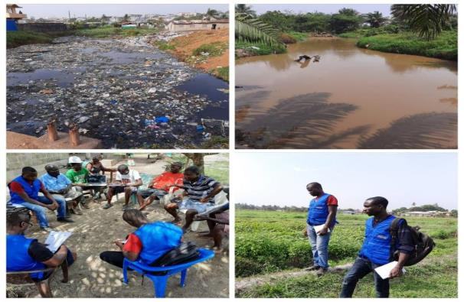
RESETTLEMENT POLICY FRAMEWORK

April 11, 2022

TABLE OF CONTENTS
ACRONYMS viii
DEFINITION OF TERMS x
1 Introduction 1
1.1 Background 1
1.2 The rationale for the preparation of the RPF 2
1.2.1 Reasons for the Use of a ‘Resettlement Policy Framework’ 2
1.2.2 Possible Types of Resettlements 2
1.2.3 Preparation of the RPF 2
1.2.4 Potential Project Impacts 3
1.3 Objectives of the RPF 4
1.3.1 Involuntary Resettlement 5
1.3.2 Physical Displacement 7
1.3.3 Economic Displacement 7
1.4 Methodology for the preparation of the RPF 7
1.4.1 Literature review of baseline information 7
1.4.2 Stakeholders’ consultation 8
1.5. Scope of the RPF 8
2 Description of the project and components 9
2.1 Introduction 9
2.2 Project Development Objective 9
2.3 Project components 10
2.3.1 Component 1 10
2.3.2 Component 2 11
2.3.3 Component 3 13
2.3.4 Component 4 13
2.4 Project area 14
3 Description of the Process for Preparing and Processing the Resettlement Action Plan 14
3.1 Introduction 14
3.2 Potential Impacts and Mitigation Measures 14
3.2.1 Potential Positive Impacts 15
3.2.2 Potential Negative Project Social Impacts 16
3.2.3 Social Risks Mitigations Measures 17
3.3 Estimated Displacement Impacts and Number of PAPs 18
3.4 Potential Relocation Areas 18
3.5 Avoiding or Minimizing Involuntary resettlement 18
3.6 Resettlement measures 23
3.6.1 Compensation 23
3.6.2 Voluntary Land Donation (VLD) 23
3.6.3 Income restoration 24
3.6.4 Consultation- Grievance Mechanisms 24
3.7 Principles and Objectives of the resettlement/ compensation program 24
3.8 Process for Screening, Preparing and Approving RPs 25
3.8.1 Screening of Sub-projects – to determine appropriate ESF instrument 25
3.9 Capacity Building 25
3.9.1 Socio-economic Baseline Data 27
3.9.2 Cut-off date 27
3.9.3 Asset Inventory 28
3.9.4 Approval Process 28
4 Socio-economic Baseline Assessment 29
4.1 Introduction 29
4.2 Setting for socio-economic baseline characteristics 29
4.3 Methodology 30
4.4 Project Location 31
4.5 Demographic Profile 32
4.5.1 Household and Population Characteristics 32
4.6 Ethnicity and Religion 34
4.7 Communities Risk Assessment 34
4.8 Gender Issues 38
4.9 Land Tenure, Ownership 40
4.10 Access to water supply and Sanitation 41
4.11 Waste Management 43
4.12 Culture and Recreation 44
4.13 Medical Facilities 44
4.14 Schools 44
4.15 Livelihood Strategies 45
4.15.1 Employment 45
4.15.2 Income and Expenditure 46
4.15.3 Agriculture 46
4.15.4 PACs access roads and Markets 47
5 Legal and Institutional Framework Analysis 48
5.1 Introduction 48
5.2 Legal framework 48
5.2.1 The Liberian Constitution, 1986 48
5.2.2 The Land Right Act, 2018 48
The Liberian Land Authority Act, 2016 50
5.2.3 Decent Work Act, 2015 50
5.2.4 Environmental Protection Agency Act, 2003 50
5.2.5 Environmental Protection and Management Law of Liberia (EPML), 2003 51
5.2.6 World Bank Environmental and Social Framework 51
5.2.6.1 Objective of ESS5 51
5.2.6.2 ESS5 Scope of application 52
5.3 Gap analysis and reconciliation 52
5.4 Institutional Framework 46
5.4.1 Ministry of Public Works (MPW) 46
5.4.2 Liberia Water and Sewer Corporation (LWSC) 47
5.4.3 Liberia Land Authority (LLA) 47
5.4.4 Ministry of Agriculture (MoA) 48
5.4.5 Environmental Protection Agency of Liberia (EPA) 48
5.4.6 Ministry of Mines and Energy (MME) 49
5.4.7 Ministry of Gender, Children, and Social Protection (MoGSP) 49
5.4.8 Ministry of Finance Development Planning (MFDP) 49
5.4.9 Liberia Electricity Corporation (LEC) 50
5.4.10 Forestry Development Authority (FDA) 50
5.4.11 Liberia Revenue Authority (LRA) 50
5.4.12 Liberia Center for National Documents Agency (LCNDA) 51
5.4.13 National Disaster Management Agency (NDMA) 51
5.4.14 Ministry of Health (MoH) 51
5.4.15 Monrovia City Corporation (MCC) 51
5.4.16 Paynesville City Corporation (PCC) 52
6 Eligibility Criteria for Entitlement 52
6.1 Eligibility Criteria and Entitlements 52
6.2 Eligibility 53
6.3 Entitlements: 57
6.3.1 Loss of Property 57
6.3.2 Vulnerable Groups 58
6.3.3 Eligibility For Community Compensation 58
6.3.4 Loss of Wages and Income 59
6.4 Supplemental Assistance 59
6.5 Valuation Method 60
6.6 Valuation Procedure To Be Followed 60
6.6.1 Preparation of Asset Inventory 61
6.6.2 Types of Compensation Payments 62
6.6.2.1 Cash compensation 62
6.6.2.2 The Voluntary Land Donation process 62
6.6.2.3 Income restoration 64
6.7 Valuation Methods To Be Adopted 65
6.7.1 Replacement Cost Approach 65
6.7.2 Rates from the Ministry of Public Works 65
6.7.3 Rates from the Ministry of Agriculture 66
6.8 Calculation of Compensation By Asset 66
6.8.1 Compensation for Land 66
6.8.2 Land Measurement 67
6.8.3 Calculation of Crops and Fruit Trees Compensation Rate 67
6.8.4 Compensation for Structures 68
6.8.5 Inflation Consideration 68
7 CONSULTATION AND STAKEHOLDER PARTICIPATION 69
7.1 Introduction 69
7.2 Stakeholders of LURP 69
7.2.1 Definition of Project Affected People (PAPs) 69
7.2.2 Categories of PAPS 69
7.3 Stakeholder Consultation 72
7.4 Engagement Methodology 73
7.4.1 Community Congress Meetings 73
7.4.2 Key Informant Interviews (KIIs) 73
7.4.3 Focus Group Discussions (FGDs) 73
7.4.4 Household Surveys 73
7.4.5 Community Involvement and Sensitization 74
7.5 Local Perspectives on the Project and its Impacts 74
7.6 Meeting procedure for conducting RP 75
7.7 Summary of Consultations during the preparation of this RPF 75
7.7.1 Introduction 75
7.7.2 Institutional Stakeholders Identification 75
7.7.3 Summary of Feedback from the institutional stakeholder consultation 76
7.7.4 Identification of local/community stakeholders 77
7.7.4.1 Results from community meetings 78
8 Organizational Procedures for Delivering Entitlements 80
8.1 Introduction 80
8.2 Institutional Arrangements 80
8.2.1 Verification Exercise 82
8.3 RP Entitlements Delivery and Resettlement Committee 83
8.4 Process to Deliver Compensation 83
8.4.1 Notification and Disclosure of Compensation to PAPs 83
8.4.2 Compensation payment processing 84
8.4.3 Entitlement Payment Team 84
8.4.4 Documents to be provided by PAPs 85
8.5 Linking Resettlement Implementation to Civil Works 85
9 Grievance Redress Mechanism (GRM) 86
9.1 Introduction 86
9.2 Objective of the GRM 86
9.3 Potential Sources of Grievances 86
9.4 Grievance Redress Process 87
9.5 GRM Records and Documentation 88
10 Funding, Fund Flow, Cost Estimates and Contingencies 89
10.1 Introduction 89
10.2 Estimated budget to implement RPF 89
10.3 Template Budget for preparation and implementation of RPs 90
11 Monitoring and Evaluation Arrangements 92
11.1 Introduction 92
11.2 Internal monitoring 92
11.3 External monitoring and evaluation 93
11.4 Responsibility of the Authorities 93
11.5 Indicators 94
11.5.1 Indicators to determine status of affected people 94
11.5.2 Indicators to measure RP performance 94
11.6 Monitoring of RPF Implementation 96
11.7 Storage of PAPs Details 97
11.8 Audit 97
11.9 Reporting and Documentation 98
REFERENCES 99
ANNEXES 100
Annex 1: Record of Stakeholder Participation (Institutional Stakeholders Consultation) 100
Annex 2: Record of Potential Affected Communities’ Participation in the RPF 103
Annex 3: Outline for preparing RP 126
Annex 4: Census Assessment of Structure Form 128
Annex 5: Land Tenure Assessment Form 129
Annex 6: Assessment of Grave and Tree Crop 130
Annex 7: Socio-economic Baseline Data Collection Form 131
Annex 8: Structure Compensation Matrix 139
Annex 9: Land Valuation Guide 1
Annex 10: Tree Crop Compensation Matrix 5
Annex 11: Grievance Log 7
Annex 12: RP Verification Form 9
Annex 13: Payment Form 11
Annex 14: Attendance Log From Public Participation 13

List of Tables
Table 1: Design Procedures 20
Table 2: Number of sampled households from each proposed Project Affected Communities 33
Table 3: Potential risks to study communities 35
Table 4: Advantages of LURP as per respondents’ perception 38
Table 5: Source of drinking water in the PACs 42
Table 6: Respondent's Educational attainment level 45
Table 7: Accessibility of roads in the study communities 47
Table 8: Comparison between Liberian Legal framework on land acquisition and ESS5 40
Table 9: Entitlement Matrix 53
Table 10: Stakeholder consulted during the RPF 76
Table 11: Institutional Arrangement 80
Table 12: RP Monitoring Indicators 96

List of Figures
Figure 1: Data collection during a field visit in the Study communities 29
Figure 2: Enumerator using Open Data Kit (ODK Collect) to generate household feedback in Southeastern Paynesville. 30
Figure 3: Map Showing Administrative Boundary of Greater Monrovia 31
Figure 4: Percentage of respondents per gender 33
Figure 5: Percentage of respondents per gender 35
Figure 6: Respondents’ view of potential causes of flooding in the PACs 36
Figure 7: Respondent's perception of potential negative impacts of LURP 37
Figure 8: FGDs with women in Northern Bushrod Island (New Kru Town, Town Hall) 39
Figure 9: Interview with women in the Southeastern Paynesville 40
Figure 10: Respondents' Ownership of the residential facility 41
Figure 11: land tenure and ownership 41
Figure 12: Drinking Water Quality 42
Figure 13: Respondent's access to toilet facilities 43
Figure 14:Clotted Drainage, Omega Tower Community (Left) & Waste disposal in the drainage channel, Redemption Road (Right) 44
Figure 15: Employment Status of Respondent 45
Figure 16: Farms along drainage channels within Omega Market (Left) and Southeastern Paynesville (Right 46
Figure 17: Town Hall Meeting in Southeastern Paynesville (Left) and Central Monrovia North, Soniwein CBD (Right) 77

ACRONYMS
AVT | Asset Valuation Team
CBO | Community Base Organization
CLPP | Commissioner for Land Policy and Planning
CLR | Compensation and Livelihood Restoration
CNDRA | Center for National Documents and Record Agency
CNRE | Committee on Natural Resources and the Environment.
COI | Corridor of Impacts
DLSA | Department of Land Surveys and Cartography
ESIA | Environment and Social Impact Assessment
EPA | Environmental Protection Agency
ESMF | Environmental and Social Management Framework
ESMP | Environmental and Social Management Framework
ESS | Environmental and Social Standards
ESS-5 | Environmental & Social Standard 5
FDA | Forestry Development Authority
FGDs | Focus Group Discussion
FRC | Full Replacement Cost
GDP | Gross Domestic Product
GIS | Geographic Information System
GoL | Government of Liberia
GRC | Grievance Redress Committee
GRM | Grievances Redress Mechanisms
GSA | General Service Agency
GSM | Global System for Mobile Communication
HH | Household
IFC | International Finance Corporation
ILO | International Labor Organization
IMC | Internal Monitoring Committee
IOL | Inventory of Losses
KII | Key Informants Interview
LCNDA | Liberian Center for National Document Agency
LDHS | Liberia Demographic Health Survey
LEC | Liberia Electricity Corporation
LISGIS | Liberia Institute for Statistics & Geo-Information Services
LLA | Liberia Land Authority
LRA | Liberia Revenue Authority
LRPL | Land Rights Policy of Liberia
LRRRC | Liberian Refugee Resettlement and Reintegration Commission
LURP | Liberia Urban Resilience Project
LWSC | Liberia Water and Sewer Corporation
M&E | Monitoring and Evaluation
MCC | Monrovia City Corporation
MFDP | Ministry of Finance & Development Planning
MGCSP | Ministry of Gender, Children, and Social Protection
MME | Ministry of Mines and Energy
MoA | Ministry of Agriculture
MOH | Ministry of Health
MOH | Ministry of Health
MPW | Ministry of Public Work
MPW | Ministry of Public Work
NEP | National Environmental Policy
NGOs | Non-Governmental Organization
ODK | Open Data Kit
PA | Partially Affected
PAG | Project Affected Group
PAH | Project Affected Household
PAPs | Project Affected People
PCC | Paynesville City Corporation
PDO | Project Development Objective
PMU | Project Management Unit
PRS | Poverty Reduction Strategy
PS | Performance Standard
ROW | Right of Way
RP | Resettlement Plan
RPF | Resettlement Policy Framework
RSA | Reconnaissance Site Assessment
SCI | Socio-Cultural Impacts
SGBV | Sexual Gender Base Violence
SME | Small Market Enterprises
TA | Totally Affected
UNEP | United Nations Environment Program
VG | Vulnerable Groups
VLD | Voluntary Land Donation
VLDP | Voluntary Land Donation Protocol
WB | World Bank

DEFINITION OF TERMS
Terms | Definition
Affected Population | Any person/household/community who, as a result of the implementation of the Project, loses the right to own, use, or otherwise benefit from an asset or resource, either in full or in part and either permanently or temporarily.
Compensation | The payment in cash or kind for private property and/or a resource acquired or affected by the project, based on replacement value as defined by the property and resource valuation.
Cut-off Date for Eligibility to Entitlement | The cut-off date for eligibility to compensation and assistance is the date of notification by the RP Consultant and MPW representative after all inventory of affected persons and assets have been taken. Persons occupying the project area after the cut-off date are not eligible for compensation and/or resettlement assistance. Similarly, fixed assets (such as built structures, crops, fruit trees, and woodlots) established after the date of completion of the assets inventory will not be compensated.
Economic Displacement | Loss of income streams or means of livelihood resulting from the land acquisition or obstructed access to resources (land, water, or forest) resulting from the construction or operation of a project or its associated facilities.
Eligibility | Entitlement to resettlement benefits (compensation or other resettlement assistance) due to economic or physical displacement.
Entitled Person | Any person who is entitled to compensation due to loss of privately-owned property or income with or without legal title.
Full Replacement Cost | The market value of the assets, plus transaction costs. In determining the replacement cost, depreciation of the asset and the value of salvage materials are not considered, nor is the value of benefits to be derived from the Project deducted from the valuation of an affected asset. With regard to land and structures, ‘replacement cost’ is defined as follows:  a) agricultural land - the market value of land of equal productive use or potential located in the vicinity of the affected land, plus the cost of preparation to levels similar to or better than those of the affected land, plus the cost of any registration and transfer taxes;  b) household and public structures - the cost of purchasing or building a new structure, with an area and quality similar to or better than those of the affected structure, or of repairing a partially affected structure, including labor and contractors’ fees and any registration and transfer taxes.
Involuntary Resettlement | Resettlement is involuntary when it occurs without the informed consent of the displaced persons or if they give their consent without having the power to refuse resettlement.
Land Expropriation | Process whereby a public authority, usually in return for compensation, requires a person, household, or community to relinquish rights to land that it occupies or otherwise uses.
Leasee | A person who hires, charter, or rent a structure, land, or a place
Physical Displacement | Loss of shelter and assets resulting from the acquisition of land associated with a project that requires the affected person(s) to move to another location.
Plot | The land plot of the future Project Site.
Project Affected Group | Communities or groups which lose community resources to the project.
Project Affected household (s) (PAHs) | All members of a household, whether related or not, operating as a single economic unit, who are affected by the Project.
Project Affected Person (PAP) | Any person directly affected by the project through the acquisition of assets belonging to him/her of his/her household or community. This includes any person whose rights, standard of living, subsistence, and income-generating capacity are adversely affected through the acquisition of assets, whether total/partial or permanent/temporary.
Project Footprint | The area that may reasonably be expected to be physically touched by Project activities across all phases. The Project Footprint includes land used on a temporary basis such as construction laydown areas or construction haul roads, as well as disturbed areas in transport corridors, transmission line right of ways (RoWs), both public and private.
Project Site | The (future) primary operational area for the Project activities. Private transport corridors (i.e., those dedicated for use solely by Project operational activities) are included as part of the Project Site.
Replacement Cost | With regard to land and structures, “replacement cost” is defined as follows: For agricultural land, it is the pre-project or pre-displacement, whichever is higher, the market value of the land of equal productive potential or use located in the vicinity of the affected land. For houses and other structures, it is the market cost of the materials to build a replacement structure with an area and quality similar to or better than those of the affected structure, or to repair a partially affected structure, plus the cost of transporting building materials to the construction site, plus the cost of any labor and contractors’ fees, plus the cost of any registration and transfer taxes.
Resettlement Plan (RP) | The document specifies the procedures that will be followed and the actions that will be taken to mitigate adverse effects, compensate losses, and provide development benefits to persons and communities affected by the Project.
Resettlement Assistance | Support provided to people who are physically displaced by the Project. Assistance may include transportation, food, shelter, and social services that are provided to affected people during their relocation. Assistance may also include cash allowances that compensate affected people for the inconvenience associated with resettlement and defray the expenses of a transition to a new locale, such as moving expenses and lost workdays
Stakeholders | Any and all individuals, groups, organizations, and institutions interested in and potentially affected by a project or having the ability to influence the Project.
Tenant | A person or people who occupy or inhabit a structure, land, or a place having paid for the use of such for an agreed period of time
Titleholder | The person in whose name the project-affected land and/or building is registered and the person who is authorized by law to receive the compensation granted for the acquisition of land. However, PAPs with legitimate land claims even without a title would be eligible to receive compensation.
Vulnerable Groups | Social categories whose livelihoods may be particularly or highly at risk due to disturbances created by the project, i.e., female-headed household, disabled, aged person with little or no support, ethnic minorities, people living below the poverty level, and socially marginalized groups.

Introduction

Background
The Government of Liberia (GoL) has received funding from the World Bank (WB) to implement the Liberia Urban Resilience Project (LURP). Permanent land acquisition and temporary restrictions on land use, through the implementation of some subcomponents, may potentially result in relocation, livelihood disruption, and an adverse impact on persons living on the land chosen for project/sub-project usage. This Resettlement Policy Framework (RPF) will be utilized for the Project to ensure that it fully complies with the Liberian government's requirements and the World Bank Environmental and Social Framework (ESF), which requires the Borrower to comply with ten (10) Environmental and Social Standards (ESSs), especially ESS5-Land Acquisition, Restrictions on Land Use and Involuntary Resettlement, which recognizes that related land acquisition and restrictions on land use can have adverse impacts on communities and persons.
The Project Development Objective (PDO) is to increase flood resilience and access to urban infrastructure in underserved neighborhoods and to improve urban management in Liberia. To measure the PDO, the following outcomes are proposed, which will be refined during project preparation:
- Outcome 1: Number of people protected from the designed return period flood events (sex- disaggregated)
- Outcome 2: Number of people provided with improved urban living/working conditions (sex-disaggregated)
- Outcome 3: Improved capacity of resilient urban planning and management in Greater Monrovia
The project will have four components. The RPF is focused on activities under component 1, including its subcomponents 1.1 and 1.2, which are the components that entail civil works and the potential risk of involuntary resettlement:
- Component 1: Climate Resilient Infrastructure and Urban Upgrading
  - Subcomponent 1.1: Climate Risk Management Infrastructure
  - Subcomponent 1.2: Climate Resilient Community and Market Upgrading
- Strengthening Integrated Resilient Urban Development Capacity
  - Subcomponent 2.1: Resilient Urban Planning and Development Control
  - Subcomponent 2.1: Solid Waste Management Operations and Financing
- Project Management
- Contingency Emergency Response Component

Environmental and social screening to identify the environmental and social risks and impacts before the start of civil works of the LURP is necessary to ensure compliance with the World Bank Environmental and Social Standards.

The rationale for the preparation of the RPF
The RPF's goal is to define the resettlement and compensation principles, organizational arrangements, and design criteria that will be used to meet the needs of people who own or use land or resources and who will be relocated or displaced from their current residences or livelihoods in order for the Project's objectives to be met.

Reasons for the Use of a ‘Resettlement Policy Framework’
The exact location, nature, and magnitude of sub-projects to be supported cannot yet be established due to the community-driven nature of most components of the LURP initiative. As a result, preparing Resettlement Plans (RPs), which define precise mitigating actions and develop strategies for livelihood restoration, is currently impossible. This RPF has been established to give recommendations on how the projects would prevent, manage, or reduce any risks, as well as the method by which RP will be prepared and implemented, in accordance with national and World Bank Environmental and Social Standards (ESSs). Once the location and scope of individual subprojects are understood and resettlement screenings report potential impact to involuntary resettlement, preparation of RP shall be implemented.

Possible Types of Resettlements
As a result of project-related land acquisition, involuntary resettlement refers to both physical (relocation or loss of shelter) and economic (loss of assets or access to assets that leads to loss of revenue sources or means of living) displacement. When affected individuals or communities do not have the right to resist land acquisition that results in displacement, resettlement is called involuntary. This occurs in the following situations:
- legally expropriation or limits on land use based on the eminent domain; and
- negotiated settlements in which the buyer has the option of expropriating the land or imposing legal restrictions on land use if discussions with the seller fail.
This resettlement policy framework covers the Project's direct economic and social impacts, which are caused by the involuntary taking of land, which results in: relocation or loss of shelter; loss of assets or access to assets; or loss of income sources or means of livelihood, whether or not the affected persons must relocate.

Preparation of the RPF
This RPF is the result of a planning study that aimed to provide the concepts, guidelines, and processes that would be used to perform resettlement and compensating activities during the Project's life cycle. The RPF describes.
- The legal and institutional framework for planning and implementing resettlement, taking into account relevant Liberian laws and policies as well as the World Bank's policy on Involuntary resettlement (ESS5),
- The provision of information on the potential environmental and social impacts of various alternative livelihoods during the project preparation phase and to offer appropriate mitigation measures.
- The establishment of explicit directives and methodologies for the environmental and social screening of project activities under component 1 that will be supported by the proposed Project
- Project-affected persons (PAPs), eligibility criteria, and Resettlement “Entitlement matrix”. Material measures will be included in the matrix, such as monetary compensation, land and structure replacement, and, in some situations, assistance for livelihood support.
- Procedures for up-taking and resolving project-related concerns and disputes; and procedures for consultation and participative approaches including PAPs and other important stakeholders

Potential Project Impacts

Overall, the project will have positive impacts as it will: (a) support drainage construction with initial capital; (b) improve resilience of climate change impacts; (c) create jobs and improve livelihood; (d) enhance institutional capacity to support service delivery; (d) improve urban drainage system; and (e) contribute to women’s empowerment through prioritization of interventions and support through training.
The project’s risks and potential adverse impacts will range from low to substantial and are mostly associated with the proposed drainage interventions under Component 1 and rehabilitation of markets and support capacity building under Component 2. The risk and potential adverse impacts are mostly short-lived and localized and can be efficiently mitigated through cost effective and tested measures. These are summarized below:
- Erosion of flood water receiving environment; accidents and injuries; dust; noise; vibration; waste (solid, liquid, hazardous); loss of vegetation and natural habitat; loss of land and assets on land, trees and structures); sexual exploitation abuse & harassment (SEA/H).
- Traffic safety; noise; dust/fumes; vibration; safe storage of any hazardous materials
- Contamination of site and surrounding area; biodiversity losses, slips, trips, falls, attacks, manual handling risks, injuries, waste generation (solid waste); exposure to diseases; proliferation of flies and disease-borne vectors and COVID-19 spread
- Slips, falls, trips; noise; dust/fumes; vibration; waste generation (solid, liquid, hazardous); accidents and injuries; SEA/SH; physical and economic displacement (e.g. temporary and permanent loss of livelihood, and assets);
- Child labor, forced labor, Labor influx, COVID-19 spread, soil and water contamination, community health and safety
- Land taking / involuntary resettlement of people to enable rehabilitation and construction of drainage channels as well as nature-based solutions
- Loss of income of marketers and street vendors during construction works of markets
The project’s Environmental and Social Management Framework determines practical E&S measures to mitigate identified risks and impacts throughout the life of the project, which also apply to this RPF. The mitigation measures are based on the principle of the mitigation hierarchy comprising avoidance/elimination, minimization/reduction, mitigation, compensation and offsets. It is anticipated that adherence to the proposed mitigation measures will enhance social acceptability, environmental soundness, and sustainability of the project.

Objectives of the RPF
The Resettlement Policy Framework (RPF) will guide the implementation of the MPW’s Project Management Unit (PMU) civil works packages under the components and sub-components to ensure that displacement issues are resolved, affected person’s livelihoods are not negatively impacted, and they are compensated and/or resettled where it is unavoidable. The RPF will also help to explain resettlement principles, mitigation methods, organizational structures, and design criteria that will be used in the LURP’s implementation.
The RPF will outline concepts, organizational arrangements, and design criteria for any resettlement (if necessary) that may occur during the LURP’s implementation. As a result, the RPF will assist in the development of RP as required by the project.
The Resettlement Policy Framework (RPF) has the following goals:
- Establish the LURP’s resettlement and compensation principles and implementation plans; clarify the policies, principles, and procedures that will govern the MIDP’s mitigation of negative social impacts.
- Describe the legal and institutional framework underlying approaches for resettlement, compensation, and rehabilitation.
- To ascertain eligibility and compensation for the loss/impacts of the Project Affected Persons (PAPs);
- Provide guidelines to develop an Entitlement Matrix and specify eligibility criteria for defining various categories of Project Affected Person (PAPs).
- Describe the consultation procedures, including stakeholder mapping and participatory approaches involving PAPs and other key stakeholders.
- Provide procedures for the Grievance redress Mechanism and for filing grievances and resolving disputes.
- Provide a planned monitoring and evaluation as well as indicate parameters to be monitored, institute monitoring milestones, and provide resources, including responsible persons or institutions necessary to carry out the monitoring activities.
- Develop an outline for the development of Resettlement Action Plans.
- Compliance with provisions under the World Bank ESF (ESS5, paragraph 2(b)); and
- Set out the framework for monitoring and evaluation of the project.
The RPF will provide guidance to identifying and managing situations when sub-projects may lead to the displacement of people affecting their livelihoods (physical or economic displacement/resettlement, denial of rights of access to resources). It also includes guidelines on how to address impacts on vulnerable groups and gender. Any resettlement and/or compensation measures will be implemented in accordance with the RPF, which will guide when and how the site-specific RP will have to be completed and implemented before project implementation commences.
The RPF follows the guidance provided in the World Bank Environmental and Social Standard 5: Land Acquisition, Restrictions on Land Use, and Involuntary Resettlement of its Environmental and Social Framework. The RPF ensures that project activities that will cause physical and or economic displacement or any possible adverse impact of proposed project activities are addressed through appropriate mitigation measures against potential impoverishment risks. These risks can be minimized by:
- Avoiding displacement of people without a well-designed compensation and relocation process.
- Minimizing the number of PAPs to the extent possible by seeking alternative sites and designs.
- Compensating for losses incurred and displaced incomes and livelihoods where land take is unavoidable; and
- Ensuring resettlement assistance or rehabilitation is timely and as needed to address impacts on PAP’s livelihoods and their wellbeing.

Involuntary Resettlement
The eight most common impoverishment risks are:
- Landlessness
Expropriation of land undermines many people's ability to create productive systems and economical operations. The land is frequently lost forever; it is occasionally partially replaced but rarely totally replaced or compensated for. This is the most common method of de-capitalization and pauperization of displaced people. Natural and man-made capital are both being depleted.
- Joblessness
Both rural and urban displacement results in the loss of salaried work. Workers in the manufacturing and service industries, as well as landless agricultural laborers and craftspeople, may lose their jobs. Resettlers' unemployment or underemployment may last for a long time after their physical relocation. It is tough to create new jobs for them, as it necessitates significant investments, new creative techniques, and reliance on project benefits being shared.
- Homelessness
For many people, losing their home is merely a transitory situation, but for others, it is a chronic state that results in a loss of identity and cultural deprivation. If nearby homes of the same kinship group become dispersed, the loss of housing may have an impact on family cohesion and mutual aid networks. Therefore, group relocation of neighbors is usually preferable to over-dispersed relocation.
- Economic Marginalization
Marginalization happens when relocated families lose economic power and fall into lower socioeconomic positions: middle-income farm family becomes tiny landowners; small retailers and craftspeople lose business and fall into poverty. Economic marginalization is frequently followed by social and psychological marginalization, as seen by a decline in social status and the stigma that comes with it, as well as resettlers' loss of faith in society and in themselves.
Increased morbidity and mortality
Forced relocation increases the vulnerability of the poorest people to illnesses since it is connected with increased stress, psychological traumas, or the onset of parasite illnesses. Health problems arise as a result of contaminated water and sewage systems, which spread epidemic ailments like diarrhea and dysentery.
- Food insecurity
Forced uprooting reduces self-sufficiency, disrupts local food supply networks, and raises the risk of chronic food poverty. This is characterized as calorie-protein intake levels that are less than the bare requirement for appropriate growth and work.
- Loss of Access to Education
Involuntary displacement impairs all public services, with severe consequences for the functioning of schools. When a child's school attendance is disrupted, he or she loses access to education for a long time; some youngsters never return to school and are forced to join the labor force by their families.

- Restricted Access to Communal Property
When poor PAPs, especially those without assets, are relocated, they lose access to the community's common property products (e.g., loss of access to water bodies, farmlands, cemeteries, place of worship, etc.). This is a common occurrence of uncompensated income loss and livelihood deterioration that planners overlook.

Physical Displacement
If people must relocate due to the implementation of a subproject, the LURP will:
- Provide displaced persons with a range of viable resettlement options and, when appropriate, cash compensation for an impacted asset.
- Provide relocation assistance tailored to the specific requirements of each group of displaced people, with a special focus on the poor and vulnerable.

Economic Displacement
Regardless of whether or not the affected persons are physically evacuated, if land acquisition for a subproject result in a loss of income or livelihood, the Project must meet the following requirements:
- Pay full replacement cost compensation to economically displaced people who have lost assets or access to assets.
- Provide those with legal rights or claims to land who are recognized or recognizable with replacement property (e.g., agricultural, or commercial sites) of equal or better worth or financial compensation at full replacement cost where appropriate.
- Compensation for lost assets (such as crops, irrigation infrastructure, and other improvements done to the land) other than land, at full replacement cost, for economically displaced persons who do not have legally identifiable claims to land.
- Provide further targeted support (e.g., training or employment possibilities) and opportunities for economically displaced persons whose livelihoods or income levels have been adversely affected to improve or at least restore their income-earning capability, production levels, and living standards.

Methodology for the preparation of the RPF
The below sections provide methodologies that were implored to develop this Resettlement Policy Framework.

Literature review of baseline information
A review of the existing baseline information and literature material was undertaken to gain a deeper understanding of both the Project and the general location of the project. Information was collected and analyzed, and it included relevant national and international policies and regulations (see section four), World Bank ES Standards, and as well as socioeconomic reports on Greater Monrovia (the anticipated project area). The review also covered existing reports on environmental and social concerns associated with the proposed investments under the Project.

Stakeholders’ consultation
The project interventions may impact or be impacted by stakeholders. They include key government ministries and agencies, civil society organizations, NGOs, local communities, and people who have an interest in or are impacted by the Project. Consultations were held in all four of the potential project locations (Omega Market, Southeastern Paynesville, Bushrod Island North, and Central Monrovia, Soniwein CBD). Several consultative meetings were held with the projected Project Affected communities, as well as other relevant officials from the major implementing partners, appropriate line ministries, and agencies, despite the fact that the actual project footprint is yet to be decided. The goal was to get feedback from stakeholders on the LURP and talk about the project components and proposed activities that would have an influence on their lives. Furthermore, appropriate government institutions with project-related responsibilities were consulted. The Liberia Land Authority, the Ministry of Agriculture, the Environmental Protection Agency, the Liberia Water and Sewer Corporation, and the Liberia Revenue Authority are among these institutions. The issues raised throughout these conversations and field visits were integrated into the RPF's development.

1.5. Scope of the RPF
This RPF covers the following key areas in order to provide mitigation measures for estimated impacts to involuntary land acquisition or physical or economic displacement that may arise as a result of activities implemented under component 1 of the LURP:
- The rationale for the preparation of the RPF
- Principles and objectives governing RPF and Implementation
- Description of the project and components
- Description of the Process for Preparing and Processing the Resettlement Action Plan
- Potential Impacts and Mitigation Measures
- Socio-economic Baseline Assessment
- Eligibility Criteria for Entitlement
- Valuation Procedure To Be Followed
- Valuation Methods To Be Adopted
- Calculation of Compensation By Asset
- Consultation And Stakeholder Participation
- Disclosure Arrangements for the RPF and RPs
- Organizational Procedures for Delivering Entitlements
- Institutional Arrangements
- RP Entitlements Delivery and Resettlement Committee
- Grievance Redress Mechanism (GRM)
- Funding, Fund Flow, Cost Estimates and Contingencies
- Monitoring of RPF Implementation

Description of the project and components

Introduction
The Liberia Urban Resilience Project (LURP) was conceptualized based on the context of very complex urban developmental challenges inherently associated with Greater Monrovia and across Liberia. Developing and arriving at the various components of the project was very difficult due to the mixed nature of the challenges at hand, ranging from climate risks, flood risks, poor basic services delivery, weak infrastructures, poor waste management, etc. After extensive engagement with the stakeholders, mainly the Government, the project was designed to: a) mitigate climate and flood risks through structural and non-structural measures; b) provide basic services/infrastructure investments in underserved neighborhoods, and c) improve institutional capacity for the management and development of Greater Monrovia and across Liberia. A climate and flood risk assessment for Greater Monrovia has been completed that informs the resilience objectives, which will be integrated into infrastructure design, urban planning, data development, capacity building for policy and decision-making, and investment planning. To meet its development objectives, the proposed project will have four components as described below.
I. Climate Resilient Infrastructure and Urban Upgrading
  - Climate Risk Management Infrastructure
  - Climate Resilient Community and Market Upgrading
- Strengthening Integrated Resilient Urban Development Capacity
  - Resilient Urban Planning and Development Control
  - Solid Waste Management Operations and Financing
- Project Management
- Contingency Emergency Response Component

Project Development Objective
The Project Development Objective (PDO) is to increase flood resilience and access to urban infrastructure in selected neighborhoods and to improve urban management in Liberia. The following outcomes are proposed to measure the PDO, which will be refined during project preparation:
- Outcome 1: Number of people protected from the designed return period flood events (sex-disaggregated)
- Outcome 2: Number of people provided with increased access to urban infrastructure (sex-disaggregated)
- Outcome 3: Spatial Development Plans developed and endorsed

Project components

Component 1
Component 1: Climate Resilience Infrastructure and Urban Upgrading. This component will support flood risk management and community upgrading infrastructure in prioritized areas of Greater Monrovia. Investments in drainage infrastructure will improve connectivity of drainage networks and are prioritized to reduce climate and flood risk. Associated neighborhood and market upgrading interventions will improve living and working conditions and access to public services. This component will finance (i) feasibility and design, (ii) consultations, (iii) environmental and social framework (ESF) studies and instruments, (iv) compensation payments for resettlement, (v) works, (vi) supervision, and (vii) servicing and maintenance contracts. A waiver for IDA payment of resettlement compensation will be proposed, based on a desk-based estimation of the compensation costs, in the absence of design footprint and site-specific Resettlement Plans (RPs).
Four geographical key intervention areas are being considered, based on their flood risk/climate vulnerability, government priorities, economic significance, balance between MCC and PCC and consideration of other ongoing donor investments. The prioritization of these areas and associated investments in these areas will be confirmed through a feasibility study. The selected areas of intervention include a) Northern Bushrod Island, including Duala market (MCC), b) Central Monrovia – Soniwein drainage system (MCC), c) Omega Market Area (PCC), and d) South-Eastern Paynesville, Duport Road area (PCC). Climate vulnerability has been accounted for through assessment of pluvial, fluvial and coastal flood risk in the entire Greater Monrovia area. Three out of four areas have a relatively high risk per unit area, whereas the fourth area has the potential to become a high risk area due to the ongoing rapid developments.

Subcomponent 1.1: Climate and Flood Risk Management Infrastructure. This subcomponent will support climate and flood risk management in prioritized areas of Greater Monrovia. It will finance construction of new drainage infrastructure and upgrading of existing channels. New and upgraded drainage infrastructure will be designed with climate resilience in mind, so that 10-year floods under the most likely 2050 climate scenario will be anticipated and designed for. Designs will also consider opportunities to minimize operations and maintenance needs and costs, due to limited government capacity. In particular nature based solutions will be used wherever possible, including blue solutions (open water areas for temporary stormwater storage), and green solutions (wetland or green vegetated areas to maintain soil infiltration and temporarily store surface stormwater). Civil works under this subcomponent will make use of the affected community’s work force, especially women. The final site selections will be made based on the climate screening to be included in the feasibility study. .

Subcomponent 1.2: Climate Resilient Community and Market Upgrading.
This will finance community infrastructure investments in neighborhoods and market areas in the same locations as the drainage and water retention infrastructure. Infrastructure will be prioritized based on climate change local area plans that are developed with community and market representatives to prioritize investments. Infrastructure that has a climate change mitigation and adaptation benefit and that compliment flood risk management infrastructure supported under component 1.2. will be prioritized. Investments could include improved water supply, sanitation and waste management/transfer/sorting facilities, community halls, childcare and health facilities, cold storage facilities, and green parks and recreational spaces. To ensure future sustainability of investments in light of climate change vulnerability and impacts, all infrastructure activities will be based on resilient design principles and prioritize investments based on climate change mitigation and adaptation considerations by using e.g. energy efficient lighting and equipment, solar panels, roof top greenery, measures/design principles that reduce the need for air-conditioning, elevated construction to protect against flood risk, more resilient building materials, etc. The project will ensure that women are engaged in the envisaged participatory, community-led decision-making processes such that their needs and safety concerns will inform the proposed urban design and infrastructure interventions. The project will also ensure that women are well represented within the community work force that will help with works as well as the operation and maintenance envisaged required for this subcomponent’s interventions.

Component 2
Component 2: Strengthening Integrated Resilient Urban Development Capacity (US$6 million). Beyond Greater Monrovia, primary cities across the country are growing rapidly, and while they do not face the same intensity of urban challenges due to their much smaller populations, support to effectively plan urban growth and associated infrastructure and service delivery needs, can help these cities to avoid some of the challenges that Greater Monrovia now faces. This Component will therefore support resilient integrated spatial planning, capacity needs assessment and investment plans in Greater Monrovia, including Paynesville, as well as the next three largest cities in Liberia, Buchanan, Ganta, and Gbarnga. Activities will use climate risk maps to orient and inform resilient urban growth and development. It will also provide dedicated capacity building of municipalities and other institutions associated with resilient urban development planning and control, and solid waste management service delivery. Capacity building activities are intended to contribute to better resilient planning and development control, integrating gender-informed urban design, increasing fiscal space, and improved coordination.
Subcomponent 2.1: Resilient Urban Planning and Development Control.
This subcomponent will finance activities to increase the capacities of relevant stakeholders to develop, maintain and update a climate resilient spatial development plan. The plan would be developed through a participatory process involving intensive stakeholder engagement, especially with women through targeted focus group discussions, and the output would emphasize the spatial elements needed to guide climate resilient infrastructure investments and land use in Greater Monrovia as well as primary cities and safeguarding against development on land most vulnerable to climate and flood risk. To promote this a focus will be set on integrating climate vulnerability aspects into the spatial development diagnostics and subsequent plans, e.g., outlining no build zones in existing or future flood prone areas, identifying key infrastructure at risk etc. The plan will also include a climate resilient infrastructure diagnostic and investment plan, including transport, drainage, ICT, water and sanitation, and market infrastructure identifying priority investment needs with a view towards low carbon and resilient urban development and economic growth trajectory. To oversee the development of the proposed plan, the project will finance operational expenses of a Greater Monrovia Task Force. Similar plans and task forces will be developed for Buchanan, Ganta, and Gbarnga. These task forces will ensure women’s participation at the municipal decision-making level and the task forces will develop processes for consulting with the female urban population to support increased participation of women in planning and decision-making within urban spaces. In order to support the effective implementation of such planning instruments, this subcomponent will also support an urban development control strengthening program which will (i) assess opportunities for strengthening the existing legal framework, institutional arrangements, and current practices; (ii) develop a comprehensive national training and skills development needs assessment for urban planning, management and land administration and implementation of relevant trainings, including with a focus on climate change to increase awareness of urban resilience; (iii) prepare development control tools, including digitization of permitting systems and (iv) deliver targeted training to civil servants and appointed officials at the central and local government level with the possible inclusion of community-level organizations, which will ensure that female staff of the municipalities will benefit. This sub-component is being supported by a World Bank-executed technical assistance project conducting a Climate and Disaster Resilient Building Regulatory Capacity Assessment, whose results will help to inform the design and activities under this sub-component in more detail. Ultimately, the strengthening of urban development control systems and practices, using climate risk maps to inform no-build zones, paired with a public awareness campaign on climate risks also to be supported under the program, is anticipated to contribute to a reduction of citizens settling in high climate and flood-risk zones or ecologically sensitive areas, thereby reducing climate risk in the medium to long term.
Subcomponent 2.2: Solid Waste Management Operations and Financing.
The top priority to improve Operations and Maintenance (O&M) of drainage and other hydraulic infrastructure is to improve Solid Waste Management System. Keeping waste out of the drains allows it to effectively protect against climate and flood risks. This subcomponent will finance the development of a Solid Waste Management Operational Plan for the Greater Monrovia Area that will include a detailed financial model, private sector engagement plan and inform the operational needs of the system. The plan will also lay out contractual options to combine SWM collection with regular drainage clean-up operations, since drains are acting as waste receptacles in Greater Monrovia. The work will build on recent sectoral diagnostic work of Cities Alliance. Capacity building will draw on the revenue-oriented elements of the Local Government Act and include a diagnostic and needs assessment of current local government revenue mobilization and identify an action plan to enhance revenue streams. This could include, inter alia, further technical assistance to strengthen the policy dialogue and systems related to property tax; business taxes; market taxes; etc. Equipment and capacity development needs to enhance revenue mobilization and collection will also be supported. Similar, smaller scale SWM planning, and capacity support will be offered to Buchanan, Gbarnga and Ganta. The sub-component will build on the technical assistance provided under the Bank Executed Pro Blue project, and opportunities to reduce, re-use and recycle especially plastics will be integrated throughout this component. It is anticipated that activities will in the medium- to long-term contribute to a reducing of the estimated SWM related GHG emissions (see sector context). This component will build on the achievements of the Cheesemanburg Landfill and Urban Sanitation (CLUS) project (P159961) in close coordination with MCC and PCC. With CLUS is reaching the end of its project lifespan and resources, some activities that may not be completed under that project could be taken up, such as the feasibility, design and ESF studies for SWM facilities.

Component 3
Component 3: Project Management (US$4 million). This component will finance all expenses required for project management and coordination, compliance monitoring of social, environmental and safety standards, fiduciary management, and monitoring and evaluation (M&E). All operational expenses of the Project Management Unit (PMU) will be financed from this component, including external consultants to be hired as PMU staff, project vehicles, equipment, and furniture. The component will also finance the services of a project management consultancy firm to swiftly fill specific technical and project management needs for specific assignments. Any project management, E&S, fiduciary or other required meetings, consultations and workshops will be financed under this component as well. Expenses required to establish, implement and monitor the Grievance Mechanism (GM) and handling of complaints and all E&S related concerns will be covered by this component. Finally, required studies, including a mid-term review and an implementation and completion report will be financed to inform the M&E system of the project. All other M&E related studies, surveys and other expenses will be financed from this component as well..

Component 4
Component 4: Contingency Emergency Response Component (CERC). Following an eligible crisis or emergency, the Borrower may request the Bank to re-allocate project funds to support emergency response and reconstruction. This component would draw from the uncommitted grant resources under the project from other project components to cover emergency response. A CERC annex to the Project Implementation Manual for this Component will be prepared by the Borrower and will provide detailed guidelines and instructions on how to trigger the CERC and use funds (including activation criteria, eligible expenditures, and specific implementation arrangements as well as required staffing for the Coordinating Authority).

Project area
The project area for Component 1 spans several communities within greater Monrovia ranging from Central Monrovia/CBD (Sonewein Canal/drainage) to Northern Bushrod Island (New Kru Town, Duala, Logan Town/King Peter Town) and Paynesville (Omega Market, Duport, etc.).
Central Monrovia/CBD (Sonewein Canal/drainage). The largest drainage/canal in Monrovia commences from the top of Benson Street, Mamba Point, running through and beneath some of the principal streets as well as through Buzzy Quarter Community and discharges at the back of the BTC barrack where it empties into the Atlantic Ocean. At several points along the canal, the water and sewer utility sewage line intercept the drainage leading to combined runoff and sewage flowing through the drainage.
Northern Bushrod Island (New Kru Town, Duala Market, Logan Town/King Peter Town). This area covers the New Kru damaged drainage belt beginning from D. Tweh high school, Redemption Hospital through Duala market, and beyond. It extends to parts of Caldwell bridge up to Logan town (King peter Town/along the railway track).
Paynesville (Omega Market, Duport, etc.). This corridor begins from the Coca-Cola community to the Omega market and extends to the Soul clinic community and beyond. It continues to Duport road (Cow field) towards GAS road along the Mesurado belt.

Description of the Process for Preparing and Processing the Resettlement Action Plan

Introduction
The core fundamental requirements that underpin the formulation and implementation of the resettlement instrument are the WB principles on involuntary resettlement. These guidelines are designed to help people avoid, minimize, or ameliorate the adverse consequences of involuntary resettlement. Any impact of the LURP project on land and/or people (land acquisition and resettlement, of impacted individuals) would be managed in accordance with Liberian legislation and the World Bank's involuntary resettlement safety policy (ESS5). In the event of any discrepancies or inconsistencies between Liberian laws and World Bank policy, the World Bank Environmental and Social Standard (ESS5) will take precedence in accordance with this RPF.

Potential Impacts and Mitigation Measures
The potential social impacts (both positive and negative) associated with the project are described below

Potential Positive Impacts
- The project will have significant benefits, in particular and with regards to the improvement of health and wellbeing, especially in terms of the reduction of water-borne illnesses and reduction in the potential outbreaks of epidemic infectious diseases such as cholera and diarrhea through its sanitation and water supply system component.
- The sub-projects will largely generate positive impacts contributing to public health, provision of improved water supply to targeted communities to address dire water needs in such communities, and go a long way to improve delivery of social services such as health and education in the targeted communities
- Construction works (e.g., construction of drainage channels, toilet facilities, water points, etc.) will present employment opportunities to local people (including women) and generate direct income benefits to local households. Employment, as men and women will potentially supply casual labor to the contactors.
- Use of an appropriate labor-intensive workforce during construction (e.g., excavation for pipelines, providing security, and preparation of meals for contract workers) will provide employment opportunities to the communities, which will generate direct income to the households.
- Mitigation of tension/conflict over water: scarcity of water is one of the sources of conflict in the beneficiary communities, particularly in Northern Bushrod Island, Central Monrovia, Soniwein CBD, and Southeastern Paynesville areas.
- The intervention will improve safe water and sanitation availability and accessibility, thereby improving the health of children and the communities.
- Reduce the burden of women who bear the burden of water collection from long distances, which directly affects their well-being as they are sometimes assaulted on their way from these water sources.
- It will boost the economic livelihoods of women in the project area as they will have more time to engage in income-generating activities.
- Contribute to the GoL agenda for transformation and the Ministry of Public Works Transformation Agenda.
- At the neighborhood level, interventions are likely to include the provision of all-weather access by implementing blue-green-grey infrastructure beyond traditional concrete drainages, such as protected green water retention areas, permeable paving, rainwater capture, and other Nature-Based Solutions (NBS).
- The project has a strong focus on gender considerations and will specifically expand women's economic opportunities through their involvement in the LURP and mapping of the number of women, youth, and the disadvantaged group who possess and could participate directly in the project is being pursued.
- The project will provide employment opportunities through engaging labor in civil and infrastructure works, which will translate to economic empowerment at household levels and improvement in livelihoods though it will depend on a short-term basis.

Potential Negative Project Social Impacts

The LURP subprojects may involve land acquisition and displacement of land-users and/or livelihoods. It will try as much as possible to avoid resettling or displacing people. However, in the event that the proposed interventions, particularly under components 1 and 2, are implemented, these may affect land holdings of individual and joint property owners as well as affect people’s livelihood. While these interventions are yet to be identified, as a precautionary measure, this Resettlement Policy Framework (RPF) will address any issues which might arise from the economic and physical displacements of residents and traders.
The project shall pay special attention to selected localities where the project interventions are planned given that these localities: a) are densely populated, b) hosts the largest and most popular wholesale and retail markets, c) accommodates important economic hubs in the greater Monrovia, d) are places where traders are carrying day-today trading activities to support their livelihoods and, e) are localities where diverse communities and assertive people are found. The project intervention in the four selected localities is expected to have economic and physical displacements on large number of people residing and carrying on livelihood activities in each locality. While the number potential Project Affected Persons (PAPs) cannot be determined at this stage of the project, the nature of the physical and economic displacements and their associated impacts are expected to be permanent and temporary.
Direct social risks associated with displacements will likely includes: i) interruptions or permanent income losses for those day-to-day traders who are depending on trading activities to support themselves and their families - which could result to potential youth and market women unemployment as well loss/reduction of household income; ii) full or partial losses of structures/properties used for residence, commercial and rental purposes, iii) denial or limitation of access to local residents to the Atlantic Ocean coastal areas and to the freeport facilities that could likely limit their fisheries activities and deprive them from providing cash to support their households, iv) potential increase in urban poor including women and youth who may be affected by temporary or permanent loses of income due to their inability to undertake trading activities in project affected areas; vi) potential exclusion of vulnerable people (women, disabled, elderly, the ill and those ethnic minorities) from compensation and the project benefit - thereby worsening their situation and widening the inequality gaps; vii) likely increase in exploitation of women, girl and children who are likely to become most vulnerable as result of project interventions and losses of income; viii.) the unknown nature of MPW/PMU’s capacity to manage social risks, ix.) potential rise in SEA/SH related cases as result of labor influx; x) potential community health risks associated include i) traffic and road safety, ii) safety of services and community exposure to health issues, iii) infrastructure design issues, and iv) potential risks and impacts arising from labor influx.
The Sexual exploitation and abuse and sexual harassment (SEA/SH) risk is rated moderate. GBV, SEA/SH continues to be a major challenge for Liberia. Early marriage, rape, offensive touching (sexual assault), forced prostitution, wife inheritance and forced servitude are the main types of sexual and gender-based violence perpetrated in the communities. As per the 2020 Demographic and Household Survey report, 60 percent of women and girls in Liberia have experienced physical violence and 9 percent have experienced sexual violence. Services for GBV survivors (including healthcare, psychosocial support, and justice) are limited, even in urban settings. Further, transactional sexual relationships are often viewed as a survival mechanism for adolescent girls in urban areas to obtain food, housing, clothing, school fees and other essentials. The project has the potential to increase these risks in several ways, including by bringing workers and laborers implementing the project’s infrastructure activities into contact with vulnerable women and girls.

Social Risks Mitigations Measures

Given the ranges of social risks flagged above and considering the sensitive nature of the areas where the project is planned to be implemented, the project will required to implement mitigation measures proportional risk including: a) exploring and considering design options that could avoid or minimize livelihoods disturbances in the four localities as well as consulting affected communities on design options to be considered taking into consideration: a) population density; b) examining livelihoods activities undertaken in the project impact corridors and their economic implications both to affected people and to the greater Monrovia as a whole; c) examining contexts and characteristics of local communities in each of those intervention locations and; d) understanding the nature and challenges faced by vulnerable people when designing the project and the mitigation measures. In addition to the proportional design measures discussed, the project will be required to adopt robust risk mitigation measures capable of offsetting the direct socioeconomic risks associated with displacements includes: i) providing adequate compensations for income losses; ii) providing full replacements cost for affected structures; iii) ensuring alternative route and means of livelihoods for those who are dependent on fisheries; iv) reducing, to extent possible, trading activities disruptions; vi) ensuring inclusion of vulnerable people in compensation and livelihood restoration plan and to project benefit sharing arrangements; vii.) demonstrating and enforcing no tolerance to exploitation of women, girl and children who may become most vulnerable as result of project interventions; viii.) ensuring that the implementing agency has in place efficient PCU with competent E&S staff, ix) developing and implementing SEA/SH action plan; x) adopting community health and safety plan.

In view of the high prevalence of GBV in Liberia the likelihood that the project will tilt the power dynamics towards those contractors’ workers with cash on their hand, the project will address these risks by conducting a site-specific SEA/SH risk assessment and developing an SEA/SH Action Plan. Measures will include at a minimum; (a) requirements for contractors to submit Codes of Conduct and include plans for worker training and accountability in their C-ESMPs and other safeguards instruments; (b) a project Grievance Mechanism with special procedures for confidential and ethical reporting of SEA/SH incidents; (c) mapping of GBV service providers in the project area to provide a referral pathway for survivors who report; (d) community sensitization on SEA/SH risks and reporting; and (e) training for the Implementing Agency on addressing SEA/SH as part of social risk management. The project will explore the engagement of a qualified GBV service provider or NGO to support the MPW/PCU one month after project effectiveness to design and implement the measures and respond to any incidents.

Estimated Displacement Impacts and Number of PAPs
It is important to underscore that at this stage it is not possible to determine the number of PAPs for several reasons:
- The necessary studies to fully identify the viable investments are either just launched or to be launched soon but have not yet reached the stage of final identification and design of subprojects.
- The individual subprojects of the community-driven development components (LURP Components 1 & 2) will be identified during project implementation. Due to this, the precise locations, nature, and magnitude of these subprojects cannot be determined before implementation.
- The RPF study identified structures and farmlands that are within waterways and drainage channels. To meet Components 1 and 2 of the LURP, these structures and agricultural farming lands, if affected, will be considered for resettlement and compensation. Consequently, for each subproject that is considered during screening to require physical and/or economic resettlement, the number of PAPs will be established through a RP, which will be elaborated before the subproject is approved for inclusion in the work program of the project.

Potential Relocation Areas
The location for resettlement will be identified during the development of individual subproject RPs, which will involve consultation with relevant authorities and the PAPs involved.

Avoiding or Minimizing Involuntary resettlement
In accordance with World Bank Environmental and Social Standards (ESSs), with specific reference to ESS5, the design and implementation of subprojects under this Project shall prioritize avoiding resettlement; if that option is not feasible, alternative measures will be used to minimize and/or ameliorate the Project's displacement implications displaced persons in improving or at least restoring their livelihoods and standards of living in real terms relative to pre-displacement levels or to levels prevailing prior to the beginning of project implementation, whichever is higher.
Measures to avoid and minimize involuntary resettlement impacts include the following: (i) explore alternative alignments which are less impacting by carrying out all improvements within the existing footprint, (ii) usage of appropriate technology and software that are accurate enough with the least minimum margin of error to minimize land requirement, (iii) modify the designs, cross-sections, and geometrics of components to ease out and ensure involuntary resettlement is avoided or minimized.

Table 1: Design Procedures
Subproject (Activities) | Output |  | Potential Impacts | Alternatives to avoid or minimize involuntary resettlement | Measures to address residual impacts
Based on consultation with the PACs, the LURP might require upgrading poor urban neighborhoods (Secondary and tertiary infrastructure constructed (Roads, Water supply, sanitation, community facilities)
 |  | Community Upgrading targeting basic infrastructure (Water supply, sanitation, community facilities)
Sanitation | - Extension and rehabilitation of sewerage networks  - Septic Tanks |  | The LURP will require land for the construction of sewerage network in the Project Beneficiary Communities. This might lead to land acquisition and displacement of residents. | Design considerations to avoid or minimize displacement | Cash compensation for marginal impacts on structures and livelihood activities
Water Supply Systems | - Extension and rehabilitation of water supply networks  - Drilling of new deep-water wells  - Construction/ rehabilitation of water reservoirs  - Overhead water tanks |  | The project component might require small areas of land for the location of groundwater pumping stations and, in some cases, construction of storage tanks/reservoirs. This might necessitate land acquisition and resettlement.  Displaced households, particularly vulnerable populations who inhabit land that the project will occupy, might suffer detrimental effects on their livelihoods, productivity levels, and living standards | Design considerations to avoid or minimize displacement | Cash compensation for marginal impacts on structures and livelihood activities
 |  | Provision of resilience infrastructure (Green, blue, grey infrastructure constructed or improved (permeable paving, drainage system, rainwater catchment)
Rehabilitation/ construction/ lining of drains | Improvement of Communities’ drainage system  - Widening of existing drains  - Rehabilitation of existing drains  - Drilling of new shallow wells/rehabilitation of existing for flood control and reduction with the installation of pumps |  | Trees and shrubs along watercourses will be removed in order to allow access for modifying the watercourse and the drainage channels  The number, quality, and diversity of available habitats are reduced when drainage channels are straightened, widened, or smoothed out at the bottom. Widening of the drainage channel can change water depth and allow higher flows to pass downstream.  Drainage maintenance activities can potentially have a negative impact on water quality by releasing contaminants contained in bottom sediments or drastically limiting the amount of dissolved oxygen accessible to fish and other aquatic animals. Due to the exposure of the water surface to sunlight after the maintenance work is completed, water temperatures may rise  Acquisition of land for the development or enlargement of existing drainages is one of the potential negative implications of this component of the project. Residents may be displaced as a result of this. | Conduct ESIAs to consider alternatives relating to disposal of silt material. | Cash compensation
De- silting of drainage channels
 |  | Market Rehabilitation
Market Upgrading targeting basic infrastructure. | - Improvement of sanitation facilities,  - Improvement of storage facilities |  | Maintenance work on drainage systems, such as dredging, has a substantial impact on water quality.  Market rehabilitation could lead to temporary displacement of marketers to make space for improvement works, which in turn could lead to temporary loss of income of marketers and street vendors, including women.  Suspended silt alters fish behavior, reduces their resistance to parasites and diseases, and can even kill them.  By clogging gravels and filling up pools and side channels, sediment deposited during maintenance activities might damage downstream aquatic species.  Drainage maintenance activities can also reduce water quality by releasing pollutants trapped in bottom sediments or by dramatically reducing the amount of dissolved oxygen available to fish and other aquatic organisms. Once the maintenance work is complete, water temperatures may increase due to exposure of the water surface to sunlight.  Potential negative impacts that might result from this component of the project involved the acquisition of land for expansion or widening of existing market drainages and construction of sanitation and storage facilities.  This might lead to displacement of residents. | Design considerations to avoid or minimize displacement | Cash compensation  Other livelihood assistance measures
Construction of Drainage system | - Improvement of Market drainage system |  |  | Conduct ESIAs to consider alternatives relating to disposal of dredge material. | Cash compensation
De-silting of drainage channels

Resettlement measures
This section outlines the resettlement measures to be used during LURP implementation.

Compensation
When physical displacement is to occur, the LURP shall provide displaced persons with opportunities to participate in development of the resettlement plan and implementation of activities intended to improve, or at least restore, their standards of living. Persons who meet the eligibility criteria, as indicated in the entitlement matrix, shall be entitled to cash compensation for lost land and other assets. They shall also be provided resettlement assistance in lieu of compensation for the land they occupy and other assistance, as necessary if they occupy the project area prior to the cut-off date. In practice, this means that are people usually considered in Liberia as “squatters” will be entitled to Project assistance as long as they are present on-site at the cut-off date. However, persons who encroach on the area after the cut-off date are not entitled to compensation or any other form of resettlement assistance. All persons in the three categories above are provided compensation for loss of assets other than land (i.e., structures and crops). Compensation shall be paid prior to physical displacement.

Voluntary Land Donation (VLD)
The World Bank has prepared checklist on the process of the Voluntary Land Donation Protocol (VLDP) for due diligence purposes. Frequently, World Bank-assisted projects necessitate the temporary or permanent use of land for infrastructure or facility siting. When land is needed, it is preferable to acquire it on a voluntary basis. In the event that this is not possible, World Bank ESS5, Involuntary Resettlement, defines the conditions and processes that must be followed when land is acquired involuntarily, and the policy's social and economic implications are identified.
Voluntary land donation is defined as the ceding of a property by an owner who is: (a) appropriately informed; and (b) can exercise free will, that is, can refuse to donate. There are situations in which people are willing to donate a portion of their land for project purposes for no compensation or reduced compensation. Voluntary land donations may involve some monetary or nonmonetary benefits or incentives provided to the land donor by the project or by community members benefiting from a project. Both can be broadly classified as a voluntary land donation, because the transfer of assets takes place without payment of compensation at replacement value. Appropriately informed means that the owner has all available information regarding the proposed activity and its impacts, its land requirements, and its alternative activity sites, as well as his or her rights to compensation. The owner has also been provided with sufficient time to consider his or her disposition of the property, and has knowingly rejected the right to renege on his or her decision. Free will means that the owner can reject the proposal to give up his or her land, because, for example, there are viable alternatives available to the project (such as rerouting a water main if an owner refuses access to his or her property), or where no viable alternatives are available, the donation is to the benefit of the owner (such as a community-based investment project that benefits the owner of land to be donated).
Many of the problems involved with involuntary resettlement could have an impact on the voluntary land donation process. It's crucial to make sure the process is transparent, based on knowledge and permission, and properly documented. This Protocol, which should be followed in all cases of voluntary land donation, strives to address these concerns and aid project teams in reducing the risks.
The PMU must demonstrate that:
- The possible donor or donors have been properly informed and briefed about the initiative and their options; potential donors have affirmed their desire to proceed with the contribution in writing.
- Donation of community or collective land is only possible with the approval of those who use or occupy the land.
- All conversations and legal documentation procedures (including land mutation) related to the donation must be well recorded and kept, and PMU shall keep a transparent record of all consultations and legal agreements achieved.
The details about the VLD process are described in section 6.7.3.6 (The Voluntary Land Donation process).

Income restoration
One of the most important World Bank principles is that where people have been displaced due to land acquisition, the goal of resettlement must be for them to be "no worse off, if not better off" after the relocation. In accordance with the Liberian Constitution and ESS-5 of the World Bank, precedence shall be given to land-for-land solutions rather than financial compensation if the impact on land use is such that people's livelihoods may be jeopardized. This includes those who are not physically relocated but are affected by a land loss that threatens their livelihood. During and after the transition phase, affected people will be monitored for the rehabilitation of their livelihood. Depending on the specific situation of the examined location, income restoration strategies will be assessed in applicable Resettlement Plans (RPs).

Consultation- Grievance Mechanisms
Liberian law's obligations for consultation and information, as well as those for grievance management, fall short of WB standards. Regardless, the LURP will carry out a number of activities through key E&S staff to ensure that: meaningful information and consultation will take place before the process leading to displacement begins in each specific location affected by a LURP activity, and specific grievance registration and processing mechanisms will be put in place.

Principles and Objectives of the resettlement/ compensation program
The following are the main objectives of the resettlement related/compensation program:
- To avoid or minimize displacement as much as possible.
- To ensure that Project affected people are consulted and their concerns are included in the resettlement/compensation program for implementation.
- To ensure that Project affected people are adequately compensated for the loss of use of land, crops, and structures (either farm, businesses, residential structures, or communal properties)
- To identify vulnerable groups among the Project's affected persons, such as the elderly, physically challenged, and women heads, and to prescribe any additional support they may require in terms of extra attention during the Project's execution; and
- To comply with both national and WB regulations.

Process for Screening, Preparing and Approving RPs
This section explains how to establish whether the subprojects would cause physical or economic displacements, and if so, whether an RP is required, as well as how to design and implement one.

Screening of Sub-projects – to determine appropriate ESF instrument

According to the World Bank's ESSs, specific to (ESS5), screening is a mandatory procedure for identifying prospective involuntary resettlement. The PMU shall evaluate the sub-projects for social consequences based on the specific design and sub-project components that are planned. During the screening, the extent of land being purchased and the impact on private and public structures will be identified, and appropriate design modifications/changes should be investigated to minimize social consequences. If the sub-project would include involuntary resettlement based on the screening and any adjustments to minimize consequences, a socio-economic survey will be required.
Based on screening results, the scope of requirements and level of detail of the resettlement plan vary with the magnitude and complexity of resettlement. The plan shall be based on up-to-date and reliable information about (a) the proposed project and its potential impacts on the displaced persons and other adversely affected groups, (b) appropriate and feasible mitigation measures, and (c) the legal and institutional arrangements required for effective implementation of resettlement measures. The appropriate resettlement plan shall include measures to address physical and/or economic displacement, depending on the nature of the impacts expected from LURP—for example, where a project involves only economic displacement, the resettlement plan may be called a “livelihood plan”.

Capacity Building

For an effective implementation of the RPF, the Project will set up a dedicated capacity building program to ensure that MPW, LLA and PMU staff are familiar with the RPF and its provisions. Similarly, contractors, including consultants, that would work on resettlement related issues, would require adequate capacity building.
The Project will have institutional arrangements comprises the Project Management Unit (PMU, the Project Technical Committee (PTC) and, the Project Steering Committee (SC). The PCU will be hosted in the MPW and MPW will be responsible for the overall coordination and implementation of LURIP. As part of the ESF due diligence institutional assessment was conducted to determine the readiness of the Ministry of Public Work to handle Environmental and Social Risk Management (ESRM). The overall assessment of the report pointed to the existence of some level of safeguards/OPs capacity in the MPW/IIU where two major road projects in Liberia have been implemented. The report stated that the MPW is yet to establish the Project Management Unit (PMU) for the new project/LURP for which it is responsible for implementing. The E&S institutional assessment report on the LURP (new project) is more about the plan in terms of establishing and operationalizing the new PMU and it is a good starting point to chart the roadmap forward to address ESRM capacity challenges.
The report also points out that the new project/LURP E&S risk rating is ‘substantial’. In view of the plan to establish the new PCU, the Bank E&S team and the TTL, in collaboration with MPW, will start leading the thinking and vetting processes for establishing and staffing of the E&S safeguard unit under the new PMU. Once the thinking and vetting processes have started, the actual operationalization and hiring of E&S staff can be done in accordance with the timeline stated in the ESCP. The project plans to hire one Social Specialist, one Environmental Specialist, one GBV Specialist and one Communication Specialists six months after project effectiveness. The main objective is to ensure that the project team, including MPW, PMU, LLA and relevant contractors/consultants, has a general appreciation and understanding of the resettlement process, the regulatory requirements and ESF standards, as well as the importance of ensuring PAPs, are not made worse off.
MPW as the implementing agency will require training. While capacities exist based on experiences with previous World Bank financed projects under the ESF, additional training for the specifics of this project will be required. The PMU will hire a Social Safeguards and Gender Specialist who will be the main focal person for all RPF related matters in close coordination with the Community Engagement and Communications Specialist of the PMU. Where needed, the Environmental Specialist of the PMU will support the other two E&S PMU Specialists. All of these positions will be new hires and while their TORs are clear on the requirement to be familiar with the ESF, additional trainings are needed on this project specific RPF.

Socio-economic Baseline Data
The socioeconomic survey will be conducted using a structured questionnaire to record the current occupants of the land being acquired, their tenure status (primary land user or secondary land user), and the amount of land required for the proposed improvements in order to: (i) assess the magnitude of impact on private assets; and (ii) assess the extent of physical and/or economic displacement, as well as standard of living, asset inventory, sources of income, level of indebtedness, a profile of household members, health and sanitation, perceived benefits and impacts of the sub-project and resettlement preferences of those who require to relocate. This information would facilitate the preparation of a resettlement plan to mitigate the adverse impacts. The baseline socioeconomic survey of affected people is designed to capture the socio-economic characteristics of those who have been impacted and to develop monitoring and assessment measures. The primary socioeconomic indicators will be used as a baseline for tracking the socioeconomic status of project participants. All PAPs shall be surveyed, and gender-disaggregated data will be collected to address gender issues in resettlement.
A wide range of consultations with different impacted groups as well as other stakeholders shall be done as part of the socio-economic survey to understand their perspectives and preferences. The design revisions, if necessary, and mitigation measures will be implemented based on the results of these discussions. Women will be consulted, and their concerns and reactions will be addressed through an appropriate mitigation strategy, with a focus on land tenure, livelihood impacts, compensation delivery, and resettlement planning.

Cut-off date
When a site for a subproject under this Project is chosen, the RAP preparation team, in collaboration with the PMU, will set a cut-off date as well as plan and commission the census. The cut-off date will be determined in accordance with applicable laws and policies and will enable sufficient time for all qualified PAPs to be captured. The cut-off date is used to determine when project-affected people are eligible for compensation. Affected individuals and communities will be notified of the cut-off date via community meetings, radio announcements, and other methods. After the Cut-Off Date, no compensation or resettlement assistance is available to anyone who enter or develop in the Project Area. A cut-off date will be decided, in accordance with ESS5, for each LURP sub-project activity, taking into account the sub-expected Project's implementation schedule. This cut-off date should be the date of asset/property inventory, which will then inform the preparation, consultation, and implementation of appropriate Resettlement Action Plans, Livelihood Assistance Plans, and other forms of social support, in order to ensure consistency between Liberian legal requirements and WB policies. According to ESS5, the following three categories of affected people will be eligible for Project resettlement assistance:
- those who have formal legal rights to land (including customary and traditional rights [recognize ownership and use systems inherent in customary land tenure systems]);
- those who do not have formal legal rights to land at the time of the cut-off date but have a claim to such land or assets-provided that such claim is valid; and
- those who do not have formal legal rights to land but have a claim to such

Asset Inventory
Although the exact locations of the subprojects have not yet been determined, investments will be made in the Greater Monrovia area. Each asset will be counted and inscribed on an inventory during the survey, which will be carried out in conjunction with local authorities, and a valuation of the asset will be carried out using the RPF's principles and recommendations. The whole list of affected assets, as well as their assigned values and any extra compensatory measures, will be entered in a register and presented to the affected person for approval. In the presence of local government representatives, the register will be signed, and a copy delivered to the affected person on the scene. The document will state when the affected individual will be contacted, as well as the fact that the inventory will not be finalized until a second signed copy is returned to the affected person, which will be validated by project supervisory staff. As mentioned in the grievance resolution method, a copy of the grievance procedure shall also be given to the affected person at this time.

Approval Process
The Resettlement Plan will be based on the census, socioeconomic survey, and consultation outcomes. It will include the results of the Project affected persons' census, as well as their right to compensation, socioeconomic characteristics of Project affected persons, institutional mechanisms and implementation schedules, budgets, assessments of feasible income restoration mechanisms, grievance redress mechanism, and coordination of implementation. Depending on the severity and nature of the impacts, the Resettlement Plan should be developed as specified in (Annex 3: Annotated outline for preparing RP) with additional information added as appropriate. The ideas mentioned in the Project's RPF will be used to develop the Resettlement Action Plans.
The World Bank will examine and endorse the RP for sub-projects before inviting bids for civil works, and the PMU will approve it. The land will be apportioned, compensation payments shall be provided, and entitlements will be dispersed prior to displacement and handing over of land parcels to contractors.
The LURP shall follow the following approval and clearance steps/procedures once the amount of subprojects activities has been assessed, the proportionality of impacts mitigation measures has been agreed upon, and the relevant planning instruments have been prepared:

- A component-specific RP must be submitted to the Bank for approval as a condition of its financing of the appropriate subproject for Component 1 activities (including any associated facilities, if applicable).
- Before the site can be cleared and construction can begin, evidence of satisfactory RP implementation, including payment/delivery of all compensations, must be presented to the Bank for each subproject.
- Prior to disclosure and finalization, the World Bank must approve the RP.

Socio-economic Baseline Assessment

Introduction
Establishing appropriate socio-economic baseline data to identify the people who will be displaced by the individual subproject, determining who will be eligible for compensation and assistance, and discouraging the inflow of people who are ineligible for these benefits is an important part of preparing a RP.

Setting for socio-economic baseline characteristics

This chapter provides a description of socio-economic baseline conditions in the proposed project area for the infrastructure interventions under Component 1 as applicable to this RPF. A baseline overview of conditions in Project communities is provided to give context to observations made during the study. The proposed LURP Project’s infrastructure activities will be implemented in Greater Monrovia. Greater Monrovia is one of four districts located in Montserrado County, Liberia. It contains the country's capital Monrovia. Unlike other districts of Liberia, which are divided into clans, Greater Monrovia is divided into zones.

In addition to a literature review of available statistics, field visits were undertaken in the potential project-affected areas, and a total of 100 individual households were sampled during stakeholder engagements in Northern Bushrod Island, Central Monrovia Soniwein CBD, Omega Market, and Southeastern Paynesville communities. These included potential Project Affected Persons, local government officials, and other relevant stakeholders. The rationale for selecting the participants was based on the impact from either of the project components, for example, flooding, sanitation concerns on public defecation and waste hazard, proximity to potential subproject areas of influence, vulnerability, and influence or involvement in communities’ decision-making.
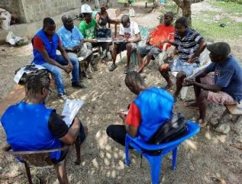
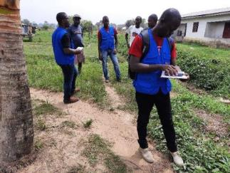
Figure 1: Data collection during a field visit in the Study communities

Methodology
The preparation of the socio-economic baseline data for the development of the RPF involved conducting socio-economic surveys, review of secondary sources, and consultations with stakeholders.
A reconnaissance survey of the four proposed project locations was undertaken to plan meetings with the potential project-affected people and to have an overview of the likely extent of the Project's impact on people. Before conducting extensive field surveys, secondary sources were used to gain a better understanding of the project area's social, economic, and cultural landscape.
As per the LURP's scope, a survey was undertaken by interviewing probable project-affected persons using a survey form on a tablet device, Open Data Kit (ODK Collect). The rationale was to gather information or data to understand the socioeconomic status of PAPs and assess the likely magnitude of impacts, consult with PAPs, local communities, and stakeholders to understand their concerns, issues, and suggestions, and incorporate them into the project design where possible.
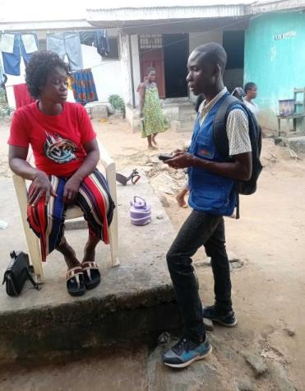
Figure 2: Enumerator using Open Data Kit (ODK Collect) to generate household feedback in Southeastern Paynesville.

Project Location
The project's proposed operations under Component 1 will be carried out in the Greater Monrovia region. Monrovia, the country's capital, and its environs are home to a quarter of the country's 4.5 million residents. Greater Monrovia is extremely vulnerable to floods due to its geographical characteristics (low-lying and flat topography; high rainfall, especially along the coast) and socio-economic characteristics (fragility, poverty, and informality), which are expected to become more frequent and intense as a result of climate change. The Mesurado wetlands are a certified Ramsar site and are located within the Greater Monrovia area. Existing vital infrastructure and assets in Monrovia, such as 30 kilometers of main roadways, 35% of schools, and 14% of hospitals, are currently in flood risk zones. Between 1975 and 2014, the metropolitan region's built-up area increased at an average yearly rate of 0.37 percent, resulting in 104sq.km of built-up area in the flood risk zone. Figure 3 shows a map of the area. A one-meter rise in sea level by the end of the century is expected to put about 230,000 people in danger and result in the loss of 2,150 square kilometers of coastal land, including infrastructure and much of Monrovia, worth US$250 million to the government. Civil wars and internal conflicts hampered infrastructures and commercial operations in Greater Monrovia, as they did in the rest of Liberia, from 1989 to 2003. With the end of the internal strife, there is a lot of hope for restoration and recovery. The process of rebuilding and reshaping institutions was lengthy and uneven, with increases in fundamental social indices and progress toward diversifying the economy restricted.
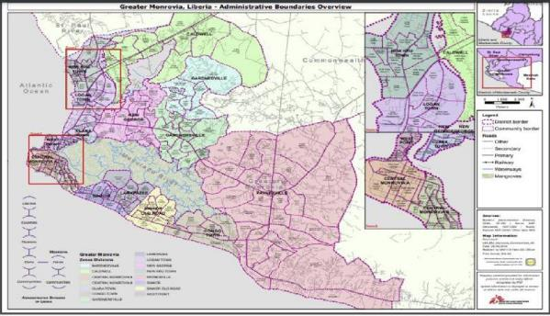
Figure 3: Map Showing Administrative Boundary of Greater Monrovia

Source 1: Sources: Borders, Administrative divisions: GDAL, LIZ-GIS / Places: MSF, Geonames, HOT-OSM / Roads, Natural: HOT-OSM / Other data: MSF

Demographic Profile
Liberia's population is estimated to be 4.81 million people, with 40 to 54 percent of the population living in poverty, according to various estimates. With a fertility rate of 4.4 children per woman in 2020, the population is fast expanding. Roughly half of the population is under the age of 35, and nearly two-thirds of the population lives in cities. Rural and urban populations have significant wealth, health, and education gaps, which are exacerbated by poor infrastructure and insufficient domestic investment.
With a population density of 1,514 people per square mile, Greater Monrovia is also the country's most densely inhabited urban area. The national average is 90 people per square mile. The 14-year civil unrest pushed the city's population to around 1.5 million, putting a strain on the city's already obsolete and poorly maintained utility systems and infrastructure, which were planned for a service delivery capacity of 250,000 people. Despite the high density of urban regions, many are hesitant to return to rural areas, where poverty is more prevalent and economic possibilities are limited. Many people regard Greater Monrovia as their economic future. The below diagram gives detailed facts about Greater Monrovia.

Greater Monrovia facts and figures
Nationally, the birth rate in Liberia is almost double the worldwide average, leading to an extreme annual growth rate. As of (world population review) 2019, the population of Liberia was increasing 2.56% each year, which is extremely high considering the economic and political conditions in the country, yet relatively low when you look at years past. The rate of growth is pretty much exclusively because 4.58 children are being born to the average Liberian woman. The death rate is 7.6 deaths/1,000 population (Indexmundi, 2018). The Greater Monrovia area has a very young population. More than half the population is under the age of 18, which results in a high level of child dependency and creates a built-in momentum for future growth.

Household and Population Characteristics
According to the Liberia Demographic Health Data (LDHS) 2019, Liberia has a population of 4.8millions individuals with a 3.5 fertility rate (the average number of children a woman delivers over her lifetime). Similarly, LDHS 2019/20 provided that the average household size in Liberia is 4.6 persons. Wherein thirty-six percent of Liberian households are caring for foster and/or orphaned children. The Household Income and Expenditure Survey (HIES) 2016 data estimated 938,383 households in Liberia, with a mean household size of 4.26 persons per household. For PACs, one hundred households’ heads were a sample from the four proposed project locations.

The distribution of sampled individuals from the PACs is depicted in Table 2.

Table 2: Number of sampled households from each proposed Project Affected Communities
 |  | Frequency | Percent
Valid | Northern Bushrod Island | 25 | 25.0
 | Central Monrovia, Soniwein CBD | 26 | 26.0
 | Southeastern Paynesville | 26 | 26.0
 | Omega Market | 23 | 23.0
 | Total | 100 | 100.0

The total respondents interviewed per gender were male (57%) and female (43%). The World Bank's approach to fostering gender equality considers all factors relevant to ensuring that males and females have different demands and interests when it comes to public participation. Gender inclusion and involvement is critical component of ensuring that World Bank-funded initiatives are implemented in a long-term, sustainable way. The ambitious poverty-reduction strategy set out in the Sustainable Development Goals will be difficult to achieve until women and men have equal capacities, opportunities, and voices.

The high percentage of women participants in the socio-economic baseline survey was, to some extent, based on their availability during the time of the survey, their interest in the LURP, and their willingness to discuss issues pertinent to them.

Figure 4: Percentage of respondents per gender

Like the rest of the county, the census from the LIGIS, 2008 indicated that the majority of the household heads are males (71.1%), and 29.9% are females. This is similar to the findings of the study where 75% of the households are headed by males, and 25% are headed by females. Most household members' relationships to household heads are mainly brothers/sisters and nephew/nieces.

Ethnicity and Religion

The population of Liberia is 97 percent indigenous to the land, with barely 3% Americo-Liberians. The majority of indigenous tribes have maintained their beliefs and traditions, and tribal culture may still be found in Liberia today. Each tribe has its own dialect and traditions. The indigenous peoples speak languages from the Niger-Congo language family, which can be found all over Sub-Saharan Africa. Women have traditionally played important roles in tribal life, and most tribes practice female circumcision. Both monogamy (having only one wife) and polygamy (having multiple wives at the same time) are legal and practiced in Liberia. Dating and marriage are seen as a sensible social and economic arrangement between families among non-Western educated Liberians. When a marriage is agreed upon, it is common for the bride's parents to be paid a bride price. There are 16 ethnic groups in the country, and Christianity (85%), Islam (12%), and indigenous religions (3%) are all practiced.
Greater Monrovia is the epicenter of most political, economic, and social activity, with higher educational, health, security, and infrastructural standards. Its population includes members of Liberia's 16 main tribes. As a result, it is home to Liberia's ethnic and tribal groups. The outcomes of the community meetings and focus groups revealed that the study communities were ethnically diverse. Considering religion in Greater Monrovia, Christianity and Islam are dominant religious institutions. Though other community members still subscribe to their traditional beliefs, these are not on a larger scale.
It is important to note that in in Liberia, indigenous people are not used in the same context as defined in the ESF. They are not marginalized groups, but those who are native to the land (97%). The term is used to distinguish between the freed slaves (Americo-Liberians) who returned and those who were already in Liberia.

Communities Risk Assessment

The development issues and flood risks in Greater Monrovia present a strategic opportunity to execute a cross-cutting approach that simultaneously facilitates the delivery of basic services, decreases food hazards, and builds capacity for Greater Monrovia's future management. Figure 5: Percentage of respondents per gender gives a flood map for a combined 50-year return period under different climate scenarios.
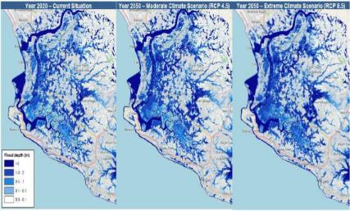
Figure 5: Percentage of respondents per gender

.
Source: Source: Deltares; Flood risk profile for Greater Monrovia March 2021.
During the household surveys, participants were asked as to the most potential hazards the community was exposed to. The perceptions of the respondents are summarized in Table 3.
Table 3: Potential risks to study communities
 |  | Frequency | Percent
Valid | Flooding | 59 | 59.0
 | Prevalence of water-borne diseases | 16 | 16.0
 | Fire Hazard | 10 | 10.0
 | Unsanitary conditions of the Communities | 15 | 15.0
 | Total | 100 | 100.0

From the table, 59% of the respondents indicated that flooding is the major risk posed to their respective communities. This information was validated by participants in the Town Hall Meetings, Focus Group Discussions, and Key Informant Interviews
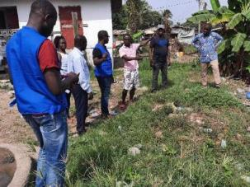
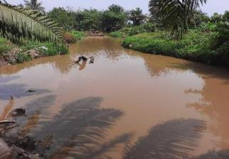

Figure 6: Residents showing flood-prone areas in Southeastern Paynesville
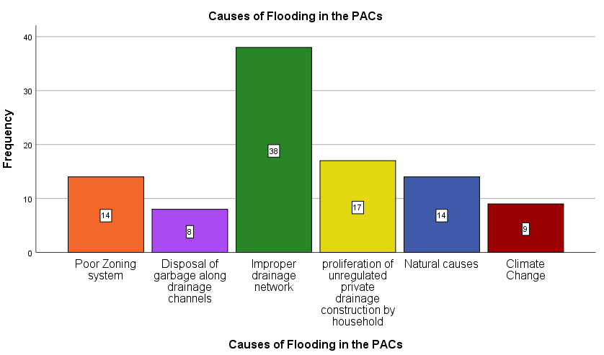
When asked what they thought was the most likely cause of flooding in the area, the respondents offered a wide range of opinions. Flooding was blamed on insufficient drainage connectivity and inadequate zoning planning by 38 percent and 14 percent of respondents, respectively. Other respondents, on the other hand, had opposing viewpoints, citing waste disposal along drainage channels (8 percent) and the expansion of uncontrolled private drainages by households to manage waterlines (17 percent) as the principal causes of flooding in the areas. In addition, 9 percent of respondents linked the communities' flood risk to the influence of climate change, while 14% attributed it to natural causes such as hydrogeological and topographic factors. In Figure 7, their perspectives are depicted.
Figure 6: Respondents’ view of potential causes of flooding in the PACs

In addition, respondents were asked about their thoughts of any negative consequences that the planned project would have. In Figure 8, their reactions are depicted.

Figure 7: Respondent's perception of potential negative impacts of LURP
From the table, 28% of the respondents confirmed the fear of being relocated for several reasons. Some of these reasons were mainly respondents’ children being dropped out of school or loss of job as a result of relocation. Difficulty in adjusting to a new environment was also cited by 14% of the respondent. When asked, the respondent noted that the probability of finding another dwelling place for rent would be difficult and at a higher cost, thereby resulting in the need to find an affordable area that most likely will be far away from their previous residence. These views were mostly stated by respondents in Central Monrovia North and Northern Bushrod Island. Also, 20% of the respondent cited unfair and untimely or delay in compensation to affected persons as potential negative social impacts associated with the LURP. In continuation, other respondents highlighted the difficulty in acquiring arable land (12%) and change in livelihood (17%) as the primary potential negative impacts associated with the LURP. The former was mainly stated by the respondent from Omega Market and Southeastern Paynesville communities, where some of the populations are involved in rain-fed small-scale gardening. When asked about the advantages or benefits of the project, respondents were enthusiastic about giving their views. The results are summarized in Table 5.

Table 4: Advantages of LURP as per respondents’ perception
 |  | Frequency | Percent
Valid | Mitigation of flooding in PACs | 53 | 53.0
 | Enhancement of mobility of residents due to improved communities access roads | 10 | 10.0
 | Eradication of water-borne diseases | 5 | 5.0
 | Income opportunities through job provisions | 19 | 19.0
 | Optimization of storage facilities for goods | 7 | 7.0
 | Improved drainage system for markets | 6 | 6.0
 | Total | 100 | 100.0

Gender Issues
Liberia has significant gender discrepancies in terms of women's access to productive assets, according to the National Gender Policy (2009). Many women are unable to take full advantage of economic prospects. Liberia has made great progress in improving the position of women and girls after the end of the civil war. However, the country's paternalistic system has made it impossible for women to hold decision-making roles at all levels of society. In Liberia, gender inequality and women's marginalization are maintained and reinforced by most people's traditional and religious conceptions of women as inferior and males as superior. In terms of division of labor, access and control over resources, and decision-making positions, girls and boys, women and men are socialized and culturally assigned different and strict roles, obligations, and responsibilities. These are then passed on to schools, communities, and workplaces.
Respondents in the study that led to the development of this RPF bemoaned the position of women in the project areas. Many women were discovered to be semi-educated and, as a result, unable to find work. As a result, respondents were asked about the most pressing concerns that they were facing. Twenty-four percent said they are the breadwinners in their families (women-headed households), and 63 percent said they required financial and infrastructural assistance to grow their businesses. Sadly, 5% of respondents said they had experienced SGBV from their spouses, fiancés, or elder male relatives. In addition, 8% reported that they had had psychological distress as a result of the loss of possible relatives who were largely an asset to the family, as well as properties destroyed as a result of heavy flooding in their communities.

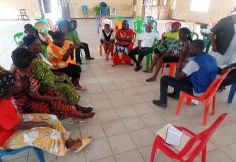
Figure 8: FGDs with women in Northern Bushrod Island (New Kru Town, Town Hall)

Despite their significant economic contribution, women and girls have restricted access to the inputs and services necessary to carry out their productive duties and are underrepresented in key economic sectors. Land, skills training, basic tools, and technology are among the productive inputs and services that women have less access to than men. When asked what can be done to mitigate some of the above issues, respondents said that empowerment from both government and non-government institutions to optimize their businesses, enhancement of Small Market Enterprises (SME), skills training, and employment opportunities could help alleviate some of the effects. In conclusion, all of the respondents backed the project and emphasized that throughout its implementation, employment options for less fortunate women, even at low-skilled levels, should be made available.
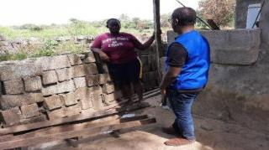
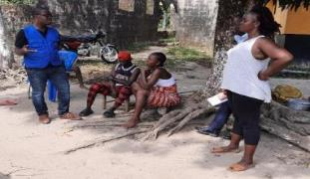
Figure 9: Interview with women in the Southeastern Paynesville

Land Tenure, Ownership

In Liberia, the land is still mostly owned under a dual land tenure system, which recognizes both traditional and statutory land tenure systems. According to the Land Rights Act of 2018, land in Liberia is divided into four distinct categories. Public land, government land, customary land, and private property are the four categories. Government land is owned and used by the state for ministries, agencies and branches of the Government, military purposes, public education facilities and hospitals, airports, museums etc. Public land is any land that is not Government Land, Private Land or Customary Land. Private Land is owned or otherwise held by private person(s) under the provision of the Land Rights Act and other applicable laws of Liberia. Customary Land is owned by a community or managed in accordance with customary practices and norms, such as residential areas, agricultural land, wetland, communal forest or fallow lands.
The underlying idea of the latter bill is that anyone in the country who does not have formal title to land can have the right to or occupy land through a lease, easement, or license arrangement. Private family land and public land make up the majority of the land in the study region. During the household survey, participants were solicited to elaborate upon their residential status and land ownership. The results are depicted in Figure 10 and Figure 11.

Figure 10: Respondents' Ownership of the residential facility

Land ownership and land/house plots are generally controlled by private land, which can be gained through land purchase from individual and family representatives, according to various attendees at the community consultation and focus groups. According to some key informants, a plot of land which is equivalent to ¼ of an acre (1,011.7m²) can be sold for anything from US$1,800 – 6,000. Depending on the number of lots the customer wishes to acquire, this pricing is frequently flexible. Community leaders are usually present at such sales to act as witnesses. Legal title to land is provided by the government, which can protect landowners against land instability. However, due to the project's proposed locations being in Greater Monrovia, it has been found that finding vacant land is now challenging.

Figure 11: land tenure and ownership

Access to water supply and Sanitation

The potential PACs have access to boreholes wells, hand pumps, and sachet water. The sachet water is usually sold by vendors. The Liberia Water and Sewer Corporation is the sold distributed of portable water in Greater Monrovia. These sources of water are used for drinking and domestic use in all the PACs.
In conformity to Component 1 of the LURP, i.e., to enhance secondary and tertiary infrastructure such as water supply, respondents were asked to give specific information about their household environment. The survey collected information about drinking water, including the source, perceptions about the quality of drinking water, any treatment prior to drinking, and persons who usually collect the water. The source of drinking water is an indicator of whether the water is suitable for drinking. Sources of water believed to be relatively free of disease are improved sources such as piped water into dwelling units, boreholes, and hand pumps. Non-improved sources, like unprotected dug wells, unprotected springs, and surface water, are more likely to have disease-causing agents that have a negative impact on health. The results are depicted in Table 5.
Table 5: Source of drinking water in the PACs
 |  | Frequency | Percent
Valid | Hand Pump | 34 | 34.0
 | Vendor (Sachet water) | 35 | 35.0
 | Open Well | 21 | 21.0
 | LWSC | 10 | 10.0
 | Total | 100 | 100.0

Figure 12: Drinking Water Quality

Poor sanitation coupled with unsafe water sources increases the risk of water-borne diseases and illnesses due to poor hygiene in the study areas. Studies have shown that the absence of proper toilet facilities and improper disposal of fecal material increases exposure to the risk of diseases like dysentery, diarrhea, and typhoid fever. Members of households with improved sanitation facilities are less likely to contract diseases.
During community consultations, attendees emphasized building resilient sanitary facilities in the PACs. The exposure to feces has caused numerous health risks and hazards to nearby communities that children and people of all ages are normally seen in the morning and evening hour defecating along road and beach shore. This has increased waterborne diseases amongst children and vulnerable groups such as the disabled and elderly.
To assess the socio-economic conditions under which the population lives, in terms of sanitation, few households have constructed pit latrines, whilst most community residents practiced open defecation, especially on beaches and dumpsites. This practice is insalubrious for the safety of the community. Public latrines are also provided at considerable cost to the community members.
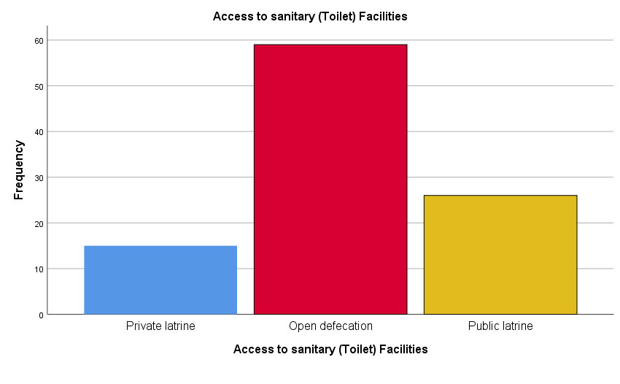
During the household survey, respondents were asked to elaborate on their access to sanitary or toilet facilities. The results are depicted in Figure 13.
Figure 13: Respondent's access to toilet facilities
:

Waste Management
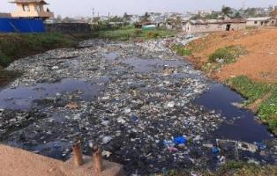
Apart from investments in access and drainage, the LURP will also cover sanitation (wastewater and solid waste collection facilities). In general, waste disposal in Liberia's urban population is growing, resulting in poor waste collection and insufficient disposal facilities. Solid wastes affect the quality of surface and groundwater in metropolitan settings. People residing in the vicinity are also exposed to health dangers as a result of inefficient garbage management. The majority of households in the studied communities dump their trash at a community dumpsite (35%), while others (14%) dump it in wetlands, waterways, and drainage channels. This acts as a stumbling block to the free flow of water in some of the PACs, putting the community at risk of flooding. Fewer households (11%) bury their garbage, whereas 29 percent dispose of it in the backyards of their homes. Finally, 11% of households burn their garbage.
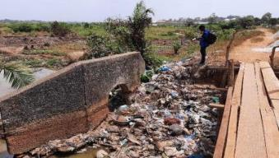
Figure 14:Clotted Drainage, Omega Tower Community (Left) & Waste disposal in the drainage channel, Redemption Road (Right)

Culture and Recreation
Many of the localities investigated have one or more cemeteries. Some families bury their loved ones in their backyards as well. The FGDs and KII interviews revealed no other culturally or historically significant resources. It is worth noting that the RPF assessment found no graves or sacred sites would be impacted by the proposed project.
Recreational facilities and events can not only help to maintain or establish a sense of communal humor, but they can also help to redirect people (particularly unemployed teenagers) away from substance misuse. Football is a popular activity among the men in the areas; therefore, it is no surprise that most settlements have at least one football field. With men, football is the most popular sport in the region. Women, on the other hand, participate in kickball games (a type of sport played in Liberia by women.) Apart from football and kickball, most members of the community host or participate in traditional dances and song sessions for public entertainment (even modern dances performed by the youth).

Medical Facilities
Liberia's health system was largely decimated as a result of the war's impacts. There are various public and private health facilities in the Project Affected Area. These medical facilities provide emergency services to the surrounding area and beyond. Other community clinics located at strategic spots throughout these PACs are enhancing the healthcare system and providing emergency services.

Schools
At the secondary school level, Liberia's education system is divided into three categories: primary (elementary), middle (junior high), and secondary school (senior secondary education). Liberia's elementary (years 6-12) and junior high (ages 12-15) schools are both free and compulsory, though enforcement is difficult. Vocational/professional schools and grade schools are notified in PACs in large numbers as a result of observations and focus groups. While some of these schools are public, the bulk is private. Some neighborhoods, such as Soniwein, GSA, and Omega, are close to universities (both public and private).
During the household survey, respondents were asked to elaborate on their educational attainment levels; the results are as depicted in Table 6.
Table 6: Respondent's Educational attainment level
 |  | Frequency | Percent
Valid | Primary Education | 35 | 35.0
 | Secondary Education | 23 | 23.0
 | Tertiary Education | 32 | 32.0
 | No formal education | 9 | 9.0
 | Vocational Training | 1 | 1.0
 | Total | 100 | 100.0

Livelihood Strategies

Employment
Employment can be defined as either being regular (often referred to as ‘formal’) or non-regular (informal). Typically, employment statistics only include households with members aged 15 to 65, which is the globally acknowledged working-age demographic range. Work for which an employee has a formal and set contract with an employer is referred to as regular employment (also referred to in some instances as being employed in the formal sector). Such work is usually long-term or without a fixed period and could entail being employed by a company, the retail sector, or even domestic work. Non-regular employment relates to a range of jobs that are usually more short-term and mostly without a formal contract, but for which some form of remuneration is obtained. This often includes trading, small shops or even carpentry, and some type of farm work that is paid. The official unemployment figure for Liberia is 2.34% (2016) (Statista, 2018). Figure 15 below illustrates the employment levels of respondents.
Figure 15: Employment Status of Respondent

Greater Monrovia is the center of the country’s industrial and commercial activities. Most of the population in Greater Monrovia is engaged in business, mostly medium, small, and micro in nature, and mostly informal.

Income and Expenditure
The predominant sources of income are businesses, fishing, and farming (gardening). In terms of expenditure, most households referred to education, health, and transportation as being some of their highest expenditures. However, Bike/Kekeh riding is another huge source of income in Greater Monrovia. This economic activity is occupied by young men who are dominantly high school graduates. They commute with passengers, including marketers, from one point to another destination between PCAs and/or outwardly.

Agriculture
Agriculture is an important element of the PACs' livelihoods, and it continues to be the backbone of the region's and country's informal economy. Agricultural production is mostly for subsistence purposes; hence it is intimately tied to food security while being an informal economic sector. Poverty and hunger are often linked to a community's yearly agricultural calendar, which means that one year's agricultural harvest can have an impact on poverty and famine cycles.
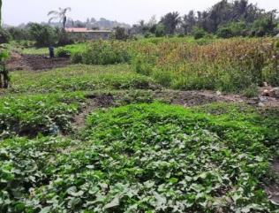
In terms of project locations, some inhabitants in Omega Market and Southeastern Paynesville used wetlands and flood-prone regions for agricultural uses during the dry season. Because they are located along drainage channels and waterways, some of the farmlands may be impacted by the planned project. Produce income is primarily used to supplement the family's income. In PACs, food insecurity is a big issue. Some families have members who go to bed hungry at least once a week. Food insecurity exists in the PAC for a variety of causes, including a shortage of arable space and a high unemployment rate.
Figure 16: Farms along drainage channels within Omega Market (Left) and Southeastern Paynesville (Right
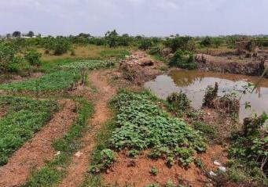

PACs access roads and Markets
Market districts and commercial/business centers abound across Greater Monrovia. In proposed project-affected neighborhoods, the Omega and Duala markets are two larger market hubs. Within PCAs, there are minor market areas such as GSA Road and others. There are also numerous shops and stores that sell construction materials, pharmaceuticals, provisions, and food. There are entertainments, vehicle and petrol stations along key streets and strategy points, all of which provide services to these communities.
Another significant source of income in the study communities is commercial motorcycle riding. Certainly, the majority of motorbike riders are young guys. Within and outside of study groups, these riders move with merchants and commodities. When access to motorbikes is limited, walking or trekking is an option. The government has made great efforts to make several neighborhood roads more accessible. There is, however, room for development.
When asked about the accessibility of roads in their towns for commuting, 74% of respondents said their areas' roads are only somewhat accessible. 10% stated that the roads are impassable, limiting mobility. As one of the respondents regretted the loss of a resident due to the communities' poor road network, the majority of the respondents in this category were from Northern Bushrod Island and South-eastern Paynesville communities. However, 16 percent of respondents said that the roads in their areas are accessible all year.

Table 7: Accessibility of roads in the study communities
 |  | Frequency | Percent
Valid | Partially accessible | 74 | 74.0
 | Inaccessible | 10 | 10.0
 | Accessible | 16 | 16.0
 | Total | 100 | 100.0

Legal and Institutional Framework Analysis

Introduction
This chapter reviews the existing national legal and regulatory framework in terms of land acquisition, restriction to land use, and involuntary resettlement so as to determine how these regulations comply with the requirement of the World Bank Environmental and Social Framework. It provides a gap analysis between both policies and proposes measures to bridge these gaps.

Legal framework
The following Liberian laws and policies comprise the legal framework governing this RPF are provided below.

The Liberian Constitution, 1986
The Liberian Constitution of 1986 replaced the 1847 Constitution for the purposes of establishing a framework of government to promote unity, liberty, peace, stability, equality, justice, and human rights under the rule of law, with opportunities for the political, social, moral, spiritual and cultural advancement of society. The citizen’s right to own property is a fundamental right in the Constitution found in Article 22 (a) and (b); however, this does not extend to mineral resources on or beneath the land.
Article 24 of the Constitution of the Republic of Liberia states that “while the inviolability of private property shall be guaranteed by the Republic, expropriation may be authorized for the security of the nation in the event of armed conflict or where the public health and safety are endangered for any other purposes, provided reasons for such expropriation are given and there is prompt payment of just compensation. It states that such expropriation or compensation may be challenged freely in a court of law, and that when property taken for public use when ceased to be so used, the Republic should accord the former owner or those entitled to the property through such owner the right of first refusal to reacquire the property. For the expropriation to be successful the following issues need to be addressed:

- That such expropriation or the compensation offered may be challenged freely by the owner of the property in a court of law with no penalty for having brought such action; and
- That when property taken for public use ceases to be used for the intended purpose, the GOL shall accord the former owner the right of first refusal to reacquire the property.

The Land Right Act, 2018
Land Rights Act (2018), in furtherance of the Land Rights Policy, is intended to:
- Define and delineate different categories of land ownership and rights;
- Prescribe the means by which each category may be acquired, used, transferred, and otherwise managed;
- Ensure all communities, families, individuals, and legal entities enjoy secure land rights free of the fear that their land will be taken without due process of law; and
- Confirm, declare and ensure equal access and equal protection with respect to land ownership, use, and management, including ensuring that Customary Land and Private Land are given equal legal protection and that land ownership is provided for all Liberians, regardless of identity, custom, ethnicity, tribe, language, gender or otherwise.
The Land Rights Law, also called the Land Rights Act, or LRA in short was passed by members of the National Legislature on August 23, 2018. The President of Liberia signed this law on September 19, 2018. The law was printed into handbills on October 10, 2018. The Law provides the Liberia Land Authority (LLA) the power for land rights in Liberia, centered on four basic types of rights:
- Public Lands – land that is not Private Land, or Customary Land, or Government Land. It is land designated for future use, managed in the public interest, owned by a community, and used or managed in accordance with customary practices and norms.
- Government Land - land owned by the Government, including land used by government buildings, such as government offices, government schools, and government hospitals. The land the government roads pass on is also Government Land.
- Customary Land - land owned by a community and used or managed according to the customs and tradition. Customary Land includes, but is not limited to residential land, farmland, communal forestlands, and fallow lands; and
Private Lands: land owned by an individual or private entity, in which management and use decisions are based solely on formal law (i.e., statutes, regulations, executive orders, and court decisions), where the owner enjoys the full bundle of land rights, which include, but are not limited to, the right to exclude all others, use and possession, own natural resources on the land (e.g., forest), and to transfer all or some of the rights through sale, lease, concession, gift, donation, will, or any other lawful means.
5.2.2.1 Right to own and dispose property
In keeping with the provisions of the Constitution of Liberia, ownership of property shall be limited to Liberian citizens, non-citizen missionary, educational and other benevolent institutions. Reference to article 8 of the land right act, a sole proprietorship or a partnership organized under Liberian law and the ownership of which is entirely Liberian shall be eligible to acquire ownership of, and hold title to, land in Liberia. The law also states that all persons, irrespective of nationalities or place of domicile or residence, shall be eligible to acquire, hold and enjoy rights in land other than ownership, including but not limited to the right of possession and or use pursuant to a concession, lease or otherwise.
5.2.2.2 National law on Eminent Domain and protocols
Though the Liberia Land right law gives the right to own property, however in keeping with the provisions of the Liberian Constitution and Article 54 of the Land Right Act (2018), the Government may acquire any land and property thereon not presently owned by it through the exercise of Eminent Domain or expropriation in even of armed conflict, where the public health and safety are endangered, or for any other public purposes. Accordingly, prior to exercising Eminent Domain in acquiring property (Private or Customary), the Government is to ensure a reasonable, good-faith effort to first lease, and then if necessary for the public purpose intended, acquire the Private Land or Customary Land through mutual agreement that provides just and timely compensation in accordance with fair market value and the principles. Following the mentioned procedures by law, if mutual agreement cannot be reached between both parties (the Government and Property owner) for sale or transfer of particular property needed by Government for any of the reasons provided in Section (1) of Article 54, the Government shall have the right to institute special proceeding in a court of competent jurisdiction for condemnation or expropriation of the land in accordance with the provisions of the Constitution of Liberia, the Civil Procedure Law and the provisions of this article. Considering the aforementioned, it is required that all provisions of the Liberian Constitution relative to Eminent Domain as well as Article 54 of the Liberia Land Right Act be adhered to where appropriate.

The Liberian Land Authority Act, 2016
Liberia Land Authority Act of 2016 created the Liberian Land Authority with the primary mandate to develop policies on a continuous basis, undertake actions and implement programs for land governance. The Authority shall, among other things, hold and manage all public and unallocated lands in Liberia, make a land inventory, sell or otherwise alienate public land and allocate land, absorbing all land-use and zoning powers from the MPW.
The LLA’s Land Administration Department hosts the Valuation Services Division, which is expected to provide timely and reliable real property valuations through execution of the following key functions:
- Assessment of compensation for land and properties acquired by government or any competent authority through exercise of right to eminent domain.
- Rental valuation to support leasing of public land
- Valuation for sale and purchase of properties by the Government of Liberia
- Valuation for real property taxation purposes
Currently, the Valuation Services Division is understaffed and not well capacitated.
The LLA’s Policy and Planning Department includes a land alternative dispute resolution division. The division is mostly focused on customary land rights related disputes in rural areas.

5.2.3 Decent Work Act, 2015
The purpose of the Decent Work Act, 2015 is to:
- Promote the attainment of decent work in Liberia, by establishing a regulatory environment;
- Ensure respect for, and the protection and fulfilment of fundamental rights at work;
- Give effect to obligations incurred by Liberia as a member state of the International Labor Organization;
- Establish transparent and accountable institutions and procedures of labor market governance; Contribute to the enhancement of the human capabilities of all who work in Liberia; and
- Promote economic development and growth.
Part IV of the Act deals with Occupational Safety and Heath, while the rest of the Act deals with employment and labor requirements.

5.2.4 Environmental Protection Agency Act, 2003
The Act creating the EPA provides the legal mandates and authority to manage, coordinate, monitor, and supervise in consultation with relevant line Ministries, Agencies and organizations, and other relevant stakeholders for the protection of the environment and sustainable use of natural resources. The act details the functions of the EPA from the Policy Council to environmental inspectors. The Act also clearly explains the entire environmental and social impact assessment (ESIA) process in its totality.

Environmental Protection and Management Law of Liberia (EPML), 2003
The Environmental Protection and Management Law (EPML) of Liberia is a legal framework for the sustainable development, management, and protection of the environment to be administered by the Environment Protection Agency in partnership with regulatory ministries and organizations and in a close and responsive relationship with the people of Liberia; and to provide high-quality information and advice on the state of the environment and for matters connected therewith. EPML principles and objectives include sustainable development; pre-cautionary, polluter-pays, inter-generational equity, public participation, international co-operation in the management of environmental resources shared by two or more states; and other principles of natural resources and environmental management.

World Bank Environmental and Social Framework
The World Bank’s Environmental and Social Standards 5 (ESS5): Land Acquisition, Restrictions on Land Use and Involuntary Resettlement is developed to prevent and mitigate potential adverse impacts associated with the Bank’s lending operation to people and their environment.
This policy covers direct economic and social impacts that may result from Bank-assisted investment projects and is caused by; a) the involuntary taking of assets resulting in relocation or loss of shelter; loss of assets or access to assets; or loss of income sources or means of livelihood, whether or not the affected persons must move to another location, (b) the involuntary restriction of access to legally designated parks and protected areas resulting in adverse impacts on the livelihoods of the affected persons. If the negative impacts are not mitigated properly, Project Affected Persons (PAPs) will face difficult economic, social, and environmental risks. Thus, ESS5 suggests avoiding, if it could not be avoided, then minimize the acquisition and those risks and adverse impacts on PAPs and their livelihoods. The impacts must be mitigated or managed in a way that improves the condition of PAPs from their pre-project condition and, if not improved, then at least restore it to the level of their pre-conditions.
The Bank requires the Government of Liberia (GoL) through the Ministry of Public Works to comply with the ESS5 provisions when carrying out components’ activities entailing involuntary land acquisition and land restriction. Hence, this Resettlement Policy Framework (RPF), along the ESS5, is to be applied during project preparation and implementation phases. Section 5.3 presents gaps analysis between the Liberian legal framework and ESS5 as well as measures to bridge policy gaps.

Objective of ESS5
The objective of Environmental and Social Standard 5 on land acquisition, restriction on land use, and involuntary resettlement are:
- To avoid involuntary resettlement or, when unavoidable, minimize involuntary resettlement by exploring project design alternatives.
- To avoid forced eviction.
- To mitigate unavoidable adverse social and economic impacts from the land acquisition or restrictions on land use by (a) providing timely compensation for loss of assets at replacement cost and (b) assisting displaced persons in their efforts to improve, or at least restore, their livelihoods and living standards, in real terms, to pre-displacement levels or to levels prevailing prior to the beginning of project implementation, whichever is higher.
- To improve living conditions of poor or vulnerable persons who are physically displaced through the provision of adequate housing, access to services and facilities, and security of tenure.
- To conceive and execute resettlement activities as sustainable development programs, providing sufficient investment resources to enable displaced persons to benefit directly from the project, as the nature of the project may warrant.
- To ensure that resettlement activities are planned and implemented with appropriate disclosure of information, meaningful consultation, and the informed participation of those affected.

ESS5 Scope of application
ESS5 applies to all PAPs regardless of the total number affected, the severity of the impact, and whether or not they have legal title to the land. Informal or traditional tenure is to be treated in the same manner as formal, legal titles. Therefore, this RPF covers permanent or temporary physical and economic displacement resulting from the following types of land acquisition or restrictions on land use undertaken or imposed in connection with project implementation. Project-related land acquisition or restrictions on land use may cause physical displacement (relocation, loss of residential land or loss of shelter), economic displacement (loss of land, assets or access to assets, leading to loss of income sources or other means of livelihood), or both.

Gap analysis and reconciliation
Project Affected Persons (PAPs) may face tremendous economic, social, and environmental risks if negative impacts are not appropriately addressed. As a result, ESS5 recommends preventing, or if that is not possible, minimizing the acquisition, as well as the risks and negative effects on PAPs and their livelihoods. The impacts must be minimized or mitigated in a way that improves the status of PAPs from their pre-project state or, at the very least, restores it to their pre-project state. When carrying out component activities involving involuntary land acquisition and land acquisition, the Bank requires the Government of Liberia (GoL) to follow the ESS5 rules through the Ministry of Public Works. As a result, during the project preparation and implementation phases, this Resettlement Policy Framework (RPF) along with the ESS5 will be used. Table 9 shows a gap analysis between the Liberian legal framework and ESS5, as well as policy shortcomings and efforts to close them.

When the Liberian legislative framework/regulation was compared to the World Bank's Land Acquisition, Restriction on Land Use, and Involuntary Resettlement policy, it was discovered that there are policy gaps in compensation and resettlement support. When offering compensation and resettlement assistance to PAPs, the gaps filling measures specified in Table 8 shall be utilized when there are gaps between the Liberian legal framework and the World Bank's Policy on Land Acquisition, Restrictions on Land Use, and Involuntary Resettlement. The GoL will be required to completely comply with and implement each gap-filling measure listed in Table 8, where appropriate, when formulating and implementing subsequent RPs if any. Furthermore, where gaps exist between Liberia's legal framework and that of the ESS5, the GoL take further efforts to guarantee that the project meets the EES5 standards.

Table 8: Comparison between Liberian Legal framework on land acquisition and ESS5
Theme | Liberian Legislation | World Bank ESS | Measures to Bridge the Policy Gaps
Avoid or Minimize Involuntary Resettlement | There is no specific law and/or regulation in Liberia requiring project proponents to prepare a resettlement plan or to avoid or reduce resettlement | Because it has the potential to disturb and disrupt income-generating activities and contribute to poverty, involuntary displacement/ resettlement of individuals should be avoided or minimized where possible.  Therefore, the preparation of a resettlement plan cleared by the Bank prior to the implementation of the resettlement activities is required. | RPs will be prepared.  The Bank's policy will prevail because Liberia has no official guidelines on involuntary resettlement, and neither of the country's two primary land laws, the Constitution and the Land Rights Act, contain any provisions to prevent or minimize involuntary relocation. Affected people should be given a variety of relocation choices (not just one) that are at least comparable to their previous home or site.
Land acquisition procedure | Liberian law has a provision on how private land is acquired for public interests, which includes providing: “private property owners with reasons for expropriation.” Therefore, Owners of Private Land and Customary Land will be provided just and prompt compensation such that, as much as possible, they are put in the same position they were in before the decision to expropriate. | World Bank ESS recognizes the rights of those affected people: Who have formal legal rights to the land or assets they occupy or use.  ESS5 provides guidelines on how to acquire land for a public interest project | While Liberian laws provide a solid foundation for private land acquisition, the Bank's guidelines will be used to supplement the country's current procedure.  Replacement value compensation in cash (based on market value + disturbance allowance).
Categories of affected individuals | Addresses only the direct physical impact of acquiring land. Socio-economic considerations are not given priority.  There is no distinction between affected individuals. Landowners, land tenants, land users, owners of buildings, and owners of perennial crops are all lumped together and treated likewise. There are no separate provisions for especially vulnerable classes of people. | There are three categories of affected people: (i) those who have formal legal rights; (ii) those who do not have formal legal rights to land at the time the census begins but have a claim to such land or assets; and (iii) those who have no recognizable legal right or claim to the land they are occupying.  Compensation refers to the direct economic and social consequences of the acquisition. It is good practice for the borrower to conduct a social evaluation and execute measures to reduce negative consequences, especially for poor and vulnerable people. | The Bank's policy will prevail because Liberia has no official guidelines on involuntary resettlement and the project shall follow the ESS5 guidelines and principles.
Vulnerable groups | Liberia Constitution Article 18 states:  - All Liberian citizens shall have equal opportunity for work and employment  - regardless of sex, creed, religion, ethnic background, place of origin or  - political affiliation, and all shall be entitled to equal pay for equal work.  There is no distinction made on the basis of gender, age, or ethnic origin in Liberian law during compensation.  Liberian constitution only mentions that particular attention to the issue of the rehabilitation of vulnerable groups or war victims (children, women, the elderly, and the disabled) within Liberia, who have been severely affected by the conflict in Liberia. Therefore, No provision in Liberian Laws. | Particular attention is to be paid to vulnerable groups, especially those below the poverty line, the landless, the elderly, women and children, indigenous peoples, and ethnic minorities.  The Plan and/or Framework be designed to mitigate the negative impacts of displacement, identify development opportunities, and establish the entitlements of all categories of affected persons (including host communities), with particular attention paid to the needs of the poor and the vulnerable | During the development of the RP, the project will adhere to the standards of WB-ESS5 and best practices in reference to the needs of vulnerable groups.  Special measures for vulnerable groups will be included in the RPF and RP.  The government will pay special attention to those who are most vulnerable in the project's effect zone.
Squatters | In Liberia, law, “Squatter Right,” does not cover Title. Squatter’s Right is only intended as a temporary arrangement for accommodation and a Title.  The Liberian law does not mention any provision of squatters. | Considering the Bank policy on involuntary resettlement (ESS5), squatters are to be provided resettlement assistance, If they occupy the project area prior to a cut-off date established by the borrower and acceptable to the Bank. Persons covered under the mentioned provision are provided resettlement assistance in lieu of compensation for the land they occupy, as well as other assistance, as needed, to achieve the objectives set forth in this policy. | Anyone who does not have a legal claim to the land in Liberia is not entitled to compensation under Liberian law. Relocation and compensation for investment shall be made available to those who do not have formal legal rights or claims to these regions. Additionally, squatters shall be given resettlement help but will not be reimbursed for their land.  Under the absence of squatter provisions in Liberian legislation, the Bank's policy on involuntary resettlement will apply. Squatters must be considered in any relocation operation, and they must be given options, such as alternate shelters or reasonable compensation that allows them to locate new housing.
Consultations with Affected Persons and Disclosure | Constitution, Article 24a, I, ii, iii, iv:  While the inviolability of private property shall be guaranteed by the Republic, expropriation may be authorized for the security of the nation in the event of armed conflict or where the public health nd safety are endangered or for any other public purposes, provided:  - that reasons for such expropriation are given;  - that there is prompt or just payment;  - that such expropriation or the compensation offered may be challenged freely by the owner of the property in a court of law with no penalty for having brought such action; and  - that when the property taken for public uses ceases to be so used, the Republic shall accord the former owner or those entitled to the property through such owner, the right of first refusal to reacquire the property.” | The Bank will require the Borrower to engage with stakeholders, including communities, groups, or individuals affected by proposed projects, and with other interested parties, through information disclosure, consultation, and informed participation in a manner proportionate to the risks to and impacts on affected communities. The Bank will have the right to participate in consultation activities to understand the concerns of affected people, and how such concerns will be addressed by the Borrower in project design and mitigation measures in accordance with ESS10. The Bank will monitor, as part of its due diligence, the implementation of consultation and stakeholder engagement by the Borrower. | SEP shall be implemented in accordance with the provisions of ESS 5 and ESS10 and consultation and engagement be done throughout the Project cycle  Nongovernmental organizations (NGOs) and community leaders will be involved as appropriate.  Opportunities will be provided to participate in the planning, implementation, and monitoring of the resettlement program and in respect of compensation measures, additional livelihood restoration proposals, and the timing of activities.  Given challenges expected with literacy rates, all information needs to be at least one time presented orally to the PAPs to ensure that everybody, and specifically the women, do understand the project, the impacts, and their rights.  All relevant documents shall be disclosed in a format and at locations accessible to affected persons and for a reasonable minimum period. These include project designs, mitigation and compensation measures, progress on implementation, and changes in designs
Livelihood Assistance | Liberian law, however, does not recognize compensation for such lost income. Constitution, Article 24 (as quoted above) does not extend to this aspect of the bank’s ESF requirements. | Displaced persons should be assisted in their efforts to improve their livelihoods and standards of living or at least to restore them, in real terms, to pre-displacement levels or to levels prevailing prior to the beginning of project implementation, whichever is higher.  Under the Bank Policy (ESS5), lost income due to project implementation should be compensated. | Resettlement facilitation and support to follow WB ESS5 requirements.
Notice to vacate | According to Liberia Land Policy 2018, the government must notify individuals, private entities, and communities that are likely to be impacted, allow them a fair amount of time to evaluate the notice, and publicize the notice for a reasonable amount of time. | Affected people should be identified and recorded as soon as possible in order to establish their eligibility through an initial baseline survey (including a population census that serves as an eligibility cut-off date, asset inventory, and socioeconomic survey), preferably during the project identification stage, to avoid an influx of encroachers of others who wish to take advantage of such benefits in advance. (WB) | During the RP preparation, the project will follow WB ESS5 and best practices.
The extent of Compensation and Resettlement Assistance | Compensation is payable under Liberian law for the loss of land, structures, crops, profit, and other damages resulting from the acquisition of land for a project. Moving costs or rehabilitation assistance to return to previous levels of livelihood are not recognized as government responsibilities under Liberian law, and no government agency is charged to carry out such a responsibility. | Sites for the resettlement of project impacted individuals, new residences and accompanying infrastructure, public services, and moving allowances must all be provided in accordance with the resettlement plan's provisions. | Moving allowances and assistance to re-establish livelihoods are not considered in Liberian law. During the RP preparation, the project will follow WB policy and best practices.
Preparation for RPs | The Liberia ESIA procedural Guidelines 2017 Section 3.2.10 outlines procedures for the development of a Resettlement Action | Prior to the start of the resettlement activities, a resettlement plan must be prepared and approved by the Bank. | All gaps should be addressed by the GoL, completely executing all mitigating measures outlined in this RPF.  World Bank standard ESS5 on Involuntary Resettlement and EPA guidelines both require that the require that project affected persons must be compensated and facilitated to resettle before displacement. The project is to ensure the preparation of RP.
Compensation and Participation | Affected persons are to be informed before repossession of land. However, there is no provision on the notice period; neither is there a distinction between farmed land nor developed land.  According to Section 3.2.10 of the Liberia EPA Procedural Guideline 2017, affected parties are to be compensated and/or resettled during development projects.  It also makes provision for broad-based stakeholder participation to ensure that issues regarding resettlement are properly addressed.  Chapter 3 Article 17 of the Liberian Constitution (1986) provides the right to assemble and consult upon the common good,  Section 1.4 (b, c, and d) of the Freedom of Information Act of Liberia states the principles which shall govern the construction, exercise, and protection of the right of access to information. | Affected persons should be:  - informed in a timely manner on their options and right pertaining to resettlement.  - Offered choices among and provided with technically and economically feasible resettlement alternatives; and  - Provided timely and relevant information to host communities receiving re-settlers. | Since common good is subject to different interpretations, it is important that land acquisition consultations are done under Bank-financed projects to observe the principles of prior, informed, and free consent. Affected groups should get access to full information about the resettlement process and options for compensation. Participatory planning and decision-making should be applied in resettlement options and compensation.
Calculation of compensation | Article 24 (a) 1 Provision is made for prompt payment of just compensation. However, the provision is not very clear. | Full replacement cost: a method used to determine the amount sufficient to replace lost assets and cover the transaction cost. | Full replacement cost will be used.
Timing of compensation payment | Prompt payment of just compensation | Prompt compensation payment prior to commencing project or before acquiring land and assets | Consider adherence to Involuntary resettlement (ESS5) to pay compensation prior to commencing the project or before acquiring the land and assets.
Grievances Redress Mechanisms (GRM) | Chapter 3 Article 17 of the Constitution of Liberia provides a venue for grievances.  Whereas formal legal redress exists through the Liberia court system with final appeal at Supreme Court | There shall be an appropriate and accessible established GRM consistent with Bank ESS5 and ESS10 to receive and address specific concerns about compensation and relocation that are raised by displaced persons or members of host communities, including a recourse mechanism designed to resolve disputes in an impartial manner. | Grievance Redress Mechanisms (GRMs) shall be established at a project, local community, county, and national levels.  Grievance committees will be established, but the method will not replace Liberia's existing judicial system. Rather than turning to costly and time-consuming legal action, it aims to resolve difficulties swiftly in order to speed the collection of rights and seamless relocation. If the grievance procedure does not result in a resolution, complainants can pursue legal action.
Monitoring and Evaluation | External evaluation is not required. | Internal monitoring and external evaluation are required. | Involve third-party assessment of compensation and resettlement.

Institutional Framework
Proposed activities of rehabilitation and construction of infrastructure indicate and anticipate the risks of relocating squatters and encroachers found on public properties identified for rehabilitation. To address this, A Resettlement Plans (RP) shall be prepared, if required so.

Institutions involved in the preparation and implementation of the RFP are:
- Ministry of Public Works (MPW);
- Liberia Water and Sewer Corporation (LWSC);
- Liberia Land Authority (LLA);
- Ministry of Agriculture (MoA);
- Environmental Protection Agency of Liberia (EPA);
- Ministry of Gender, Children, and Social Protection (MGCSP);
- Ministry of Finance Development Planning (MFDP);
- Liberia Electricity Corporation (LEC);
- Forestry Development Authority (FDA);
- Liberia Revenue Authority (LRA);
- Liberia Center for National Document Agency (LCNDA);
- National Disaster Management Agency (NDMA);
- Ministry of Health (MoH);
- Ministry of Internal Affairs (MIA);
- Monrovia City Corporation (MCC); and
- Paynesville City Corporation (PCC).

Ministry of Public Works (MPW)
The Department of Public Works was created in 1928 by an act of legislation and was renamed the Ministry of Public Works in 1972. The purpose of MPW is to administer the engineering component of Liberia in terms of surveying, drafting/designing, construction, and supervision, building codes and to improve and maintain, direct, or by contract all highways, bridges, roads, streets, airport, seaport, public buildings and all other public infrastructure in the Republic of Liberia.
In 2016 the 1972 MPW act was amended to reflect the transfer of land-use and zoning functions from MPW to the Liberia Land Authority; however, zoning and land-use functions currently remain with MPW. The MPW will approve all drawings for civil works and issue construction licenses to works contractors under the project.
MPW is the lead agency responsible for coordinating all activities related to developing and implementing the RP.

Liberia Water and Sewer Corporation (LWSC)
Prior to 1973, the provision of telecommunications, electricity, water, and sewer were carried out by the Public Utilities Authority, which was dissolved to establish, through acts of legislation, Liberia Telecommunication Corporation (LTC), Liberia Electricity Corporation (LEC), and Liberia Water and Sewer Corporation (LWSC).
LWSC is legally empowered to construct, install, establish, operate, manage, and supply to all parts of Liberia, safe drinking water and perform all sewerage services, as well as to maintain such water and sewerage facilities. The current capacity of LWSC to carry out its functions is limited due to a long-term lack of infrastructure maintenance and financial insufficiencies. The provision of services is sporadic and available in sections of Monrovia, and Congo Town, the sewage treatment plant, is not functional.
LWSC will be responsible for locating existing and the need for new water and sewer infrastructure within project zones.

Liberia Land Authority (LLA)
In 2016 the LLA was created through an act of legislation with the primary mandate to develop policies on a continuous basis, undertake actions and implement programs for land governance. Upon its creation, the LLA was mandated to absorb the Department of Lands, Surveys and Cartography (DLSC) from the Ministry of Lands, Mines and Energy, the Deeds Registry from the Center for National Documents and Records Agency (CNDRA), relevant functions from the Ministry of Internal Affairs (MIA) (e.g., County Land Commissioners) and land-use and zoning functions from the Ministry of Public Works (MPW). The Authority is responsible for holding and managing all public and unallocated lands in Liberia, making a land inventory, selling or otherwise alienating public land, and allocating land.
The LLA’s main activities will focus on:
a) land policy and planning, b) provision of a land survey, registration, and mapping services, c) provision of land valuation services, d) creation of a National Land Information System, e) alternative land dispute resolution services, f) coordination of access to government and public land for investment and conservation projects, g) promotion of land use planning and zoning by local governments, and h) demarcation and titling of the customary land rights of local communities.

Ministry of Agriculture (MoA)
MoA was established by an act of legislature in 1972, repealing the 1964 Department of Agriculture law. MoA is mandated to develop the agriculture sector, planning, coordinating, implementing, monitoring, and evaluating agricultural development programs. The purpose of MoA is to ensure agricultural challenges that impede production are investigated and lasting solutions found, and the farmers are provided with supportive services and the enabling environment to produce. The core areas of responsibility of MOA consist of: agriculture, both smallholder and commercial; plantation crops; fisheries; and livestock.
MOA will be part of the verification team in which they will assist with crops valuation exercises.

Environmental Protection Agency of Liberia (EPA)
EPA is the regulatory Institution of the Government of Liberia for the sustainable management of the environment and its natural resources. The Agency was established by an act of legislature in 2002. The EPA operates on three legal Instruments: The National Environmental Policy (NEP), The Environmental protection and Management Law of Liberia, and the Act Creating the Environmental Protection Agency. The purpose of the EPA is to ensure sound environmental management and put in place measures to avoid irreparable damage to the country’s natural resources.
The EPA is mandated to set environmental quality standards and ensure compliance with pollution control. It is responsible for the provision of guidelines for the preparation of Environment Assessments and Audits and the evaluation of environmental permits. These may include certification procedures for landfills and other activities potentially dangerous to the environment.
The EPA has an Inter-Governmental Steering Committee whose responsibility is to review, approve, and clear the RP. The Committee comprises Environmental Protection Agency (EPA), Ministry of Mines and Energy (MME), Ministry of Finance and Development Planning (MFDP), Ministry of Agriculture (MoA), Liberia Land Authority (LLA), and Ministry of Health (MOH). Each Institution provides its expertise based on applicable Liberian Laws and international best practices.

Ministry of Mines and Energy (MME)
MME is the statutory agency of government in charge of administering the mining sector of Liberia. It was renamed in 2017 by the Ministry of Lands, Mines & Energy when the Liberia Land Authority (LLA) was created, absorbing the Ministry’s land component by an act of the legislature.
MME has direct oversight and policy formulation responsibilities in the energy sector and developing the water resources of the country. MME will be responsible for overseeing and approving any energy and water, and mineral aspects of the project if applicable.

Ministry of Gender, Children, and Social Protection (MoGSP)
MoGSP is responsible for policy formulation, coordination and monitoring, and evaluation of Gender, Children, and Social Protection issues within the context of the national development agenda. Goals are the achievement of gender equality, equity, the empowerment of women and girls, promoting the survival and development of children, thus ensuring their rights. Also, to ensure social protection interventions for vulnerable, excluded, and persons living with disabilities and integrate fulfillment of their rights, empowerment, and full participation into national development.
MoGSP will collaborate with municipal governments to ensure vulnerable persons are protected during the resettlement process.

Ministry of Finance Development Planning (MFDP)
MFDP was created in 2013 by an act of the legislature, replacing the Ministry of Finance and the Ministry of Planning and Economic Affairs, with the mandate to formulate, institutionalize and administer economic development fiscal and tax policies for the promotion of sound and efficient management of financial resources of the government in line with international financial management best practices.
As custodian of the country’s economy, the MFDP is mandated to combine public finance, development planning, and economic management expertise and experience to effectively manage the economy.
The MFDP coordinates multilateral funding support to the Government of Liberia (GoL) and is the principal authority on fiscal and development planning and executing agency of GoL development programs from the fiscal standpoint.
The MFDP will sign off on Grant Agreement and oversee financial management services through its Project Financial Management Unit (PFMU). The MFDP will lead project negotiations between the Government of Liberia and the World Bank.
The MFDP houses the Project Fund Management Unit (PFMU), which is responsible for fiduciary management of Bank-supported projects. It supports the project to prepare a consolidated work plan and budget for the project on an annual basis. The work plans and budgets will include the planned project expenditures under each component. The PMT will be expected to coordinate and monitor the implementation progress against the work plan/budget. The PFMU will be part of the RP payment team.

Liberia Electricity Corporation (LEC)
Prior to 1973, the provision of telecommunications, electricity, water, and sewer was carried out by the Public Utilities Authority, which was dissolved to establish, through acts of legislation, Liberia Telecommunication Corporation (LTC), Liberia Electricity Corporation (LEC), and Liberia Water and Sewer Corporation (LWSC).
LEC has the mandate to produce and supply economical and reliable electric power to the entire nation while at the same time maintaining financial viability. Intrinsic in this mandate is the responsibility for improving and expanding the system to meet future growth.
If the project requires it, LEC may be in charge of situating existing and new electric power infrastructure within project zones.

Forestry Development Authority (FDA)
FDA was established by an act of the legislature in 1976 with the mandate of ensuring the sustainable management and conservation of Liberia’s forest and related natural resources for the benefit of current and future generations. FDA is currently guided by the 2006 National Forestry Reform Law, which is the current legal instrument that guides the management of forest resources in Liberia.
FDA will be part of the verification team in which they will assist with tree and crop valuation exercises.

Liberia Revenue Authority (LRA)
The LRA was established through an act legislature in 2013 as a semi-autonomous agency of Government absorbing the Revenue Department functions from the Ministry of Finance.
The mandate of the LRA is to administer and enforce Liberia's Revenue Code of 2000 as amended in 2011 and other related laws for the purpose of assessing, collecting, auditing, and accounting for all national revenues and for facilitating legitimate international trade through border management and enforcement.
LRA will play a critical role in assessing and verifying the value of project-affected land and assets.

Liberia Center for National Documents Agency (LCNDA)
Center for National Documents and Records (CNDRA), commonly called the Archives, is an autonomous agency established in 1977 through an act of legislature mandated to store and manage public records and oversee the registration of land deeds and marriages. The 2016 LLA act removed the Deeds Registry from CNDRA, now renamed LCNDA. The transfer of the Deeds Registry has not occurred to date, remaining a function of LCNDA.
LCNDA will assist with the verification of public properties.

National Disaster Management Agency (NDMA)
In 2012 NDMA was established as an autonomous agency to ensure implementation of the National Disaster Management Action Plan for disaster preparedness and the national environmental policy, the national food security and nutrition strategy, the national health policy, and other policies as related to disaster management adopted by the Government of Liberia.
All resettlements will be in compliance with NDMA policies and regulations.

Ministry of Health (MoH)
The Department of Health was renamed Ministry of Health in 1979 through an act of legislature mandated to formulate, Implement, Monitor, and Evaluate health policies, plans, and standards, deliver and coordinate the delivery of decentralized medical care in public facilities, develop health manpower, and undertake preventive services and health services, including specific health interventions.
MoH will assist with the provision of municipal data related to water, drainage, and waste.

Monrovia City Corporation (MCC)
The Commonwealth District of Monrovia became a municipal government in 1973 through an act of legislature under the management of the MCC, a legally incorporated body fully mandated to operate independently. The City of Monrovia is the national capital city of Liberia and has assumed responsibility for the provision of services and the collection of revenues in nine (9) townships and one (1) borough in its immediate environs. The largest open market in Monrovia’s territory is Duala Market, located in the Borough of New Kru Town.
MCC will participate in resettlement activities within the area it serves, identifying and cataloging structures to be removed from public properties, as well as assisting with payment distribution to affected individuals.

Paynesville City Corporation (PCC)
Paynesville Township was elevated to City status in 1976 through an act of legislature under the management of the PCC, a legally incorporated body fully mandated to operate independently. The Red-Light Market, Paynesville’s largest outdoor market, is in the process of being relocated to the former Omega Tower site.
PCC will participate in resettlement activities within the area it serves, identifying and cataloging structures to be removed from public properties, as well as assisting with payment distribution to affected individuals.

Eligibility Criteria for Entitlement

Eligibility Criteria and Entitlements
This section provides details on the entitlements, relocation and rehabilitation assistance, and benefits that encompass the measures to mitigate the project’s potential impacts on involuntary resettlement. Where businesses, communal and public facilities, private homes, and agricultural land are to be affected, the following entitlements shall be applied. For illegal land occupation, prior to the established cut-off date, all investments made on the land shall be compensated at replacement cost.
To ensure compliance not just with WB ESS5, it is particularly important that GoL laws and legislation, as well as local definitions of land occupancy by the Liberia Land Authority and its land rights procedure to land ownership and inheritance practices, be recognized. The project shall not resort to forced evictions of affected persons. “Forced eviction” is defined as the permanent or temporary removal against the will of individuals, families, and/or communities from the homes and/or land which they occupy without the provision of, and access to, appropriate forms of legal and other protection, including all applicable procedures and principles in ESS5. The exercise of eminent domain, compulsory acquisition, or similar powers by a Borrower will not be considered to be forced eviction, providing it complies with the requirements of national law and the provisions of the ESS and is conducted in a manner consistent with basic principles of due process (including the provision of adequate advance notice, meaningful opportunities to lodge grievances and appeals, and avoidance of the use of unnecessary, disproportionate or excessive force).

Eligibility
The below table is the compensation / entitlement matrix that fully displays the types of impact on asset, Eligibility criteria, and the entitlement assigned.
Table 9: Entitlement Matrix
Type of Impact | Eligibility | Entitlement
Loss of land | Owner of the formal land title holder | Entitled to compensation for land | Cash compensation for affected land with replacement cost at market value. To include USD 100 for transaction cost, Title transfer cost (15% of the cost of Land for applicable fees and any other payments). 10% of asset compensation value for Disturbance allowance
 | Tenant/Caretaker | Not entitled to compensation for land | USD 100 for transaction cost and USD100 transportation cost.
 | Non-Title user/squatter/encroacher | Not entitled to compensation for land | Compensation for loss of asset, USD100 for transaction cost, and USD100 transportation cost. 10% of asset compensation value for Disturbance allowance
 | Leaseholder | Not entitled to compensation for land | Compensation for loss of asset, USD100 for transaction cost, and USD100 transportation cost. 10% of asset compensation value for Disturbance allowance
Structures  (Commercial, Residential, Fence, Hand pump, Well, Kitchen, Toilet, Foundation, Septic tank, Monument, Communal Structure, Public Structures) | inhabited residential structures | Entitled to compensation at replacement cost for full structure if impact is more than 20% or renders the structure enviable | Compensation for loss of asset with replacement cost at current market value with no deduction of tax and depreciation cost. 3% self-transportation cost, and USD100 for transaction cost. 10% of asset compensation value for Disturbance allowance. USD300 for three months’ rent  Right to salvage materials
 | Uninhabited residential structures | Entitled to compensation at replacement cost for full structure if impact is more than 20% or renders the structure enviable | Compensation for loss of asset with replacement cost at current market value with no deduction of tax and depreciation cost. and USD100 for transaction cost. 10% of asset compensation value for Disturbance allowance. USD300 for three months’ rent  Right to salvage materials
 | Commercial Structure | Entitled to compensation at replacement cost for full structure if impact is more than 20% or renders the structure enviable | Compensation for loss of asset with replacement cost at current market value with no deduction of tax and depreciation cost. and USD100 for transaction cost. 10% of asset compensation value for Disturbance allowance. USD300 for three months’ rent, loss of business income  Right to salvage materials
 | Tenant/Caretaker | Not entitled to compensation for loss of structure | USD100 cash compensation for transportation cost, USD100 for transaction cost, and USD300 for three months’ rent
 | User or squatter’s/encroacher’s properties | Not entitled to compensation for loss of structure | USD100 cash compensation for transportation allowance, USD100 for transaction cost, and USD300 for three months’ rent
 | Owner (squatter / encroacher) | Entitled to compensation for structure at replacement cost | Compensation for loss of asset at replacement cost at current market value with no deduction of tax and depreciation cost. 3% self-transportation cost, and USD100 for transaction cost. 10% of asset compensation value for Disturbance allowance  Right to salvage materials
 | Leaseholder | Entitled to compensation for structure at replacement cost | Compensation for loss of asset with replacement cost at current market value with no deduction of tax and depreciation cost. 3% self-transportation cost, USD100 for transaction cost. 10% of asset compensation value for Disturbance allowance  Right to salvage materials
Vulnerable Households | Owner or formal land title holder | Entitled to Assistance Allowance | USD200.00 for:  Households headed by people older than 65 years  Households headed by a Single Parent  Households headed by a person with disability or sick
 | Tenant/Caretaker | Entitled to Assistance Allowance | USD200.00 for:  Households headed by people older than 65 years  Households headed by a Single Parent  Households headed by a person with disability or sick
 | Non-Title user/squatter/encroacher | Entitled to Assistance Allowance | USD200.00 for:  Households headed by people older than 65 years  Households headed by a Single Parent  Households headed by a person with disability or sick
 | Leaseholder | Entitled to Assistance Allowance | USD200.00 for:  Households headed by people older than 65 years  Households headed by a Single Parent  Households headed by a person with disability or sick
Business | Owner of business (registered, unregistered, unauthorized, or informal) | Entitled to Compensation for loss of business income during relocation | Entitled to loss of business income (3 months profit) based on tax record or, in its absence, comparable rates from the registered business of the same type with tax records, or at least equal to national minimum wage.  This is applicable with or without the possibility of re-establishing the business or an alternative.
 | Employees | Entitled to Compensation for loss of wages during relocation | Entitled to loss of wage (3 months) based on business employment record or, in its absence, comparable rates from the registered business of the same type, or at least equal to national minimum wage.
 | Formal and informal marketers and street vendors | Entitled to compensation for loss of income during construction works that may affect their business | Entitled to loss of wage (for duration of civil works affecting the market activities) based on comparable rates from the registered business of the same type, or at least equal to national minimum wage.
Public Service and Facilities | Service or infrastructure Provider | Schools, health centers, administrative services, and infrastructure. | Full replacement cost of related land, buildings, and facilities, void of depreciation cost. 10% of asset compensation value for Disturbance allowance
Tree Crop | All affected economic tree crops | Entitled to Compensation | Compensation rates as specified in the Ministry of Agriculture “Price or economic crops damaged during development projects – August 20, 2012). Entitled to USD100 for Transaction cost. 10% of asset compensation value for Disturbance allowance

Entitlements:

Loss of Property
- Land:
When land acquisition or restrictions on land use (whether permanent or temporary) cannot be avoided, the MPW shall offer affected person compensation at replacement cost and other assistance as may be necessary to help them improve or at least restore their standards of living or livelihoods, subject to the provisions of the ESS 5 and the ESIA Procedural Guidelines of 2017.
The Project shall compensate the landowner with land claims. The valuation of the land is derived from comparative market rates for land in the different project locations. The average price of land is as follow:
Project Location | Price Range  Value per lot | Price per Square Foot
Location 1: Northern Bushrod Island | US$ 3,000 – 6,000 | US¢ 0.28 - ¢0.56
Location II: Omega Market | US$ 1,800 – 2,500 | US¢ 0.16 - ¢0.23
Location III: Central Monrovia. Soniwein CBD | US$ 3,000 – 6,000 | US¢ 0.28 - ¢0.56
Location IV: Southeastern Paynesville | US$ 2,000 – 2,500 | US¢ 0.18 - ¢0.23

Notwithstanding, compensation rates may be subject to upward adjustment where negotiation strategies are employed.
Structures:
The following structures (commercial, residential, fence, hand pump, wall, kitchen, toilet, foundation, monument, communal and public structures) could potentially be affected and shall be eligible for compensation at full replacement cost, void of deduction of taxes and depreciation cost.
Tenant/caretaker of affected structures are not entitled to compensation for the loss of structure but shall be provided compensation of 100 USD to cover transportation expenses, 100 USD to cover transaction expenses, and 300 USD for three months’ rent. Squatters/encroachers shall be entitled to compensation for loss of structure, entitled to 3% of the structure cost for transportation expenses, 100 USD to cover transaction expenses, and $300 for three months’ rent.
A leaseholder who is owner of the structures is entitled to compensation for structure at full replacement cost without deduction of depreciation, but not compensation for land. All PAPs in this bracket will also be compensated 3% of their structure value to cover transportation expenses and shall also receive 100 USD to cover transaction expenses.
- Tree Crop:
All PAPs with affected economic crops will be compensated with the 2012 rates and 2014 amendments for seasonal crops developed by the Ministry of Agriculture to reflect a replacement cost. Affected tree crops owners are also entitled to 100 USD as compensation to cover all expenses made during the processing of documents and payments. The replacement cost of plantain and banana was estimated at 1.69 USD. However, the price was adjusted to 6 USD, similar to the new prices for bananas and plantain, while coconut was priced at 16.9 USD.

Vulnerable Groups
The project also allocates 200 USD as compensation for all vulnerable household heads who are either older than 65 years, single parent house head, or disabled and or sick. Furthermore, if a PAP is eligible for more than one of the mentioned categories, that household will only be eligible for payment once.

Eligibility For Community Compensation
Communal properties, like investments by all other PAPs, are entitled to compensation with or without a legal title for the land the investment is on. In some circumstances, it may be proposed that part or all of the land to be used by the project is donated on a voluntary basis without payment of full compensation. Subject to prior Bank approval, this may be acceptable providing the project demonstrates that: (a) the potential donor or donors have been appropriately informed and consulted about the project and the choices available to them; (b) potential donors are aware that refusal is an option, and have confirmed in writing their willingness to proceed with the donation; (c) the amount of land being donated is minor and will not reduce the donor’s remaining land area below that required to maintain the donor’s livelihood at current levels; (d) no household relocation is involved; (e) the donor is expected to benefit directly from the project; and (f) for community or collective land, a donation can only occur with the consent of individuals using or occupying the land. The project shall maintain a transparent record of all consultations and agreements reached. During a land donation process, the project shall apply the relevant provisions of the ESS, special care must be taken to ensure: (a) that all tenure rights and claims (including those of customary and informal users) affecting the land in question are systematically and impartially identified; (b) that potentially affected individuals, groups or communities are meaningfully consulted, informed of their rights, and provided reliable information concerning environmental, economic, social and food security impacts of the proposed investment; (c) that community stakeholders are enabled to negotiate fair value and appropriate conditions for the transfer; (d) that appropriate compensation, benefit-sharing, and grievance redress mechanisms are put in place; (e) that terms and conditions of the transfer are transparent; and (f) mechanisms are put in place for monitoring compliance with those terms and conditions.

Loss of Wages and Income
  - Loss of Business income:
The compensation for loss of Business income is awarded to PAP, whose business will be affected by the RP process. Owners of small commercial/market sheds shall receive a lump sum amount of $50, while owners of business centers and shops shall receive $50 per month for three months. Given that majority of the business owners within the project area of Greater Monrovia are categorized as petty traders, this amount accounts for inflation for petty traders’ monthly profit of US$33.00, as reported in in a baseline study conducted by City Alliance within the project area.
The mitigation of economic displacement shall be considered complete when the completion audit concludes that affected persons or communities have received all of the assistance for which they are eligible and have been provided with adequate opportunity to re-establish their livelihoods.

Supplemental Assistance
- Relocation Assistance:
This assistance comes as the result of all expenses made on transportation, transaction, and title transfer. It’s intended to help maintain PAPs' livelihood status at the pre-project level or higher.
  - Transportation Assistance:
The transportation assistance of $100 US is provided to all PAPs who are not eligible for compensation of structures (caretaker, tenants, squatters, encroachers). This amount will enable them to cover all moving expenses to a new location. For PAPs eligible for compensation of structures, the transportation allowance shall be calculated as 3% of structure cost.

  - Transaction Cost:
This cost is incurred by all PAPs as a result of processing RP documentation for payment. All PAPs are therefore eligible to receive $100 US Transaction expenses. Experience from the implementation of another RP project reveals the cost to process attestation documents at the local court cost $50. The additional $50 is to cover the cost of transportation spent to complete attestations, etc., by the PAPs during the process of the RP payment.
  - Land Title Transfer Cost:
The project also allocated compensation to be given to only project-affected landowners to enable them to cover expenses incurred during the processing of new transfer deeds for their land. The project is expected to acquire legal transfer titles for all land paid for and shall cover the cost for transfer title where land donation occurs.
  - Disturbance Allowance:
All PAPs that are illegible compensation of land or investment on the land shall receive a disturbance allowance. It is important to note that expropriation of land undermines many people's ability to create productive systems economic operations. The land is frequently lost forever; it is occasionally partially replaced but rarely totally replaced or compensated for. For many people, losing their home is merely a transitory situation, but for others, it is a chronic state that results in a loss of identity and cultural deprivation. If nearby homes of the same kinship group become dispersed, the loss of housing may have an impact on family cohesion and mutual aid networks. Therefore, although the impact to the disruption of people’s lives cannot be quantified, a mitigation measure shall be to provide disruption allowance for those impacted persons who will lose their land or investment on the land. This shall be calculated at 10% of the value of the impacted property.

Valuation Method
The goal of the asset valuation exercise is to calculate the current market worth of the impacted asset, including transaction fees so that the compensation amount is sufficient to allow the affected persons to replace the asset at its current full replacement cost.
Attempts should be undertaken to provide access to equal and culturally acceptable resources and earning possibilities for losses that cannot readily be evaluated or paid in monetary terms (e.g., access to public services, consumers, and suppliers; or to fishing). This is distinct from the resettlement aid that must be provided under ESS5 regulations.

Valuation Procedure To Be Followed
This section describes the assets evaluation to be followed during the RP implantation.

Preparation of Asset Inventory
Asset inventory shall be generated from the findings of the census survey – this is to identify individuals, households, or communities to be affected, accompanied with an inventory of major assets (land, building plots, trees, and houses) also to be affected by the implementation of the project. To ensure minimization of cost to the project, it is recommended that the data be managed and analyzed in M.S. Excel. The database shall capture the following information for each structure:

- Structure Impact Leve l
- Structure ID#
- Coordinate
- Owner Contact Details
- Community
- County
- Structure Length
- Structure Width
- Square Ft
- Structure Type
- Type of Commercial
- Number of Storeys
- Main Outer Wall Material
- Main Roofing Material
- Main Window Material
- Main Floor Material
- Ceiling Type
- Door Type
- Number of Rooms
- Number of Bathrooms
- Fence Rows
- Warehouse Description
- Shed Description
- Status of Land
- Unit Rate
- Compensation of Structure
- Compensation for Fence

Types of Compensation Payments
Based on the type of impact to the project, compensation shall be toward the following: land, structures, and tree crops. Other supplementary assistance shall be made to restore PAPs' livelihood will also be made to ensure PAPs are not made worse off post-project implementation. Due to the complex land tenure situation in Greater Monrovia, with overlapping claims and insecure tenure (caused by double sales and lingering land disputes), replacement property and in-kind compensation will not be used by the project. The government does not have a cadastre with clearly demarcated boundaries of land parcels that would enable the project to identify available public or government land for these types of compensation. To identify available land and properties free of litigation cases and other claims would be costly and time-consuming. Such compensation would bear the risk of the project getting entangled in existing land disputes in case land is identified for such compensation but later on challenged by other claimants.

Cash compensation
Payment of cash compensation may be applied, adjusted for inflation (see section 6.8.5 Inflation Consideration for details on how to calculate), for lost land or either of temporary or permanent nature and other assets may be appropriate where: (a) livelihoods are not land-based; (b) livelihoods are land-based, but the land taken for the project is a small fraction (for this project, 20%) of the affected asset and the residual land is economically viable; or (c) active markets for land, housing, and labor exist, displaced persons use such markets, there is sufficient supply of land and housing, and the Borrower has demonstrated to the satisfaction of the Bank that insufficient replacement land is available. The project shall provide fair lease arrangements as mitigation measures for temporary land take.

The Voluntary Land Donation process
The procedure for obtaining rights to any piece of land located in Liberia through donation is clearly articulated in the Land Rights Act of 2018.
Article 36: Governance and Management provides the procedures for acquiring customary land through the community acting collectively. Sub-sections 1 and 2 of the procedures are presented below:
- The authority for the development and management of Customary Land shall be vested in the members of the Community acting collectively.
- The Community Members acting collectively are the highest decision-making body of the Community. They shall have the power by a vote of two-thirds of the Community membership:
- To approve the sale, lease, or transfer of Customary Land to Persons other than Community Members.
- To approve the sale, lease, or donation of Customary Land to the Government.
- To approve requests of leases of Customary Land more than fifty (50) acres.
- To approve the sale of Customary Land, subject to the fifty (50) year prohibition on the sale of Customary Land as provided in Articles 49 and 51 of this Act.
- Investigate complaints involving CLDMC members and, in connection therewith, remove members of the CLDMC, provided that the successor of any removed member shall be elected in accordance with the provisions of Article 36(4) of this Act.
- Decide any matters relating to the Community's Customary Land consistent with the provisions of the bylaws of CLDMC.
Additionally, Article 49 of the Land Rights Act of 2018 provides the process for obtaining customary land as follow:
Para 4. A Customary Land may be leased on such terms and conditions as the Community may determine by and through its CLDMC (……) for areas smaller than fifty (50) acres, and by consensus of the Community Membership for areas larger than fifty (50) acres. The certain total period of any lease of Customary Land shall not exceed fifty (50) years.
Para 5. A lease agreement in respect of any Customary Land shall include payment of rent and equitable benefits to the community, an agreed payment schedule, and a mechanism to ensure full and timely payment of rent and the performance of all obligations assumed by the lessee.
Para 6. A lease of a Customary Land may not be made to any Person until:
- The Community has organized and established a CLDMC; and,
- The lease or transfer is duly authorized in keeping with the provisions of Articles 35 and 36 of this Act.
World Bank Procedures for Screening and Documenting Voluntary Land Donations (VLD)
The following are recommended procedures for voluntary land donations for the Liberia Urban Resilience Project (LURP).
Due Diligence:
- Voluntary land donations for a sub-project should be openly discussed in public consultations to establish that:
    - The donor is the legitimate owner of such lands.
    - The donor is fully informed of the purpose of the donation.
    - The donor is aware of the implication of donating the land and does so without coercion and retribution.
    - The donor is aware of his/her/their option to choose freely whether or not to enter into a VLD agreement.
- For communal lands donated by the chiefs, the specific individuals using or occupying the land should also be identified and consulted to verify whether they consent to the land donation and also that their livelihoods would not be adversely affected.
- For family lands, family members (including spouses) must be aware of the donation in order to minimize the risks of cross-generational conflicts.
- For government lands, MPW through sub-project screening should establish that the land is free of claims (from squatters, encroachers, tenants, or other land users); otherwise, it would trigger the World Bank’s Involuntary Resettlement Policy and follow-up, site-specific Resettlement Action Plans might be required.

Assessing and minimizing adverse social impacts:
- Voluntary land donations for public-use civil works should represent only a small fraction of the total land holding of the donor.
- For public-use civil works, the section of land to be donated should not be the donor’s main source of income and should not significantly affect the donor’s livelihood.
- Donation of land should not occur if it requires any household relocation or the loss of structures or fixed assets on the affected land area.
- The donor or user may request monetary or non-monetary benefits, incentives, or community assistance as a condition for donation.
- When appropriate, the land donation agreement should specify that if and when MPW (or other Government entity) definitively decides not to use the donated land as previously intended, the land would revert back to the previous owner.
Recommended Documentation:
- Minutes of Consultations with a list of participating stakeholders and their institutional affiliation or area of interest, along with the key information shared and the agreed-upon actions.
- Voluntary Land Donation Screening Checklist
- A formal statement or documentation of agreement (such as a Memorandum of Understanding or Deed of Donation) for each instance of land donation establishing informed consent and signed by each owner or user involved and MPW or other relevant Government agency.

Income restoration
The project shall ensure the restoration or rehabilitation of livelihood to either pre-project levels or higher. For PAPs that may lose their income source, livelihood opportunities or provisions are made in the entitlement matrix to ensure PAPs are not made worse off, as provided in section 6.2 Eligibility Owner of business (registered, unregistered, unauthorized, or informal) shall be entitled to compensation for loss of business income (3 months profit) based on tax record or, in its absence, comparable rates from the registered business of the same type with tax records, or at least equal to national minimum wage. This compensation shall be applicable with or without the possibility of re-establishing the business or an alternative.
Employees losing employment opportunities shall receive compensation for loss of wages, for 3 months, during relocation and this shall be equivalent to the national minimum wage. For PAPs whose economic tree crops will be affected, they shall receive compensation based on the rates as specified in the Ministry of Agriculture “Price or economic crops damaged during development projects – August 20, 2012). They shall also be entitling to USD100 for Transaction cost. 10% of asset compensation value for Disturbance allowance

Valuation Methods To Be Adopted
The methodology to determine the compensation amount for the different types of assets shall employ the following activities to assess the level of impact:
- Site verification and assessment
- Undertaking PAP Census and Socio-Economic Profile
- Conducting Spot Valuation
- Identification of Impacts
- Valuing Affected Assets and Compensation Payments

Replacement Cost Approach
The WB ESS defines replace cost as a method of valuation yielding compensation sufficient to replace assets, plus necessary transaction costs associated with asset replacement. In the case of Liberia, functioning land markets do not exist; therefore, replacement cost may be determined through alternative means, such as the use of the average going market prices for land and provided in section 6.8.1 Compensation for Land. In all instances where physical displacement results in loss of shelter, replacement cost must at least be sufficient to enable purchase or construction of housing that meets acceptable minimum community standards of quality and safety. The valuation method for determining replacement cost should be documented and included in relevant resettlement planning documents. To ensure compensation at replacement cost, planned compensation rates for this project shall include transportation costs to assist with relocation, transaction costs for administrative charges, registration or title fees, and vulnerability costs for vulnerable households to cover the cost of hiring external help in the process of relocation. Considering the high inflation rate in Liberia, the replacement cost shall include provisions for inflation where the period of time between the calculation of compensation rates and delivery of compensation is more than one year.

Rates from the Ministry of Public Works
For the determination of the compensation rate for structures, the RP shall use the updated compensation matrix used by the Ministry of Public Works for other development projects. This matrix was developed using the most relevant method of valuation is the Construction Cost Comparable approach. This method took the square foot of a recently developed comparable property and multiple it by the square footage, using the external dimensions or the structure of the subject property. A copy of the matrix can be found in Annex 8: Structure Compensation Matrix.
To determine the magnitude/extent of the impact, the proportion of impact shall be determined and grouped into two categories (i) partially or (ii) fully affected. A structure shall be categorized as partially affected only if the percentage of the magnitude of impact is equal to or less than 20% of the total areas of an entire structure or if the portion of impact, when acquired, completely changes the use of the structure. This partial impact shall not apply to mud dubbed structures due to their poor structural integrity, and they shall be categorized under fully affected, no matter how minimum the area of impact. It is important to note that compensation shall be made for unfinished structures or those that are incomplete and uninhabitable.

Rates from the Ministry of Agriculture
In adherence to the Ministry of Agriculture’s Tree Crop Guidance document, development projects are to pay for permanent economic crops like Rubber, Mango tree, avocado, banana, cashew nut, cocoa, coconut, cotton, grapefruit, orange, etc. Therefore, the applicable rates for the compensation of tree crops shall be The Ministry of Agriculture Price for Economic Crop Damaged during Development Projects dated August of 2012 and the price addendum of 2014 for fruity vegetable, leafy vegetables, roots, and tubers, attached in Appendix 11. This guidance document groups tree crops are into two categories:
- Economic trees - these are tree crops that require more than a year to reach full maturity.
- Seasonal crops - crops that take less than six months to reach full maturity to allow for harvest and need to be replanted for the next season. It is highly likely that these crops will be harvested prior to the commencement of construction and may not need to be compensated for if the timing between the RP preparation and compensation is more than a year. These crops include most fruity vegetables, leafy vegetables, tubers, and roots.
To determine the applicable rate for compensation, the assessment of these two categories of tree crops shall be captured into the following sub-categories (i) immature, (ii) In production, and (iii) Not in Production.

Calculation of Compensation By Asset

Compensation for Land
Determination for the cost of land is based on obtaining information from land sales or leasing records in the different project locations, as these can be easily accessible or made available. The cost of a lot of land, at the time of preparation of this RPF, in the different project locations are as follow:
Project Location | Price Range per lot | Total Square Area
Location 1: Northern Bushrod Island | US$ 3,000 – 6,000 | 10890sqft
Location II: Omega Market– | US$ 1,800 – 2,500 | 10890sqft
Location III: Central Monrovia. Soniwein CBD | US$ 3,000 – 6,000 | 10890sqft
Location IV: Southeastern Paynesville | US$ 2,000 – 2,500 | 10890sqft
The going price of a lot of land in the different project locations shall be used to determine the price of a square feet or square meters of land. To do this, the total area of land shall be divided by the price of land. See below an example of how the calculation to determine the price of the square foot is done.
Price per Sq. ft. = Width (82.5ft) x Length (132ft) = 10890 sq. ft.
= Total square area / price (10890/$)

Land Measurement
The determination of impacted land shall be done using either the metric system or the English system. Although Liberia’s official numerical standard is the English system, recent projects implemented by MPW have adopted the use of the metric system, making it also applicable to this project if the project proponent approves. The area of impact to land shall be done by measuring the width and length or area of impact.
The area of impact to land can be determined by (i) measuring the width and length of the extent of project impact to land required – this method is applicable if an impacted area is in the shape of a square or triangle, or (ii) for the calculation of irregular land area. A common problem for a surveyor is the calculation of the surface area of a farmer's field or irregular land plots. The fields are often irregular, which makes direct calculation of their areas difficult. In such cases, the fields shall be divided into a number of regular areas (triangles, rectangles, etc.), of which the surfaces can be calculated with simple formulas. All areas should be calculated separately, and the sum of these areas gives the total area of the field (ii) the area of the land can also be calculated using a GPS or an Application on a smartphone.

Calculation of Crops and Fruit Trees Compensation Rate
The calculation of impacted tree crops shall be done in two different methods for the different categories of crops. Inventory for tree crops shall be carried out by counting the individual trees and multiplying the total by the unit price provided by the Ministry of Agriculture. For seasonal crops such as fruity vegetables, roots, tubers, and leafy vegetables, the land area crop shall be measured, and the applicable rate shall be applied using the price per square foot calculated with a similar formula to calculate the price of a square foot of land, only changing the price of a lot of the crop undervaluation.

Compensation for Structures
The calculation of the price of a structure shall take into consideration the types of materials used for construction to determine the applicable rate, which shall be multiplied by the size of the property. For movable assets such as wooden or metal booths and containers, the RP shall only make provision for the cost of relocating those assets, in addition to other applicable supplementary allowances and loss of business income.

Inflation Consideration
The compensation rates shall be adjusted for inflation if the timing between RP preparation completion and payment is more than one year, given Liberia’s high inflation rate fluctuation. To do this, the total sum of compensation to each PAP shall be adjusted for inflation by dividing the original sum by the current Consumer Price Index and multiplying the result by 100. A much simpler way to calculate the percentage change in price levels is to subtract the base index from the new index and divide the result by the base index. The RP shall/must provide the data of the base index during the time of preparation of the resettlement budget.

CONSULTATION AND STAKEHOLDER PARTICIPATION

Introduction
Stakeholder and community consultation and participation provide opportunities for informing the PAPs and other stakeholders about the proposed project and eliciting PAP and stakeholder feedback. They also provide opportunities for people to present their views and values and for allowing consideration and discussion of sensitive social mitigation measures and trade-offs, as well as affording PAPs with opportunities to contribute to both the design and implementation of the project activities while at the same time creating a sense of ownership for the project. In so doing, the likelihood of conflicts between and among the affected persons and with the PMU will be reduced.

Stakeholders of LURP

Definition of Project Affected People (PAPs)
This RPF considers project-affected people as those who stand to lose, as a consequence of the project, all or part of their physical and non-physical assets, including homes, communities, productive lands, resources such as commercial properties, tenancy, income-earning opportunities, and social and cultural networks and activities. Such impacts may be permanent or temporary.
The guidelines of the resettlement policy framework applicable to all components under the project, whether or not they are directly funded in whole or in part by the World Bank. The policy framework applies to all economically and/or physically displaced persons regardless of the total number affected by the severity of impact and whether or not they have legal title to the land. Particular attention will be paid to the needs of vulnerable groups among those economically and/or physically displaced, especially those below the poverty line, the landless, the elderly, women and children, or other economically and/or physically displaced persons who may not be protected through Liberia’s land compensation legislation.

Categories of PAPS
Land acquisition for sub-projects may result in negative impacts to different categories of PAPs. Until the exact sub-project locations are determined, it is not possible to estimate the likely number of people who may be affected because the technical details of the sub-projects have not yet been developed. However, the likely displaced (economically or physically) persons can be categorized into these three (3) groups:
- Affected Individual. Individual who risks losing assets, investments, land, property, and/or access to natural and/or economic resources as a result of the LURP subproject. This could be a person, whose farms, or properties fall within the proposed project impacted areas.
- Affected Household. A household is affected if one or more of its members are affected by the LURP subproject. This includes:
- Any members in the households, men, women, children, dependent relatives and friends, tenants.
- Vulnerable individuals who may be too old or ill to obtain livelihood for themselves; and
- Members of households who may not eat together but provide housekeeping or other activities critical to the family’s maintenance;
- Vulnerable Households. Vulnerable households may have different land needs from most households or needs unrelated to the amount of land available to them. Vulnerable households are:
- Vulnerable and Marginalized Groups - are often closely tied to their traditional or customary lands and natural resources on these lands, but these lands may not be under legal ownership pursuant to national law. Due to that, any form of resettlement embodies for vulnerable and marginalized groups more serious risks than for any other populations and should consequently be avoided. If this is not feasible, the vulnerable and marginalized groups’ land use will be documented by experts in collaboration with the affected households without prejudicing any land claim, the affected vulnerable and marginalized groups will be informed of their rights with respect to these lands under national laws, including any national law recognizing customary rights or use, the project will offer affected vulnerable and marginalized groups at least compensation and due process available to those with full legal title to land in the case of commercial development of their land under national laws, together with culturally appropriate development opportunities; land-based compensation or compensation-in-kind will be offered in lieu of cash compensation where feasible, and the project will enter into good-faith negotiation with the affected vulnerable and marginalized groups,
- Single parent headed households – such households are considered vulnerable because if impacted by the project, these households might incur extra expenses in hiring help as (I) they pursue obligations and attend meetings for resettlement, and (ii) during the actual relocation and transitional process.
- Zogos – these are disadvantaged youths with sometimes no permanent residence. They live as squatters, mostly in slum communities. In order to ensure the participation of vulnerable individuals and groups in project consultations, specialized strategies must be used to include this group in the project's implementation.
- Elderly – elderly people farm or work as long as they are able. Their economic viability may depend on how much land they farm on or how much work they do generate income for themselves. Losing land or property will affect their economic viability. What would damage their economic viability even more than losing land is resettlement that separates them from the person or household on whom they depend for their support. The definition of household by including dependents avoids this.
- Woman-headed households – findings from the RPF revealed that most of the women in this category are “market women,” i.e., they obtain their livelihood from selling products in the market. They may depend on husbands, sons, brothers, or others for support. However, in other cases, these women are the main breadwinners in their household even where the men have remained with the family. These women, therefore, need relatively easy access to health service facilities as mothers and wives. For example, where the land being acquired is used by a woman with no formal rights to it or a woman who is dependent on a man other than her husband for her primary income. These women should not be resettled in a way that separates them from their households, as the very survival of their households may depend on them. Their compensation must take into account all these factors.
- Small-scale female farmers – Potential PAPs under this group were identified within the Omega Market Area and Southeastern Paynesville. They are considered vulnerable because these are women who may not have men available within the household to carry out male-specific land preparation tasks such as clearing or plowing land. Either male relatives in other households help them voluntarily, or they hire men for cash. Land compensation specifically includes the labor costs of preparing a new land, so these women are provided for by the compensation plan.
- Non-farming females – these earn income from other sources and/or depend on relatives for livelihood provision. Since they do not farm, they will not be affected by the subprojects needed for agricultural land. If a building of theirs lies on land needed by a subproject, they will receive replacement cost compensation. If someone on whom they depend is resettled, they are protected because the resettler can name them as part of the household.
These household types are not mutually exclusive, so a female heading a household may be a small-scale farmer.
These groups could be identified as being particularly vulnerable to land acquisition activities, and as such, the following considerations will be made when project sites are identified and PAPs listed:
- Special consideration should be paid to these groups by identifying their needs from the socio-economic and baseline studies undertaken as part of the RP process.
- The groups should be individually consulted and given opportunities to participate in the resettlement decision-making process, as well as project activities.
- Consultation with these groups should ensure that resulting resettlement and compensation improves their pre-project livelihood.
- The RP should be designed to ensure special attention is paid to the monitoring of the resettlement process in order to ensure that pre-project livelihoods are indeed improved upon.
- Decisions concerning them should be made in the shortest possible time.
The three groups discussed may also fall into either of the following categories
Private Property Owners | Are those who have legal title to land, structure, and other assets
Unlawful resident | Are those who have illegally (informal settlements) occupied municipality/commune lands for residential, business, and or other purposes?
Encroachers | Encroachers are persons who have extended their building, agricultural lands, business premises, or workplaces into commune lands, safety zones of utility lines.
Tenants | Tenants are those persons having tenancy agreements, written or unwritten, with a private property owner with clear property titles, to occupy a structure or land for residence, business, or other purposes
Street Vendors | Street vendors are those persons who have or mostly do not have legitimate permission to occupy a public structure or land for business purpose
Project-Affected Families | Are defined to include each adult displaced person, his/her spouse, minor children, and other dependents who habitually reside in one household.
Project-Affected Persons | Are persons who have economic interests or residences within the project impact corridor which may be adversely affected directly by the project. Project-affected persons include those displaced, those losing commercial or residential structures in whole or part, those losing agricultural land or homesteads in whole or part, and those losing income sources as a result of project activities.

Stakeholder Consultation
Public consultations in relation to the RP shall occur at all stages, starting with the inception and planning when the potential lands and alternatives are being considered. A participatory approach should be adopted as an ongoing strategy throughout the entire project cycle, starting with the RP preparation. Public participation and consultations take place through individual, group, or community meetings. The role of community leaders in the participation strategy is important and should be one of the tools used during all consultations. The RP team should ensure that these leaders and local representatives of PAPs are fully involved in designing the public consultation procedures. Particular attention shall therefore be paid to public consultation with potential PAPs, households, and homesteads (including host communities) when resettlement and compensation concerns are involved.
Relocating or compensating people implies communication or dialogue with the stakeholders. The consultation and participation process will include:
- Data collecting
- Implementation of operation
- Monitoring and evaluation.
The project will coordinate all three operations
Data Collection Phase - Consultations during preparation, in particular, the collection of background information and the social survey or social assessment, are critical for successful data collection. The levels of consultation will vary from households to community groups, based on the particular context of the sub-project(s). The RP team shall design the questionnaires, but it will be the households, organizations, and institutions that will validate their effectiveness through feedback. Focus group discussions with women, communities, as well as primary and/or secondary schools and health centers are usually good sources for establishing the community baseline situation.
Implementation Phase - During implementation, PAPs will be informed about their rights and options. The grievance mechanism will continue to operate, and all grievances will be recorded. The participation of local leaders and PAPs in disseminating information and resolving disputes will be important once RP implementation starts. A dynamic participatory approach involves PAPs in decision-making about livelihood and community development programs.
Monitoring and Evaluation Phase - PAPs representatives will participate in the sub-project workshops at mid-term and at the end of RP implementation. To the extent possible, the RP should include social accountability tools to assess the quality of RP implementation and, in some cases, assist the RP team in tracking expenditures. The latter would be significant in helping PAPs with money management and restoring their livelihoods. PAPs will be able to suggest corrective measures, as needed, to improve RP implementation in the sub-project(s). Prior to closing the RP, PAPs will participate in a feedback survey as part of the RP’s independent impact evaluation exercise.

Engagement Methodology
A participatory and inclusive approach shall be used for all stakeholder engagement activities. All efforts shall be made to minimize interruption to stakeholders’ daily activities, with careful selection of meeting times and locations. All community meetings shall be undertaken within project affected area, as well as the inclusion of interested parties. English shall be used during engagements as it is the official language in Liberia. All meetings shall be recorded, with meeting notes, lists of comments, concerns, and feedback all captured. All comments shall be reviewed and considered and the right to stakeholder confidentiality fully observed. Furthermore, the RP team shall consult widely with a broad range of stakeholders using varieties of mechanisms and media (town hall meetings, stakeholder consultation, a household survey of affected residents, etc.).

Community Congress Meetings
These are introductory meetings with community members and their leaders. During these meetings, the surveys and proposed engagement meetings are explained, along with how potential PAPs will be involved with the project. These meetings will address concerns or queries regarding the proposed project.

Key Informant Interviews (KIIs)
Key informants are usually community leaders, opinion leaders, or other individuals who are knowledgeable about the community or subject matters. Key informants that shall be engaged during the RP study are communities leaders and those who have expert knowledge on key indicators of the study.

Focus Group Discussions (FGDs)
These are informal, small group discussions with people that have similar characteristics – these may be gender, age, or livelihood orientated, depending on the topic of the discussion. The aim is to understand the different perspectives of different sectors of the community.

Household Surveys
Household surveys shall be conducted in all areas of implementation of the subprojects. The survey tools should capture detailed socio-demographic data pertaining to conditions under which people in the affected communities live, their well-being, activities in which they engage, housing ergonomics, and demographic characteristics. Specific focus should be given to households who are to be physically displaced. A prioritization and ranking exercise should be included in the survey to help understand households’ preferences with regard to compensation and resettlement.

Community Involvement and Sensitization
The affected persons shall be engaged in active consultations at the beginning of the project, and they shall have access to the Resettlement Action Plan and be encouraged to provide input. Consultations shall happen in the local language where possible; women shall be consulted separately if that is more appropriate. The consultation process shall ensure sizeable participation of women, youth, migrants, and groups at risk of exclusion and ensure prior distribution of project information in a form that is accessible to community members, etc. Communities within the project areas will be sensitized on the project and likely project impacts and the extent of their involvement to ensure project success. Measures instituted to address negative project impacts will be well communicated to the community. The Liberian law requirements on consultation and information, as well as those related to grievance management, fall short of meeting WB requirements. The application of these will require
- Meaningful information and consultation to take place before the process leading to displacement is launched in each particular location concerned by a subproject.
- A specific grievance registration and processing mechanism to be put in place.

Local Perspectives on the Project and its Impacts
During the preparation of this RPF, consultations were carried out with a range of stakeholders, including the Project affected Communities, Local Government Officials, and the Local NGOs. In all meetings, stakeholder questions and concerns were discussed, dispute settlement procedures presented, and the importance of amicable transactions was emphasized.
Overall, the studied communities in the Project Area have been found to have a positive attitude towards the Project. They are hopeful that the project will mitigate flooding in the area, improve the drainage system and access roads as well as encourage economic development in the form of new infrastructure and livelihood opportunities. The points below are the communities’ feedback on the implementation of a resettlement process for LURP if involuntary resettlement is triggered:
- There should be a proper budget allocated to handle both environmental and social issues.
- The MPW should have interventions to reduce Gender-Based Violence.
- Affected communities should be aware of the cut-off date, which should be widely published to avoid grievances and speculative developments on project sites.
- Property valuation should be transparent, the basis of valuation communicated to affected persons, verifiable, and ensure replacement value of assets.
- LURP should establish very early the implementation process a grievance management system that is accessible to affected persons and easy to follow, and quick to provide remedies to complaints. GRM responsibilities should be assigned to a delegated staff and be equipped with appropriate skills to manage the process.
- The project should maintain accurate records of the resettlement process to provide a future references for auditing and monitoring.
- LURP should develop a stakeholder engagement plan to be implemented in a structure to inform receive information/concerns and feedback from the affected communities and any other interested persons.
- It should also clearly indicate the mitigation measures and the entitlement matrix.

Meeting procedure for conducting RP
All meetings shall begin with the RP team introducing themselves and the purpose of their visit. The participants shall also introduce themselves, and the stakeholder engagement agenda generally followed this structure:
- Introduction and purpose of the meeting
- Welcome Remarks
- Description of project/potential impacts/RP process
- Project Design/activities/impacts (loss of assets, physical/economic displacement)
- Project consultation, baseline/resettlement surveys, asset measurement, and valuation
- Compensation/benefits for affected persons, Grievance mechanism, Resettlement Planning & Implementation – The compensation matrix, entitlement matrix, and valuation methods shall be presented and explained to the communities and posted at strategic sites
- Public Inputs (comments/concerns, suggestion/recommendation)
- Questions and Answers

Summary of Consultations during the preparation of this RPF

Introduction
Consultations were carried out with both institutional and local stakeholders (community stakeholders) in potential areas where the subprojects under the proposed project will be implemented. The rationale was to inform the stakeholder about the proposed project, have an insight on how resettlement and land acquisition issues are addressed by these stakeholders, and understand the social,-economic baseline of the project areas.

Institutional Stakeholders Identification
Prior to the field assessment within potential project impacted areas, reconnaissance and/or preliminary visit was carried out in Greater Monrovia on January 31, 2022, where key stakeholders were initially identified. At this time, information was also gathered on flooding, climate change, vulnerabilities, and any likely key issues associated with resettlement. This process was followed by the main survey phase of data collection for the RPF. This phase involved socio-economic baseline studies. The second phase focused on consultation with Key Administrative Stakeholders (Government Agencies, Local Government Authority, and Community Leaders); selected communities in Greater Monrovia. Table 10 shows the list of stakeholders that were consulted. Information on community consultations is provided in the next subchapter.

Table 10: Stakeholder consulted during the RPF
Institution | Method of Engagement | Date of engagement
INSTITUTIONAL STAKEHOLDERS
Liberia Land Authority | Face to face interview | February 2, 2022
Ministry of Agriculture | Face to face interview | February 2, 2022
Liberia Revenue Authority | Pending
Ministry of Public Works | Face to face | February 15, 2022
Environmental Protection Agency | Face to face | February 21, 2022
Japan International Corporation Agency (JICA) | Pending
National Disaster Risk Management Agency | Pending
Paynesville City Corporation | Face to face interview | February 2, 2022
Monrovia City Corporation | Face to face interview | February 3, 2022
Ministry of Finance & Development Planning (MFDP) | Face to face interview | February 9, 2022
Liberia Water and Sewer Corporation | Face to face interview | February 21, 2022
Ministry of Internal Affairs | Pending
KEY INFORMANTS
Chairpersons of all divisions of Omega Market Tower Hill Community | Focus Group Discussion | February 3, 2022
Chairpersons of all divisions of GSA Road Community | KII Interview | February 3, 2022
Chairman of Soniwein | KII Interview | February 3, 2022
Chairman of Buzzy Quarter | KII Interview | February 3, 2022
Chairman of Capitol Hill | KII Interview | February 3, 2022
Chairman of Doula  New Kru town Governor | KII Interview | February 5, 2022
PUBLIC PARTICIPATION
Omega Market | Town hall Meeting | February 3, 2022
Southeastern Paynesville | Town hall Meeting | February 3, 2022
Central Monrovia Soniwein/CBD | Town hall Meeting | February 4, 2022
Bushrod Island North | Town hall Meeting | February 6, 2022

Summary of Feedback from the institutional stakeholder consultation
During Key Informant Interviews, Focus Group Discussions and Town Hall meetings, all necessary information about the nature of the project, the financing agency's potential site, timeframe, and implementation, as well as institutions that will be involved in the implementation of the subprojects, was provided to the public for better understanding. The purpose of each meeting was outlined, stating that they were held to gather stakeholder opinions, suggestions, and concerns about the project.
Furthermore, some potentially identified Communities who are likely to be project beneficiaries for subprojects were notified, and public meetings were arranged to fully explain the project's nature. The communities' concerns were documented as well. Local governments and national leaders were also contacted or written to about the project.
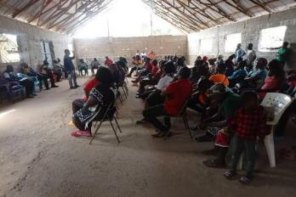
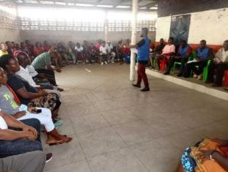
Figure 17: Town Hall Meeting in Southeastern Paynesville (Left) and Central Monrovia North, Soniwein CBD (Right)

Identification of local/community stakeholders
A variety of public meetings (Town Hall meetings) and KIIs and FGDs were conducted in all four of the project’s locations to generate feedback from potential PAPs and Interested Parties (IP) concerning the LURP as well as inform the RPF. The meetings were held from the 2nd - 9th of February. During these meetings, the project information was presented to the participants. This allows the participants to have a general knowledge of the full aspects of the project, including the four major components, the funding agency, scope of implementation, and potential impacts that will be felt by would-be-affected communities.
Annex 14 provides all attendance logs from these public consultations. The participants were chosen based on their geographical location within the four potential project intervention areas. Consultations were conducted in Southeastern Paynesville on February 2 and 3, 2022; at the Omega Market site on February 2, 3 and 4, 2022; in Central Monrovia for the Soniwein area on February 2 and 4, 2022; and in Northern Bushrod Island on February 6, 2022. The interactions included community town halls and focus group discussions.
Generally, over 300 community residents (incl. potential PAPs and IPs) were in attendance for the public consultative meetings at all four locations the meetings were held. Unlike other public meetings that experience low female attendance, the public meetings saw a large number of female participants. In total, 33.11% of the overall participants were female. This is primarily due to rising gender sensitization and women's involvement in political and social matters.

Results from community meetings
The main findings and feedback from these events are summarized below:
- Members of the public lamented the issues of flooding and urged the speedy implementation of the project;
- During public meetings, participants from Bushrod Island North revealed that around half of the residents are squatters, while the other half are legitimate property or landowners in the region.
- The leadership of the various host communities urges for local involvement in the implementation of the project;
- Due to impassable road networks within Southeastern Paynesville, some participants, particularly from the GSA communities, stated that family members and grieving families must carry their ailing relatives and corpse on their shoulders.
- The provision of micro-loans and vocational school/training to increase women empowerment was noted by the majority of women participants in public meetings and Women FGDs.
- The majority of participants in the Central Monrovia / Soniwein area confirmed that property in the area is inherited, resulting in more than one landlord for the same property.
- The residents of Omega community complaint that the presence of the market has exacerbated the issues of flooding as well as worsened the sanitation problem within the area
- If their properties are impacted, majority of the meetings participant indicated that they would prefer cash or financial compensation over alternative forms of compensation.
- The participants in all of the meetings are willing to be relocated if their properties or land falls within the project corridor.

Organizational Procedures for Delivering Entitlements

Introduction
The overall coordination of the project will be provided by the MPW, which will oversee all resettlement planning and coordinate all issues relating to the compensation. The implementation arrangements of the RPF build on the implementation arrangements for the LURP and the implementation arrangements for resettlement and compensation activities in line with the Liberian legislation and the World Bank Environmental and Social Framework (ESF) as outlined in this document.
Actors involved in both these sets of institutional arrangements need to be taken into account in the implementation of resettlement and compensation activities for sub-projects. This section describes the optimal arrangements that build on responsibilities already in place to ensure that the requirements of this RPF are met for each project activity. These are based on the institutional structure at the time of writing the RPF. Should these institutional structures change, this will need to be reflected in the arrangements outlined.

Institutional Arrangements
The institutional structures for drafting and coordinating RP preparation and implementation, as well as the organizational mechanisms for delivering entitlements—such as line ministries, dependents, units, committees, and the PMU—are discussed in this chapter.
The following institutional and departmental arrangements will be used to connect and mobilize resources and capabilities of all relevant institutions who will be involved in the preparation and implementation of the RP associated with all components of all subproject activities in order to ensure efficient resettlement activities preparation and implementation as well as compliance with the Bank's ESS5 and the relevant Liberian legal provisions and policies.
The implementation activities will be under the overall coordination and support of the MPW. The responsibilities of the various institutions are presented in Table 11.
The Ministry of Public Works has the overall responsibility for preparing the RPF and implementing same with World Bank approval. It will ensure that all RPs are completed as and when required and measures - compensation and resettlement - carried out satisfactorily before works commence. The RP preparation activities will ensure that communities are properly and adequately informed (timely) about the project and Plans, and also their rights and options relating to their properties that may be affected by the project and the compensation issues, if any.
Table 11: Institutional Arrangement
Institution | Responsibility
The Project Management Unit | The PMU, which is housed in the Ministry of Public Works, will carry out project activities and will be led by an overall Project Coordinator who will oversee overall project coordination and oversight, as well as the consolidation of project-related data. The PMU will be in charge of carrying out the project's day-to-day operations (including subproject screening and RP implementation). The E&S staff of the PMU includes a Social Safeguards and Gender Specialist, Environmental Specialist, and a Community Engagement and Communications Specialist. The specialists will be new hires and their TORs clearly outline their roles and responsibilities. It is envisaged that trainings will be required to ensure that these E&S PMU staff as well as the Project Coordinator and technical specialists in the PMU understand the RPF and the implications of the ESF/ESS5 adequately (see section above on capacity building).  Through its Project Management Unit, it will be in charge of implementing the overall environmental and social risks measures related to involuntary resettlement and land acquisition and well as the Stakeholder Engagement Plan. For project activities, the MPW will work closely with other relevant ministries/agencies and their departments. To ensure the implementation of this RPF, the PIU will be staffed with one each, an Environmental Specialist, Social Development and Gender Specialist, Communication and Community Engagement Specialist and a Junior Information and Communication Technology/Digital Communications Specialist. These specialists shall work together to design and implement social standards including gender inclusion activities.
The Ministry of Public Works | Overall responsibility for ensuring that participating ministries apply RPF. Trigger the process through screening and inventory of affected persons and assets and implement plan.  Coordinate and support RP preparation and implementation  All drawings for civil works will be approved by the MPW. In Liberia, the MPW is in charge of infrastructure development and zoning regulation. Some of the most serious environmental challenges, such as unplanned settlements and urban flooding, can be traced back to a lack of zoning regulations. The screening and property valuation team will include the Ministry of Public Works.
Ministry of Internal Affairs (MIA) | The Ministry of Internal Affairs (MIA) has played and will continue to play a critical role at the local level in furthering social safeguarding efforts at the community levels. Local government relations since the commencement of this RPF have been excellent, and their contributions will continue to improve in the LURP implementation stage. Furthermore, their advice and participation in conflict resolution and establishing peaceful solutions would be crucial when dealing with compensation and resettlement concerns. As a result, throughout the implementation of LURP, coordination and close collaboration with MIA local authorities would be increased.
Environmental Protection Agency | During the project's implementation, the EPA will oversee the RP to ensure basic compliance with all relevant protocols. The EPA is the main authority for environmental and social management, and it is responsible for coordinating, monitoring, supervising, and consulting with relevant stakeholders on all activities related to environmental, social, and sustainable natural resource use. The Agency works to raise environmental and social awareness while also carrying out the national environmental policy and the Environmental Protection Management Law. Relative to the project, the EPA is in charge of enforcing international environmental and social treaties, reviewing screening reports and advising on level of environmental assessment if necessary, and assisting with training and capacity building of other institutions
Consultant | If necessary, prepare an RP and assist with implementation, capacity building, and community awareness.
Liberia Revenue Authority (LRA) | The LRA will play a vital role in verifying and establishing the value of project-affected assets when it comes to land and asset verification. It is critical that they continue to participate in work linked to land and property verification value exercises.
Ministry of Finance Development Planning | The Project Fund Management Unit (PFMU) of the MFDP is in charge of the fiduciary management of Bank-supported projects. It assists the project in preparing a consolidated work plan and budget for the project. The planned project expenses will be included in the work plans and budgets for each component. The LURP project management will be expected to coordinate and monitor the implementation progress against the work plan/budget. The RP payment team will include the PFMU.
Ministry of Health | Water and sanitation issues will be handled by the Ministry of Health's Department of Environmental and Occupational Health. It will inspect the planned project for sanitary issues and give community health education. The Ministry of Health will also be involved in the investigation of potential water contamination in the project's vicinity, as well as supporting the development of a protocol for PAPs gathering, consultation, and meetings from a health standpoint, as well as ensuring adherence to the COVID-19 protocol.
Ministry of Agriculture | MOA staff will be part of the verification team, assisting with the crop appraisal exercise. PAPs whose livelihoods are based on agricultural products will be supported by agricultural extension officers at the local level. In cases where the initiative has a significant impact on farmers, agricultural extension officers will work closely with MPW to support and track the progress of the impacted farmers.
The Liberia Land Authority | The LLA will aid in the resolution of land disputes as well as the verification of land deeds and titles.  The LLA will also help with community awareness, notifications, and support for inventories of impacted people, land compensation concerns, grievance remedies, and land valuation.
National Disaster Risk Management Agency | The NDRMA implements the National Disaster Management Policy, coordinates the national disaster management system, which includes state and non-state actors at the national, county, and district levels, and handles disaster-related issues to ensure reduced vulnerability to natural and human-induced hazards. The NDRMA will play a crucial role in the implementation of this subproject because the LURP is concerned with reducing flood risk in disadvantaged communities.
Liberia Water and Sewer Corporation | LWSC provides water supply and sewerage services to urban centers in Greater Monrovia. LWSC shall ensure that subprojects involving water supply are implemented in accordance with its relevant safeguard standards
Monrovia City Corporation | The MCC shall provide monitoring responsibilities of the LURP in Bushrod Island and Central Monrovia, Soniwein CBD relative to Component 1 and 2 of the subproject’s implementation.
Paynesville City Corporation | The Paynesville City Corporation is a municipal corporation existing, functioning, and functioning under the Laws of the Republic of Liberia  The PCC shall provide monitoring responsibilities of the LURP in Southeastern Paynesville and Omega Market relative to Component 1 and 2 of the subproject’s implementation.

Verification Exercise
Prior to the finalization of the list of projects affected person, determination of the magnitude of impact, and the final budget for the RP, the RP department of MPW, the PMU will carry out a verification exercise.
During the RP verification process, the following procedures are followed:
- The RP verification team will get a copy of the RP Report covering assets affected by the project and subproject if it is prepared by a third party appointed by MPW and approved by the World Bank.
- The Team will revalue the impacted properties as needed to verify that the cash value placed on them is neither inflated nor undervalued and that it reflects the current situation.
- Collect from each Project Affected Person (PAP) a certificate of ownership for his or her affected property, such as an attestation from the Court, Magistrate, Town Chief, or City Mayor, as well as two passport-sized photos of the property owner.
- Fill in the RP Verification Form containing the verification date, structure code, name of the owner, sex, location of structure, total dimension in square feet (sq. ft.), category (fully affected - FA or partially affected - (PA), kind of structure, US$ rate per sq. ft. and total appraised value for each structure and shall also include the applicable allowances and assistance benefits to each PAP.
- Ensure that each member of the RP verification team, as well as the PAP, signs in the places provided on each RP Verification Form as proof of the assessed values.
- The RP verification form, two passport-sized pictures, a photo of the structure, and confirmation of ownership from the local court are all submitted to the PMU for final vetting.
- PAP vouchers—which include the RP verification form, two passport-sized pictures, a photo of the structure, and confirmation of ownership from the local court—are forwarded to the Finance Office (PFMU) for check-writing after approval.
- Upon receipt of verification reports along with a list of verified PAPs forms, the PMU shall approve the payment processing request.
- Following approval, the MPW will make copies of all confirmed PAPs forms and submit compensation payment requests to the PFMU/MFDP, along with necessary justifications.
- The PFMU will execute compensation payouts after validating papers presented by MPW.
- PAP compensation checks will be distributed by the PFMU pay team in coordination with MPW.
- PAPs will be able to register their names, phone numbers, dates, and signatures with the team.
- For each legitimate PAP, payment forms will be prepared. Fingerprinting will be done on PAPs, and they will be photographed holding their checks.

RP Entitlements Delivery and Resettlement Committee
A resettlement committee made up of the following parties will be formed:
- Ministry of Public Works:
- LURP Project Management Unit
- Ministry of Agriculture
- Ministry of Internal Affairs
- Liberia Land Authority
- Environmental Protection Agency
- Monrovia City Corporation
- Paynesville City Corporation
- Two community representatives (1 man and 1 woman) from PAPs
Every three months, the committee will meet. It will perform the following tasks:
- Review resettlement progress and challenges,
- Evaluate grievances from affected persons regarding resettlement issues
- Discuss any pending and emerging E&S/social safeguard issues,
- Prepare and submit quarterly reports to the MPW and the Bank.

Process to Deliver Compensation
This section presents the procedures in which compensation to affected PAPs shall be processed.

Notification and Disclosure of Compensation to PAPs
Documentation of Assets and Holdings - The RP implementation committee shall meet with affected individuals to disclose the compensation procedure. For full disclosure, the project PMU shall:
- prepare a detailed attestation form for each PAP showing the different payments each PAP is entitled to:
  - The cost of structure (showing the composition of material and measurement of the house)
  - The compensation amount for transaction allowance
  - Compensation amount for loss of business income
  - Compensation for Rental Property/Tenant
  - Compensation for vulnerability assistance
  - Compensation for disturbance allowance
- Two copies of the disclosure form shall be developed, and when signed, one copy must be provided to the PAP. The two forms must be signed by the PAPs as proof of disclosure.
- The form should reflect the breakdown of the different components for compensation and the total amount due each PAP. That is full disclosure.

Compensation payment processing
The MFDP/PFMU will be in charge of processing compensation payments to PAPs.
- The PFMU will proceed to write compensation checks to PAPs after receiving a verified and validated list of PAPs, payment requests, and the relevant documents from the MPW.
- If the PFMU is not completely pleased with compensation payment requests, it must return them to MPW within five days of receipt, explaining why the compensation payment request was not processed (s).
- The PFMU will then request that the MPW provide the necessary paperwork.
- Within five days of receiving the stated letter from PFMU, the MPW must make the necessary modifications and resubmit the compensation payment request to PFMU for check processing.

Entitlement Payment Team
The RP payment team will be responsible for making door-to-door compensation payments to PAPs. Staff from the PFMU and the MPW's E&S team will make up the payment team. There are some drawbacks to the door-to-door compensation payout scheme. Poor accounting for cash received, and assertions by some PAPs that they did not get their payment are two major risk factors. Specific processes, on the other hand, have been put in place to limit these dangers. The payment team must follow the following processes when making door-to-door compensation payments to PAPs:
- To serve as a foundation for identifying and paying impacted structure owners, collect all checks and the appropriate documents linked to the completed verification forms from the PFMU.
- Fill out the payment form and have each legitimate PAP and member of the pay team sign their names in the slots provided.
- Take a photo of each PAP holding his or her compensation check in front of the impacted property and have his or her fingerprints placed on the payment form.
- To improve the encashment of their checks, send the signed payment forms or approved list of the PAPs paid to the Bank.
- No third-party payment shall be allowed.
- Return all checks for i) PAPs who do not show up during compensation payment and ii) those who cannot be disbursed due to a disagreement; the payment report should include a list of all undisbursed checks, their numbers, and the PAPs in whose names the checks were issued.
- Within three days of returning from the field, prepare and submit a payment report to MPW and PFMU.

Documents to be provided by PAPs
Meetings with PAPs should be arranged by national and local government officials, community elders and leaders, and representatives from the Ministry of Public Works to explain the compensation and valuation process.
The following documentation shall be attached to each compensation payment request:
- Probated and registered land deed (where land or economic crops are to be compensated). Again, clearance from local authorities is required.
- Community Leader attestation - when land ownership cannot be proven through district courts or a probated land deed, the PAP must submit a community clearance stating that he or she is the sole owner of the land. In the absence of a district court attestation and a probated property deed, the community leaders' attestation to the PAP will serve as proof of land ownership for the PAP and will serve the same purpose as a district court attestation and probated land deed.
- Submission of passport size picture
Documents pertaining to land transactions will be included in the documentation (voluntary and involuntary). A contract will be written that lists all of the property and land/farms being relinquished, as well as the sorts of compensation (both cash and in-kind). Prior to signing, the contracts will be presented in community meetings.

Linking Resettlement Implementation to Civil Works
Before works on the sub-project can begin, PAPs must be compensated in accordance with this Resettlement Policy Framework and subsequent Resettlement Action Plan.
The project schedule must make provisions for full implementation of the RP before the site can be handed over to the contractors for the start of civil works. Civil works must be timed and coordinated properly to ensure that no affected persons are displaced economically or physically as a result of civil works activity before compensation is given and any project activity can begin. The Project Planning team and PAPs must agree on a schedule for the implementation of activities, which must include:
- dates of possession of land used by PAPs (this date must be after the transfer date for completed civil works to PAPs and payment of all compensation), and the link between RP activities and the implementation of the overall sub-projects
- target dates for the start and completion of civil works
- timetables for transferring completed civil works to PAPs,

Grievance Redress Mechanism (GRM)

Introduction
During RP implementation, this section explains how PAPs can file a complaint or express a grievance about the project, its staff, or contractors. It also explains the necessity of grievance management, as well as methods, roles, and responsibilities. The method must make use of existing local governmental and community systems in order to be effective. Parties with grievances or who are dissatisfied with any aspect of the resettlement and compensation process must have access to a grievance mechanism. These complaints could be over asset assessment, compensation paid, level of consultation, contract non-fulfillment, and compensation timing, among other things. Complaints and grievances often include concerns about construction safety and construction-related annoyances. Grievances shall be resolved through negotiation with the goal of reaching an agreement.
The World Bank's Grievance Redress Service (GRS), which provides a simple means for project-affected communities and individuals to convey their grievances directly to the attention of Bank Management, will improve the project GRM. The GRS will ensure that complaints are immediately forwarded to the appropriate Bank Task Teams and/or Managers for review and action. The objective is to increase the Bank's participation, responsiveness, and accountability.

Objective of the GRM
The objective of the GRM is to provide the community and project-affected parties an avenue to raise their concerns and grievances related to the implementation of the RPF/RP, as well as other project activities, within a timely manner. A robust grievance mechanism must be designed and put in place to adequately address concerns and complaints arising from the project activities. The procedures also ensure that the entitlements are effectively transferred to the intended beneficiaries. For this purpose, the project shall propose and implement a grievance procedure that will ensure that interested parties and PAPs are able to lodge complaints or concerns without cost and with the assurance of a timely and satisfactory resolution of the issue. The proposed mechanism, process, or procedure shall in no way prevent access to judicial or administrative remedies.

Potential Sources of Grievances
During the development and implementation of the RP as well as the project, grievances could potentially arise and may be related to the following:
- Mistakes during the valuation and calculation of inventory and valuation during the census;
- Mistakes during the identification of property owners or property boundaries;
- Mistakes during the identification of supplementary assistance to deserving PAPs;
- Dissatisfaction with eligibility criteria used;
- Dissatisfaction with compensation rate, payment time, relocation, encroachment on private property without compensation due to oversight and treatment of vulnerable PAPs

Grievance Redress Process
The project’s grievance redress process shall be carried out at different stages of the resolution if one fails. The first level of grievance redress will comprise of the influential members of the communities (members of the community leadership, elders and representatives from women, youth, and two representatives of the directly affected households), representatives of the project contractor, communications and community engagement specialist and the project’s social safeguards and gender specialist, employed by the PMU. The next level shall comprise of high-level representatives of the relevant line ministries (MPW, LLA, PCC, MCC, MFDP, and MGSPA), the project coordinator and communications and community engagement specialist and the project’s social safeguards and gender specialist, and if resolution is not achieved at this level, the aggrieved party shall proceed to use the judicial system.
The project shall ensure that subsequent to the consultation process, the grievance committees at the various project locations shall be established and trained on their key roles, importance and benefits of grievance redress, grievance handling procedures, and how to record grievances. The number of members can range from eight to ten, depending on the needs of the location and the community preference. It is important to ensure that the selected members from the community are trusted by the community to represent their interest to also establish a sense of ownership of the committee and are willing to work pro-bono. The list of committee members and contact details must be distributed across the project location and posted at strategic locations.
Additionally, another level of committee, to address GBV and SEA/SH related risks, shall be established to addressed inherent forms of gender segregation and defined roles and responsibilities may affect women’s access to and use of a grievance mechanism. Women may also be inhibited or hindered from complaining about specific incidents (e.g., compensation, land ownership, harassment, and inequality in getting employment). The Project therefore should ensure that the grievance mechanism committee to be established, specific for GBV/SEA/SH cases, includes members who are aware of and sensitive to the role of women and how to reach out to women and benefits them in local society. The project should train the committee in handling GBV/SEA/SH related risks. The committee shall be equipped to receive, register, and facilitate the resolution of SEA/SH complaints, including through the referral of survivors to relevant gender-based violence service providers, all in a safe, confidential, and survivor-centered manner.
The community shall be informed that the committee is the first point of grievance redress, and if the complaint is not resolved at the first level within two weeks, it shall be forwarded to the second level, which comprises representatives of the relevant line ministries. As a last resort, and if the grievance is not resolved at any of this level after 3 weeks, the complainant can take the complaint to a competent court of jurisdiction.
Both the first and second levels of committees are to be trained by project, and the training on grievance handling are summarized below:
- All complaints, actual or perceived, must be recorded using the given form provided by the project. A sample form is provided in Annex 11: Grievance Log.
- The committee shall draft a note acknowledging receipt of complaint and assure the aggrieved person the committee will investigate and address the complaint within the specified timeframe, to be communicated in a second training after the preparation of the RP report and before the start of the Project
- Committee convenes to decide course of action.
- If complaint is of physical nature, visit location to authenticate complaint and investigate if it is project-related.
- Investigate the source and consult all parties involved.
- Record all actions, decisions taken, and recommendations made.
- Close case if grievance is resolved at the committee level and forward paperwork to the Project-level grievance committee.
- If the grievance cannot be resolved at this level, it must be forwarded to the second-level grievance committee, and continuous follow-ups should be made on the redress process.
Other responsibilities and roles of the committee shall include:
- Representing PAPs
- Mediation between affected communities and the project
- Grievance Handling
- Witnessing inventory and census process
- Participate in the disclosure of the compensation Package
- Witness the process of compensation payments

GRM Records and Documentation
During the training sessions, members shall be given a sample grievance form and trained on how to capture and report complaints and concerns. Grievance shall be documented or recorded by (i) assigning reference number that represents the town, (ii) recording the full name and contact of complainant, (iii) record and detail grievance, (iv) record the date and location incident occurred, (v) record the complainant’s proposed dispute resolution, and (vi) and full name of the recipient and date the complaint was registered.
The project shall establish an Excel database to store all grievance records, monitor the progress on redress, develop reports and carry out analysis. The database shall be managed by both the SSGS and/or the CCES.

Funding, Fund Flow, Cost Estimates and Contingencies

Introduction
The project budget will include all LURP preparation and implementation expenditures, including compensation and resettlement cost.
Because the technical designs/details have not yet been established and land needs have not yet been identified, it is not possible to estimate the actual number of individuals who may be affected at this stage of the project. When the exact locations are known and the detailed site-specific socio-economic study is completed, information on specific impacts, individual and household incomes, the number of people affected, and other demographic data will be available, making it easier to prepare detailed and accurate budgets for each RP. The MFDP will manage and monitor the resettlement budget, as well as finance it using the same administrative and financial management rules and regulations that it does for any other project-related activity. All that can be realistically and usefully created at this point is an indicative budget that highlights essential aspects that the budget must include.

Estimated budget to implement RPF
Implementation of this RPF would require budgetary allocation of US$225,000.00 by the project. The estimates consider the cost to prepare Resettlement Action Plan(s), cost, stakeholder engagement, and project staff capacity building, and cost for the establishment and training of the different GRMs.
Activity | Estimated Cost | Comment
Stakeholder Engagement | 15,000.00 | Prior to the preparation of the RP, the project will need to engage key stakeholders, communities, relevant line ministries, and agencies, as well as its internal stakeholders.
RP Preparation | 160,000.00 | This estimate shall cover the cost for the preparation of a RP and its disclosure. Implementation cost shall be estimated in the budget of RP.
Establishment of GRM | 20,000.00 | This cost shall cover the formation, training, and operations of the GRM during the preparation and implementation of the RP.
Project Team (MPW, LLA, PMU, contractors/consultants) Capacity Building | 25,000.00 | Cost to ensure the project team has a general appreciation and understanding of the resettlement process, the regulatory requirements and ESF standards, as well as the importance of ensuring PAPs, are not made worse off.
RPF Disclosure | 5,000.00 | Cost for printing and distributing copies of the RPF to the different stakeholders.
Total Cost | 225,000.00

Template Budget for preparation and implementation of RPs
Cost Item | Estimated Cost (US$) | Comments | Source of Funding
Compensation to Affected Persons
Compensation for all structures |  | Compensation will be paid for loss of complete or partial structures in affected areas.
Compensation for affected tree crops |  | Amount to PAPs for affected cash/tree crops.
Compensation for affected land |  | Amount to be paid to the PAPs whose land will be affected by different components of the project
Compensation for loss of business income |  | Compensation will be paid to owners of businesses that will be relocated or disturbed during the implementation of the project.
Compensation for loss of wages |  | For the loss of wage for employees of affected businesses.
Transportation Allowance  - Structure Owners  - Landowners  - Tenants/ Caretaker/ Squatter Transportation Allowance |  | Amount to assist PAPs relocate from area to be acquired by the project
Assistance to Vulnerable Persons |  | Amount to assist vulnerable persons
Transaction Cost  - Structure Owners  - Tree Crop Owners  - Land Owners  - Tenants/ Caretaker/ Squatter Transportation Allowance |  | Amount to assist PAPs with the processing of RP payment documentations
Title Transfer cost |  | Amount to be paid for the preparation of updated land title document and transfer deed.
Rent Allowance |  | To assist tenants and squatters during the transition process.
SUB-TOTAL:
RP Implementation, Monitoring & Evaluation
Internal Review and Implementation |  | Amount to be utilized by the internal monitoring team to review the RP and payment of compensation.
External Monitoring & Evaluation |  | Amount to be utilized for the implementing entities to ensure that the RP is undertaken to its end.
Demolition |  | Amount to be used for the demolition of all properties in the right-of-way and acquired land after the payment of compensation.
Completion Report |  | Amount to be used to produce the final report on the implementation of the RP
SUB-TOTAL:
Contingency: (% of Compensation to Affected Persons) |  | Budget to cover expenses not budgeted. This is also supposed to cover the cost of inflation
Total RP Budget

Monitoring and Evaluation Arrangements

Introduction
Monitoring and evaluation are key components of the RPF. The Monitoring and Evaluation (M&E) mechanism serves as a foundation for evaluating the overall success and efficacy of various resettlement processes and policies. Monitoring and evaluation will be a continuous process that will provide the World Bank, MPW/PMU, MFDP, and other relevant stakeholders with feedback on RP implementation.
The general objectives are:
- Screening and identifying subproject activities that require the preparation of an or RP.
- Monitoring of specific situations or difficulties arising from implementation and of compliance with the objectives of the RPF and methods as set out in this RPF.
- Evaluation of the impacts of the Resettlement/Compensation Actions on PAPs’ livelihoods, environment, local capacities, economic development, and local communities.
Monitoring and evaluation aim to identify and rectify implementation challenges confronting the RP. The evaluation process will also take stock of resettlement benefits that have been delivered to PAPs and ensure that the outputs of resettlement are consistent with relevant resettlement policies of the World Bank and applicable Liberian laws relating to land acquisition and resettlement. Ultimately, the M&E reports will provide lessons for better planning and management of social impacts of projects.
This mechanism is made up of two parts:
- Internal monitoring conducted by the PMU within the Ministry of Public Works,
- External evaluations carried out by a third party, such as an independent entity or a consultant.

Internal monitoring
Monitoring shall be led by the social safeguards and gender specialist and shall address the following aspects:
- Focus on selected socioeconomic indicators to assess:
- the livelihood recovery status of displaced or affected persons; and
- re-establishment of livelihoods of affected persons.
- Complaints and grievances and how complaints are being addressed
Internal monitoring's overall goals and tasks are as follows:
- Tracking progress of RP implementation including number of PAPs compensated, relocated, and assistance to the vulnerable.
- Creation of a mechanism to analyze M&E data against a pre-resettlement baseline.
- Regularly respond to M&E findings by adapting existing measures or by modifying implementation processes.
The monitoring process will be used to analyze progress and change at regular intervals and shall be linked to the various stages of the RP, as follows:
During resettlement, M&E should focus on resettlement issues such as:
- Number of families that have been moved.
- Number of people given possession and legal papers to new property (land or house)
- Impacts on livelihood and income
- Registration of unemployed people
After the physical relocation is completed, monitoring shall focus on rehabilitation issues and status on each of the measures will be assessed, for example:
- Target date for completion (e.g., within two months of resettlement);
- Progress to date
- Progress in the last month
- Target for the month
- Reasons for delay, if any; and
- Action to be taken, including specific responsibilities of other members of implementation team.
- Socio-economic assessment to ensure minimal impacts – that the PAPs are not worse off than before the RP process.

External monitoring and evaluation
External monitoring will be conducted by external agency, e.g., independent entity/consultant. LURP will engage a local consultant to carry out independent external monitoring and evaluation of the RPs developed and implemented under the project. The external evaluation process will be informed by internal monitoring reports and will be done soon after the RP completion. The independent evaluation will determine:
- If compensation payments have been completed in a satisfactory manner.
- If there are improvements in livelihoods and well-being of PAPs; and
- If grievances or conflicts emanating from the LURP have been successfully resolved.

The evaluation will use selected indicators including:
- Comparison of income levels of PAPs before and after RP implementation.
- Livelihoods and employment assistance offered under the LURP and other accessible alternative incomes.
- Experiential changes in standards of living/housing conditions of PAPs.
- Number of grievances and their status, time, and quality of resolution.
- Number of vulnerable people/groups identified and assisted, and impact of resettlement assistance provided on them.
- Number of demolitions, if any after giving notice if any, and
- Number of PAPs paid in a given period in comparison with what was planned.

Responsibility of the Authorities
The role of the implementing authorities is critical in the operationalization of the Resettlement Policy Framework. The following are important points to observe:
Ensure that there is trust between the PAPs and the authorities throughout the process by being transparent in every action and sharing information.
- Being realistic with time frames and sequencing of related activities.
- When registration will be completed.
- When assessment will be completed.
- When computation of entitlements will be carried out.
- When payments will be made by whom and where; and
- When the acquired land will be vacated and when the contractor will move on site.

Adhering to the agreed and publicized timetable of delivery of compensation is critical. This calls for a deliberate effort to ensure.
- Funds for compensation are ready, set aside, and accessible when payment commences.
- The location for resettlements is demarcated and available without encumbrances for those who opt to be relocated.

Indicators
The following methods and/or specific monitoring indicators among others will be used for measuring impacts during project implementation:

- Questionnaires with data stored in a database for comparative analysis (before-after and with without);

- Documentation and recording of PAP situations including subsequent uses of assets / improvements;

- Relocation/resettlement and Compensation Reports;

- Consultations

The PMU will review these statistics to determine whether RP implementation arrangements, as defined in this RPF, are effective in addressing RP-related issues. Financial records will be maintained by the sub-projects and the PMU to determine the final cost of RP implementation. The indicators listed above can be used to monitor implementation of the RP

Indicators to determine status of affected people
These indicators are most important with respect to the RPF policy on resettlement and compensation. They will be informed by the baseline survey and will provide the council and the World Bank data and trends for refocusing the project and for improving delivery. The following will be considered:
- Number of affected persons by types of losses
- Status of resettlement with timelines whether met or outstanding

Indicators to measure RP performance
In terms of the resettlement process, the following indicators could be used to understand the success of the measures identified and the working of the relevant parties in implementation the RP:
- Percentage of individuals selecting cash or a combination of cash and in-kind compensation.
- The number of contentious cases as a percentage of the total cases.
- The number of grievances and time and quality of resolution.

These will be determined through the following activities:
- Questionnaire data will be entered into a database for comparative analysis coordinated by the PMU.
- Each individual will have a compensation dossier recording his or her initial situation, all subsequent project use of assets/improvements, and compensation agreed upon and received.
- The PMU will maintain a complete database on every individual impacted by the subproject land use requirements, including
- Relocation/resettlement and compensation, land impacts or damages, and the PMU should prepare Resettlement Completion Reports for each RP, in addition to other regular monitoring reports.

Table 12: RP Monitoring Indicators
Monitoring | Specific indicator | Frequency
Social and economic monitoring | On the basis of pre-project baseline survey, provide number of PAPS: i) whose livelihoods have been restored to pre-project level, ii) whose livelihoods have improved beyond pre-project level, iii) whose livelihoods are worse than pre-project level. | Monthly until the end of RP implementation
Private structures | Provide number of PAPs: i) whose private structures have been restored/constructed to pre-project level, ii) whose private structures made better / improved beyond pre-project level, iii) whose private structures are made worse than pre-project level | Monthly
Public  Structures | Provide number of PAPs: i) whose public structures have been restored/constructed to pre-project level, ii) whose public structures made better / improved beyond pre-project level, iii) whose public structures are made worse than pre-project level | Monthly
Economic Crops | Track progress on i) number and type of economic crops replanted by affected farmers, ii) number of farmers who have restored their income to pre-project level, iii) number of farmers who have not restored their income to pre-project level, iv) number of farmers, whose income has been restored beyond pre-project level, and v) number of affected farmers who have changed their livelihoods mode from farming to other livelihood earning activities, | Monthly
Assistance to  Businesses | Track progress on i) number of affected businesses that have resumed business operation, ii) number of businesses that have restored their net income to pre-project level, iii) number of businesses that have restored their net income beyond pre-project level, iv) number of affected businesses that have not to resume operations. | Monthly
Vulnerable Groups | Provide number of vulnerable PAPs: i) whose livelihoods have been restored to pre-project level, ii) whose livelihoods have improved beyond pre-project level, iii) whose livelihoods are worse than pre-project level, iv) who have received assistance from the special package, v) who are sick and who benefited from health service in the project area, vi) number of disable friendly facilitates constructed by the project such as access ramp from main road to their living quarters or neighborhood, | Monthly
Tenants | Provide number of affected tenants: i) who have found new rental places, ii) who reported that the rental allowance is inadequate, iii) who showed satisfaction over their new rental places compared to the ones they occupied before the project, and iv) number of tenants who have not yet found rental places. | Monthly
Grievances | Track grievances and report: i) number of cases at each impact location, ii) the number of cases resolved, iii) number of cases pending, iv) reasons for pending cases, v) frequency of GRMs meetings, and vi) description of compliance to GRM procedures | Monthly
Post RP Compensation Payment  Audit | On the basis of the census and entitlement matrix, the post RP compensation payment audit exercise will verify and confirm: i) overall total number of PAPs paid full compensation) total number of private structure owners (PAPs) paid full compensation; iii) total number of public structures (fences and signboards) paid full compensation iv) total number of economic crops (rubber trees, oil palm trees, and sugar cane) paid; v) total number of business owners (loss of income/revenue) paid compensation; vi) total number of tenants paid three months rental assistance on; vii) total number of landlords paid three months rental losses viii) total number of vulnerable people paid full special assistance (3 months rental, living and transitional allowances); ix) number of PAPs who are not paid full compensation; x) compensation cases disputed channeled to GRMs and status of each case; and xi) potential and actual residual social risks and proposed mitigation measures. | Monthly

Monitoring of RPF Implementation

The project implementer (MPW/PMU) will compile basic information on all physical or economic displacement arising from the project. They will compile the following statistics:

- Number of subprojects requiring preparation of a RP.
- Number of households and individuals physically or economically displaced by each sub-project.
- Number of people reached or accessing information, information request, issues raised, etc.
- Length of time from sub-project identification to payment of compensation to PAPs.
- Timing of compensation in relation to commencement of physical works.
- Amount of compensation paid to each PAP household (if in cash), or
- Nature of compensation (if in-kind)
- Number of PAPs affected (building, land, trees, crops, etc.)
- Number of local CBOs participating
- Quality of grievances or disputes resolved (qualitative)
- Number of people raising grievances in relation to each sub-project.
- Number of cases settled by GRC
- Number of cases pending with GRC
- Average time taken for resettlement of cases
- Number of GRC meetings
- Number of PAPs moved court
- Number of pending cases with the court
- Number of cases settled by the court

This process will produce quarterly progress reports on the progress achieved with the implementation of the RPF/RP and submit them to WB. It will document all meetings and consultations with minutes and will submit these to the WB together with progress reports. Cost of monitoring will be taken care of by individual implementing agencies or stakeholders as part of project operating expenses.
A final report will be developed and submitted to World Bank when all land acquisition has been completed and all impacts successfully mitigated. Internal monitoring of the resettlement/rehabilitation operations will also be undertaken by MPW/PMU, MCC, PCC, EPA, LLA, MFDP, etc. following the schedules in the RPs. The WB, as part of their supervision, will also review the implementation progress and advice on implementation issues.

Storage of PAPs Details
MPW/PMU, as executing ministry, will be the custodian of all documents related Project and the Project Affected Households or Persons.

Audit
The World Bank Safeguard Policy, ESS5 states that upon completion of a project, the project proponent oversees an assessment to determine whether the objectives of the resettlement instrument have been achieved. RP Implementation Completion Report should be prepared and submitted to the Bank 6 months after the end of compensation payment by project implementing agency. An audit should be done to determine whether the efforts to restore the living standards of the affected population have been properly designed and executed. This completion audit verifies whether all physical inputs earmarked in the RP have been delivered and all services provided. The audit also evaluates if the mitigation actions prescribed in the RP have had the desired effect. The baseline conditions of the affected parties before the relocation should be used as a measure against their socio-economic status after the resettlement.
The RP implementation report should include (but not be limited to) the following information:
- Background of the RP preparation, including a description of the project activities, scope of impacts,
- number of affected persons and estimate budget.
- Update of its implementation with actual numbers of displaced persons by segments, compensation
- paid, issues/complaints raised, and solutions provided
- Grievance mechanism and complaints status
- Early assessment of the impacts of resettlement and compensation on affected categories at the time
- of the report production.
- Total sum disbursed
- Lessons learned from the RP implementation
- Suggested annex:

To be effective, the complete audit will take place after all RP activities have been completed including development initiatives, but before the financial commitments to the program are finished.

Reporting and Documentation

The PCU’s Social Safeguards and Gender Specialist will be responsible for reporting and documenting per the M&E guidance above. The Ministry will have a dedicated M&E Specialist working on the project who will advise the Social Safeguards and Gender Specialist on the best ways to monitor, report and document any related information adequately.
ESF related updates will be part of the overall project reports. Separate ESF reports will be provided on request by the World Bank and for other relevant discussions. The report will at least cover status of compensation disbursement, nature of complaints, redress actions, and follow-ups. Other information and documentation will include.
All disclosed E&S Instruments
- Minutes of all consultation and disclosure meetings and workshops (including pictures where feasible)
- Sub-project Environmental and Social screening reports/forms
- EPA permits
- RP/ Compensation Reports
- New E&S issues not anticipated during preparation
- Site Meetings, any meeting that discusses key project issues
- Changes in decisions regarding E&S related matters
- Grievance records
- E&S field visit reports etc.

REFERENCES
- Government of Liberia (GoL), 1986. Constitution of the Republic of Liberia
- Government of Liberia (GoL), 1986. Constitution of the Republic of Liberia
- Government of Liberia (GoL), 2001. Revised Rules and Regulations Governing the Hinterland of Liberia
- Government of Liberia (GoL), 2001. Revised Rules and Regulations Governing the Hinterland of Liberia
- Government of Liberia (GoL), 2008. Land Commission Act
- Government of Liberia (GoL), 2008. Land Commission Act
- http://documents.worldbank.org/curated/en/383011492423734099/pdf/114278-WP- REVISED-PUBLIC-Environmental-and-Social-Framework.pdf
- Liberia Insecurity of Land Tenure, Land Law and Land Registration in Liberia; October 2008. http://documents.worldbank.org/curated/en/158491468050694915/pdf/461340ESW0P10310Box33409 9B01PUBLIC1.pdf
- Liberian Laws and Regulations — USAID Natural Resource Management and Development Portal. http://rmportal.net/library/content/liberias-land-rights-and- community-
- Liberian Laws and Regulations — USAID Natural Resource Management and Development Portal. http://rmportal.net/library/content/liberias-land-rights-and- community-
- Liberian Laws and Regulations — USAID Natural Resource Management and Development Portal. http://rmportal.net/library/content/liberias-land-rights-and-community-
- Local Government Act 2015:
- Local Government Act 2015:
- Local Government Act 2015:
- Ministry of Gender and Development 2009: The National Gender Policy: http://www.africanchildforum.org/clr/policy%20per%20country/liberia/liberia_gender_2 009_en.pdf
- Ministry of Gender and Development 2009: The National Gender Policy: http://www.africanchildforum.org/clr/policy%20per%20country/liberia/liberia_gender_2 009_en.pdf
- Ministry of Gender and Development 2009: The National Gender Policy: http://www.africanchildforum.org/clr/policy%20per%20country/liberia/liberia_gender_2009_en.pdf
- The Ministry of Finance and Development Planning 2015. Annual Economic Review https://www.mfdp.gov.lr/index.php/economic-outlook
- The World Bank Environmental and Social Framework, 2017
- The World Bank Environmental and Social Framework, 2017 http://documents.worldbank.org/curated/en/383011492423734099/pdf/114278-WP-REVISED-PUBLIC- Environmental-and-Social-Framework.pdf
- World Bank (WB), 2001. Operational Manual- OP 4.12 - Involuntary Resettlement, 2017.http://documents.worldbank.org/curated/en/425421510962301689/pdf/SFG3795- RP-P149279-Box405310B-PUBLIC-Disclosed-11-17-2017.pdf

ANNEXES

Annex 1: Record of Stakeholder Participation (Institutional Stakeholders Consultation)
INSTITUTION | MEETING DATE | INFORMATION OF CONTACT PERSON(s) | PURPOSE OF MEETING | RESPONSE / INPUTS
Liberia Land Authority (LLA) |  | Dr. Mahmoud Solomon  Position: Asst. Director – Survey and Mapping  Contact: +231 880901702 /770105038 | Solicit views, comments and recommendations regarding the proposed project; feedback on land tenure and institutional framework regarding resettlement. | Dr. Solomon revealed his awareness of the proposed project and the LLA is in full support. He further explained that the project should identify affected occupants in close consultation with the LLA to ensure an establish valuation and compensation procedures.  Dr. Solomon also noted that there is currently no available land tenure map to fully established land ownership in proposed project vicinity. He further explained that the LLA is currently working on policy and institutional framework regarding resettlement. He recommended that the current market value should be used for compensation purposes. That an Institutional Technical Working Group be established and functional at all times to address critical issues regarding resettlement.  He finally concluded that the proposed project should refer to National Policy and Regulatory Instruments with specificity to Land Right Acts as guidance tools for project implementation.
Monrovia City Corporation (MCC) | February 03, 2022 | Mr. Franco B. Grimes  Position: Chief of Office Staff – Office of Monrovia Mayor  Contact: +231 770524695 | Solicit views, comments and recommendations regarding the proposed project; feedback on Urban Development, City governance and institutional framework regarding resettlement. | Mr. Grimes noted that the proposed project will be the first of its kind in post war Greater Monrovia. He further explained that the City Government is fully supportive in rolling out proposed project. Revealed that MCC currently has an established Environmental, Health & Safety and Community Services Departments that remained engaged with greater Monrovia communities, while providing support to Police depots, markets and sanitation. That MCC is currently developing modern laws to deal with Urban Capital City Development to address all issues related Statutory Laws regarding Resettlement among others.  Moving forward, he recommended the following:  - that the proposed project should work along with current statutory laws regarding resettlement.  - That there should be direct engagement with Local Authorities, MCC, Representatives, etc. to ensure smooth community entry process.  - Conduct pre-assessment along proposed area of interest to inform the need for Resettlement Action Plan (RP)  - That proposed project should consider the following localities: Norther region of Bushrod Island (Duala); Soniewein; Waterside; Jamaica Road; Cowfactory; GSA road through Duport road to King gray.  - That the proposed project should not prioritize drainage construction without addressing waste and sanitation.
Paynesville City Corporation (PCC) | February 02, 2022 | Mr. James Morlu Kennedy  Position: Deputy Director – City Planning  Contact: +231 770418626 / 886438188  Mr. Stephen Kiah, Jr.  Position: Director (SPO)  Contact: +231 775685653 | Solicit views, comments and recommendations regarding the proposed project; feedback on Urban Development, City governance and institutional framework regarding resettlement. | Mr. Kennedy revealed prior knowledge of the proposed project. He noted that successful implementation of said project will enhance better living condition, mitigate flood risk and support urban development initiative.  Moving on, the following communities and/or zones were highlighted as recommended areas of concern for proposed project implementation: Zayzay community through Duport road North - South to GSA road; SKD Complex through King Gray community to the Atlantic Ocean.  Noting that there is no major drainage system within the Paynesville area.  It was further explained that the major disaster within the mentioned communities during the raining days is flooding.  Noted that there is coordination with line ministries and agencies regarding land and resettlement during development projects implementation.  Recommended that the project work in close coordination with the PCC for successful implementation; that garbage control and/or sanitation issues be considered for project intervention; Resettlement process should consider existing national regulations and policy; capacity building and logistical support PCC to enhance monitoring.
Ministry of Finance & Development Planning (MFDP) | February 09, 2022 | Mr. Papin Daniels  Position: Director – Donor Financed Projects -PFMU-MFDP  Contact: +231 886 683217 | Solicit views, comments and recommendations regarding the proposed project; feedback on Urban Development, Financial Management Process and institutional framework regarding resettlement. | Mr. Daniels highlighted that Ministry of Finance & Development Planning controls the project financial management process. Noting that MFDP is not into activities of project regarding procurement and implementation. He noted that the resettlement process should manage the expectation of the project affected communities, avoid litigations and ensure risk assessment.  He furthered noted that the resettlement process should considered loss of businesses.  The following were recommended: that proper verification of affected parties be considered before payment of compensation; that to curtail settlement on public lands, along drainages, alleys and water ways, the proposed project should be used as a “Case Study”.  And strongly recommend that appraisals of PAPs and/or valuation be realistic to faithfully represent replacement cost and a policy on who, how to valuate. This will avoid conflict of Auditors flagging high cost of property (ies) that do not represent and/or justified actual values.
EPA | February 21, 2022 | Mr. Daoda S. Carlon  Position: Director – Asst. Manager - ESIA  Contact: +231 886 036695  Mr. Targen Daye – ESIA Analyst  Contact: +231 0886842133 | Solicit views, comments and recommendations regarding the proposed project | It was noted that the project will be supported by the EPA in terms of providing technical guidance ensuring environmental requirements are dully adhered to during construction and operation phases of the project.  The following was recommended:  That the EPA be fully involved during the preparation and implementation of the RP.  Revealed that the EPA is usually not fully part of the RP approval process, this should be considered during the proposed project.  Also emphasized that detail inputs and recommendations will be provided upon submission of the required reports to the EPA for review.
LWSC | February 21, 2022 | Mr. Moses Saah Tandanpolie  Position: Director for Operations  Contacts: +231 770 755759 | Solicit views, comments and recommendations regarding the proposed project | Concerns:  • Is the project going to have an alarm system or a contingency plan?  • What types of drainage are going to be built?  • Will the kiosk get water from the LWSC?  • Is there going to be a budget for the cleaning of the proposed drainage, if then, how will mentioned funding be managed?  • Is the project going to create training and build capacity for community dwellers for the operation and maintenance of the facility?  Recommendations  • The project should work with the EPA and MCC on the issue of final waste disposal.  • Also, the issue of community awareness programs for the operation, construction of the feasibility, and the water should undergo water quality testing and treatment

Annex 2: Record of Potential Affected Communities’ Participation in the RPF
FOCUS GROUP DISCUSSION
Stakeholders | Venue |  | Dates | Feedback
Omega Tower Community Leadership | Chairman’s Residence |  | Feb 3, 2022 | - The leadership pledged overwhelming support for project implementation  - Flooding is most severe in Block B, adjacent Coco Cola factory areas  - Most Structures within the community are built on private land  - The community’s members usually undertake self-initiatives yearly to open various alleys and drainage channel  - Compensation for affected parties is recommended and should be fairly and timely  - Estimated Cost of private land within the community range from US $ 1,800 to 2,500 per lot  - Seasonal gardening is the identified agriculture activities that support livelihood
GSA Community Leadership | Chairman’s Residence |  | Feb 3, 2022 | - The Chair lady of Kola Tree (Jessie F. Johnson) and the General Chairman (Dave N Fokonyuler) of the community welcomed the team and expressed their support to ensure successful project implementation.  - Concern communities are usually flooded during the rainy season, thereby affecting residents and livelihood activities.  - During intense rainy days, pluvial flooding occurs and flows above the window level of structures.  - Inaccessibility of pathways leading to communities  - Drainage channels are smaller and blocked due to waste disposal, causing easy overflowing  - People usually build within the wetland as well as use the site for disposal of waste  - Noted challenges within their communities, such as lack of toilet facilities, water, road, and livelihood for citizens.  - Need well designed and improved canal to control the flooding during the rainy season  - Estimated Cost of private land within the community range from US $ 2,000 to 2,500 per lot
The Leadership Central Monrovia/Soniwein | Chairman’s Resident |  | Feb 3, 2022 | - The Chair lady of Capitol Hill (Sandra B. Worjloh Nah) along with Chairman Tarley Johnson and others welcomed the team and expressed support to project implementation.  - Squatters had blocked the drainages due to gardening as well as building illegal structures.  - Waste is disposed within the drainages by nearby communities;  - Lack of toilet facilities, water, livelihood, and waste disposal site for the communities.  - Compensation should be fairly and timely.  - Resettlement consultation should be public to enhance the identification of properties owners  - Solid waste dumped in rivers has caused rivers to be stagnant and prune to pathogen breeding and infectious to human  - Drainages are clot with debris and mainly plastic  - Estimated Cost of private land within the community range from US $ 3,000 to 6,000 per lot.  - Communities are vulnerable to disasters (flooding, fire hazard, storm, etc.)  - Lack full support from government during disasters  - Communities lack coordination with municipalities
Northern Bushrod Island |  |  | Feb 5, 2022 | - The Governor of New Kru Town, Hon. Moses Doe Weah welcomed the team and expressed full support for the project.  - Illegal structures are built on alleys and drainages resulting in flooding  - Affected parties will be willing to accept full replacement cost for properties to avoid disasters  - Drainages are used for waste disposal due to lack of disposal sites and waste collection system by city government.  - The participants welcomed the project as it will help the people in reducing expenditure on flooding effects, enhance livelihood activities, coordination and urban development  - During the intense raining season, some waterfronts exist between the ocean water and rain running water) in communities along the beach (paggos comm.)  - The floods are directionless and take time to wash off after rain subsides  - The sustainability of the project after completion should be ensured and with a right mechanism in place to avoid adverse impact or anthropogenic activities afterward.  - Flooding is mostly severed in Lagoon, Inland communities, Popo Beach and Colonel West among others.  - Lack of toilet facilities, water, road, livelihood, and waste disposal site within communities.  - The project should address the issues highlighted.  - Estimated Cost of private land within the community range from US $ 3,000 to 6,000 per lot  - Land sales are regulated by the local land authority in coordination with the landowner.
KEY INFORMANTS INTERVIEW
Informants | Name & Contact |  | Date | The result from the KIIs
Omega Block “A” | Patrick Gongbegon |  | Feb 2, 2022 | - The establishment of the market has contributed to improper waste disposal within the community.  - Undermining and contamination of drinking water sources (wells and pumps) by flooding  - Incubation of parasites, pathogens, etc. during flooding exposed children and adults to the various ailments (feet fungus, malaria, typhoid, diarrhea, etc.)  - The flooding exposed households to creeping/swimming organisms, especially snakes  - Flooding is most severe in Block B, adjacent to the Coco-Cola factory areas  - Most Structures within the community are built on private land  - The community’s members usually undertake self-initiatives yearly to open various alley and drainage channels  - Alley construction, if considered during the project implementation will be done smoothly as the Community is already layout.  - City government (PCC) to work closely of community leaders to address the issue of sanitation and disasters
GSA Community General Chairman | Dave N. Fokonyele  0777138351 |  | Feb 2, 2022 | - Inaccessibility of pathway due to construction in alleys and drainages  - The majority of residents are private landowners  - Recent death of a community dweller due to the psychological impact of flooding  - Vacant Land is very scarce within the community  - City government (PCC) to improve monitoring system and coordination with community leaders
Chairman Capitol Hill Community -Central Monrovia North | Tarley Johnson  0777575278 |  | Feb 2, 2022 | - Increase in waterborne diseases within the area during the rainy season  - Severe seasonal flooding has contributed to worsening the health situation within the area  - Most Structures within the community are built with zinc  - Most alleys and drainages within the area are closed due to the unregulated building of structures and gardening
Revenue Clerk, New Kru Town-Northern Bushrod Island Region | Alma N. Weah  (0776383529) |  | Feb 3, 2022 | - The land is very scarce within the area due to enormous  - Land dispute is not prevalent due to the scarcity of land.  - Most of the residents in the area are squatters
Governor Secretary- Northern Bushrod Island | Adam F. Pennoh  (0777253646) |  | Feb 3, 2022 | - Nearly 50% percent of the resident in the areas are squatters  - Most land is owned by the government.  - The land is sold based on mutual agreement between the buyers and sellers  - Land dispute is not prevalent due to the scarcity of land.  - Land price has skyrocketed due to enormous socio-economic activities within the area.  - Estimated Cost of private land within the community range from US $ 3,000 to 6,000 per lot  - Sales are regulated by the local land authority in coordination with the landowner.
MEETING MINUTES FROM THE COMMUNITY CONSULTATION DURING THE PUBLIC PARTICIPATION
South-Eastern Paynesville | Town Hall |  | Feb 4, 2022 | Overview of the Meeting Minutes  The meetings with the project potential beneficiaries often commenced with an invocation that was done by a volunteer who mostly was a participant. Simple Liberian English as a standard communication language was employed during the consultation process.  Following the invocation, a member from the host community/venue usually would proceed with a welcome remark followed by a self-introduction in most instances. A member of the host community would later turn the platform over to the consultant. This proceeds with the consultant introducing his technical assistants (team of experts) followed by an overview and purpose of the meeting.  Agenda includes: Opening prayer, Remarks, self-introduction, the project background, proposed project description and activities, need for Resettlement and essence of the RPF, areas likely to be impacted, and planned mitigation strategies, questions & answers, recommendations, etc.  In his opening remarks, the Consultant, Mr. Godwin K. Senagah gave a brief background of the proposed project; noting that the Government of Liberia has received funding from the World Bank (WB) for the implementation of the Monrovia Integrated Urban Development Project (LURP) and have allotted portion of the procedure for the preparation of an RPF to informed and guide the RP process. Address the potential impacts that are likely to emanate from the implementation of project and subprojects components. The subcomponents will entail land acquisition, restrictions on the land use and could result in displacement, livelihoods disturbances, and impacting people living on the land identified for project /subproject use.  He further explained that the LURP RPF will clarify resettlement principles, organizational arrangements, institutional framework, legal and policy framework and design criteria to be applied to subprojects or projects components to be prepared during projects implementation based on the requirements of the world banks environmental and social standards (ESSs) with specificity to ESS₅ (Land Acquisition, Restrictions on Land Use and involuntary resettlement). The RPF will also establish general principles and procedures to guide the preparation of site-specific Resettlement Plan (RPRP) proportionate to potential risks and impacts during implementation.  Emphasis was on the Greater Monrovia Development Challenges and flood risks provide a strategic opportunity to implement a cross-cutting approach that concurrently enables the delivery of basic services, reduces flood risks, and increases capacities for the future management of Greater Monrovia. In response, this project is designed to (a) Mitigate flood risks through structural and non-structural measures; (b) provide services/infrastructure investments in underserved neighborhoods, and (c) improve institutional capacity for management and development of Greater Monrovia.  It was revealed that the Project Development Objective (PDO) is to improve integrated urban management, service delivery, and climate resilience in Greater Monrovia. This will be achieved through increasing the following four components:  Component 1: Resilient Urban Upgrading in Greater Monrovia  Component 2: Strengthening Integrated Resilient Urban Development Capacity  Component 3: Project Management  Component 4: Contingency Emergency Response Component (CERC)  He further deliberated that the project will be funded by the World Bank and implemented through the Ministry of Public Work. This means, therefore, that during implementation, the proposed project areas might be potentially impacted, although all efforts will be made to avoid or minimize the impacts as much as possible. He informed the meetings that where impacts are inevitable, the assessment shall be carried out to ensure that the appropriate mitigation measures are recommended and implemented. He concluded by noting that once implemented, the Project will contribute to mitigating the issues of persistent seasonal urban flooding, construction of access roads and alleys within underserved communities, improve sanitation and waste management, and interventions in market infrastructures.  In most of these meetings, the participants included members of the community council, communities’ leaders, women and youth leadership, the vulnerable groups as well as ordinary citizens. The meetings were also attended by representatives of the national government i.e. District Lawmakers Representatives, Paynesville City Corporation (PCC), Monrovia City Corporation (MCC), Governor of the Borough of New Kru Town respectively. Unlike other public meetings that sometimes have low female attendants, the public meetings held saw a large number of female turnouts. In total, 43 % of the overall participants were female. This was primarily due to prior information given to the host’s communities to inform more women to form part of the public consultation as well as the rising gender sensitization and women's involvement in political and social matters.  Attendance logs were made available while the meeting is in progress and photographs of all attendees are taken during and at the end of each meeting. Issues discussed and matters arising are documented by the Consultant and team. At the meeting, the Project document was given to interested individuals upon their request.  Like most meeting of this kind, the participants were urged to be comfortable in expressing their respective views as it is pertinent to the project. The consultant makes it known to the participants that, their views were needed for the success of a concise RPF preparation.  Following such briefing, the participants would express their gratitude to the team for the opportunity as well as lauding the proponent.  From an overall assessment of the interactive discussions with most of the community residents, it is certain that participants were overwhelmed and unanimously needed the project. Following the Consultant deliberation, the participants were allowed to ask questions and identify other issues of concern. Issues that were emphasized during the meeting were all bordered around Policy formulation and Resettlement Activities as well as the commencement of the project.  The rationale of the Public Consultations  The Consultant informed the participants that the rationale for the public consultations is for information sharing with stakeholders (including the implementing partners) to seek their opinion, learn from their experiences, and enhance informed decision making for successful project implementation and sustainability. Besides, from the consultations and field investigations, RPF report will be developed.
Omega | Town Hall |  | Feb 3, 2022
Central Monrovia/Soniwein CBD | Town Hall |  | Feb 4, 2022
Northern Bushrod Island | Town Hall |  | Feb 5, 2022
FEEDBACKS, CONCERNS, REMARKS, AND RECOMMENDATIONS-GENERAL TOWN HALL MEETINGS
South-Eastern Paynesville (GSA, Duport Road, Zayzay Community, King Gray) |  | General Comment.  - The participants lamented the issues of persistent flooding within the area and pledged to support the project implementation  - Most culverts in the area are clot.  - Seasonally relocation is often done due to flooding within the GSA community block “B”  - Houses have been destroyed and abandoned due to flooding  - Flooding has displaced many residents within the Zayzay community  - The locals should be recruited to form part of the project workforce.  - The participants inquired as to how the RP compensation will be done.  - Residents of King Gray lamented the issues of flooding and anticipate a speedy commencement of the project  - The need for access road construction was acknowledged by the participants.  - It was revealed that some community members are adamant about giving their land for alley development.  - That the City government (PCC) is not proactive in addressing issues regarding sanitation and zoning  Concerns  - Participants inquired as to whether the project will yield results considering the failure of the PCC to implement zoning order  - The participants inquired as to whether the EPA will be involved in the project.  - How will the affected structure be identified?  - What compensation mechanisms will be put in place to address structures that are partially affected.  - The participants inquired as to whether compensation will be done for all within the project area during subproject implementation.  - The participants inquired whether all components of the project will be implemented in all communities that are part of the studies.  Recommendations  - The project should assist women by providing microloans as well as the construction of a vocational schools for women empowerment  - The participants noted that fair and timely compensation should be done during RP implementation  - Participants inquired as to whether relocation will be done immediately upon being compensated.  - The local leadership should be involved during RP preparation, especially the enumeration period.
Omega Tower Community |  | General Comment.  - Flooding have affected many houses and livelihood activities within the area  - Residents often relocate seasonally to avoid flood risks  - Participants inquired as to when will the project commences.  - Due to flooding, some school going kids are unable to complete the academic year  - The participants unanimously noted the need for access roads as a major issue for the development of the area.  - Most participants welcome the project as it will address the issues of persistent flooding within the area.  - There has been a loss of crops and a small plot garden due to flooding.  - An increase in waterborne diseases is prevalent in the area due to flooding.  - The locals should be recruited to form part of the project workforce.  - The relocation of the market to omega has exacerbated the issue of waste management and flooding in the area  - Some of the existing challenges that confront marketers are access to finance, marketing, and access to markets, food safety, and equipment.  - Lack of storage facilities for perishable goods was noted as contributing factor to increase market-related waste.  Concern  - Participants inquired as to whether financial assistance will be provided to the victim of flooding  - Participants inquired whether compensation will be done once.  - Participants inquire as to whether the project will yield results considering the failure of the PCC to implement zoning order  - Participants inquired as to how will affected structure be identified?  - Participants mentioned the need for a quick impact project to address this year's potential flooding issues while awaiting the full implementation of the project.  - Participants asked if the project will provide market toilets and safe drinking water facilities for affected communities.  Recommendations  - A wider culvert should be installed to address the issues of flooding  - There should be no delay in project implementation as flooding remains a challenge to many socio-economic issues  - An assistance should be provided to flood victim  - The project should assist women by providing microloans and construction of a vocational schools for women empowerment;  - Compensation should be done for the elderly regardless of whether they are affected or not.  - The participants inquired whether the resident will have access to the affected structure upon being compensated.  - Compensation should be done in a fair and timely manner  - The leadership of the communities should be involved for further consultation during the project implementation  - The project design should consider a wider drainage construction that will mitigate flooding in the area.
Central Monrovia North (Soniwein CBD)  (UN Drive, Soniwein, Buzzy Quarter, Capitol Hill, and Redemption Road Communities) |  | General Comment.  - Residents lamented the issues of persistent flooding within the area  - Most residents often relocate seasonally due to flooding  - A wider culvert should be installed to address the issues of flooding  - Flooding remains a challenge to many socio-economic activities within the area  - Disposal of wastes in drainage channel has is a major cause of flooding in the area  - Flooding has displaced many residents within the area  - The project should provide financial support to vulnerable women.  - Lack of commitment from the national government to address the issues of flooding  - Participants urge the project PMU to consider constructing with a bigger and wider culverts like that of the current type that is at soniwein major drainage  - The issues of multiple claimants should be addressed during the RP preparation  - The locals should be recruited to form part of the project workforce.  - Compensation should be made directly to PAPs and not local leaders.  Concerns  - An assistance should be given to flood victim  - Participants inquired whether an affected residents will have access to property upon being compensated  - Participants inquire as to whether the project will yield results considering the failure of the MCC and MPW to implement zoning order  - Will the EPA be involved in the project?  - Participants inquired as to how will affected structure be identified?  - Whether compensation will be done for all within the project area during subproject area implementation.  - The proponent should start with the project  - How will potential PAPs be identified?  - Participants inquired as to how long will it take to relocate upon being compensated  Recommendations  - The project should commence without delay as flooding remain a major challenge  - The project should assist women by providing microloans construction of a vocational schools for women empowerment  - The leadership should be fully involved during the RP implementation as they are the immediate beneficiaries  - Adequate time should be given to affected residents for resettlement  - The youth within the area should form part of the Project workforce during the subproject components implementation.  - The participants inquired whether an additional markets will be built in an area where the market is already found.  - The participants inquired how will multiple claimants be compensated during RP implementation.  - The leadership should form part of the Grievance Redress Committee.
Northern Bushrod Island (New Kru Town, Beer Factory, Duala North, and Logan Town) |  | General Comment  - Participants welcome the project as it will address the issue of flooding and the provision of basic social amenities  - Flooding remains a major challenge for many residents within the area.  - Some residents have to relocate seasonally due to flooding  - Flooding has displaced many residents in the area.  - Participants inquired whether flood victims will be compensated.  - Public Participation should continue during all phases of the project.  - Participants inquired as to whether PAPs will be relocated immediately upon being compensated.  - Participants inquired as to whether compensation will be done monthly.  Concerns  - Participants inquired what type of culvert will be installed to address the issue of flooding  - Participants inquired as to whether compensation will be done for all within the project area during subproject area implementation.  - Beneficiaries asked if the project will provide financial support to women groupings to enhance their economic abilities  - The participants inquired whether compensation will be done for tenants.  - The participants inquired whether all components of the project will be implemented within the area.  Recommendations  - Participants urged for the speedy commencement of the project to address the issues of flooding  - The project should assist women by providing microloans.  - Construction of a vocational school for women empowerment  - Women confirmed that they will contribute by conducting awareness within the affected areas during the project implementation.  - Youth within the area should form part of the Project workforce.  - The local leadership should be consulted during the preparation of the RP  - The GRC should include the leadership of the community.
FEEDBACKS, CONCERNS, REMARKS, AND RECOMMENDATIONS -WOMEN FGDs
South-Eastern Paynesville (GSA, Duport Road, Zayzay Community) |  | General Comment  - Participants welcome the project as it will address the issue of flooding and the provision of basic social amenities.  - Women lamented the issues of flooding and pledge their support for the project  - Some women have to relocate seasonally to avoid flood risks  - The proponent should start with the project.  - Women-headed household is prevalent in the area.  - Most women are involved in small scale businesses  Concerns  - Women inquired whether compensation will be done for all within the project area during subproject area implementation.  - Beneficiaries asked if the project will provide financial support to women groupings to enhance their economic abilities  - How will property that has multiple owners be compensated?  Recommendations  - The project should start without delay as flooding remain a major challenge for many livelihood activities  - The project should assist women by providing microloans.  - The Project Proponent should construct a vocational school for women empowerment  - Women confirmed that they will contribute by conducting awareness within the affected areas during the project implementation.
Omega Tower Community |  | General Comment  - Women lamented the issue of persistent flooding within the area and urged the speedy implementation of the project  - Participants welcome the project as it will address the issue of flooding and the provision of basic social amenities  - The loss of seeds and crops due to flooding often hindered rain-fed gardening among local women.  - Some women often relocate seasonally to avoid flooding.  - Flood burdens often lead to psychological impact among affected women. Some women seasonally relocate during the rainy season to avoid flood risk.  - The proponent should start with the project.  - The participants noted that most women within the area are vulnerable people (Elderly, widows and women-headed households).  - Most women are involved in vegetable gardening and small-scale businesses that are often affected by flooding during the rainy season.  Concerns  - Women inquired whether compensation will be done for all within the project area during subproject area implementation.  - Will the drainage channel be like that of Soniwein?  - Women inquired whether the project would provide micro-loans to women that are involved in the business.  Recommendations  - Participants overwhelmingly confirmed the project should assist women by providing microloans.  - Women should be involved during the RP preparation  - The project should assist women by offering life skills training program.  - Women should form part of the GRC.  - The proponent should start with the project as flooding remain a major concern.
Central Monrovia North (Soniwein CBD)  (UN Drive, Soniwein, Buzzy Quarter, Capitol Hill and Redemption Road Communities) |  | General Comment  - Participants welcomed the project as it will address the issues of flooding and the provision of basic social amenities.  - Flooding remains a major challenge for women headed household  - Flooding often hindered women socioeconomic activities  - The rise in education costs (School fees) is a major challenge confronted by women in the area  - An increase in crime rate and teenage pregnancy is prevalent within the area  - Women in the area lack basic health facilities like maternity centers.  - Most Women are vulnerable people (Elderly, widows and women-headed households).  - Most women are involved in small-scale businesses  - Pregnant women seek the attention of traditional midwifery on delivery issue  Concern  - Women inquired how Land/Squatter Right will be addressed during RP implementation  - Women inquired whether tenant will be compensated during RP implementation  - Whether compensation will be done for all within the project area during subproject area implementation.  - The proponent should start with the project.  - Will the drainage channel be like that of Soniwein?  - Women inquired whether the project will provide micro-loans to women that are involved in the business.  Recommendations  - The project should commence without delay as flooding remain a major challenge  - Participants overwhelmingly confirmed the project should assist women by providing microloans.  - Women should form part of the project workforce during the implementation  - Women's inclusion should be considered on the GRC.
Northern Bushrod Island (New Kru Town, Beer Factory, Duala North, and Logan Town) |  | General Comment  - Some women often relocate to avoid flooding within the area  - Women lamented the issues of flooding as it hindered livelihood activities  - Participants appreciated the team, MPW, and Donor at large  - Participants welcome the project as it will lead to the mitigation of flooding and the provision of basic social amenities.  - Lack of water and sanitation is a pressing issue among women  Concern  - Women inquired how affected property that has multiple claimants will be addressed during RP implementation  - Women inquired whether tenant will be compensated during RP implementation  - Will the drainage channel be like that of Soniwein?  - Women inquired whether the project will provide micro-loans to women that are involved in the business.  Recommendations  - The project should commence as it will address the issue of flooding  - Participants overwhelmingly confirmed the project should assist women by providing microloans.  - Women should form part of the project workforce during the implementation  - Compensation should be done in a fair and timely manner.

PHOTOS FROM RPF STAKEHOLDER CONSULTATION
Potential Project Areas | Consultation | GPS Position and partial View of the proposed project site
South-Eastern Paynesville (GSA, Duport Road, Zayzay Community)  Venue: YMCA, GSA Road  Date: February 3,2022 | 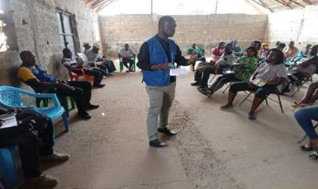  29N UTM 0312687/0692388  Town Hall Meeting held in South Eastern Paynesville (GSA Road)  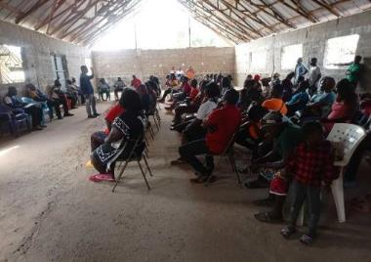  Town Hall Meeting Participants (South Eastern Paynesville) | 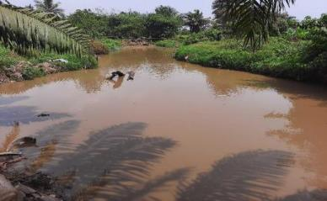  Polluted Stream observed in South-Eastern Paynesville  29N UTM 0313773/0691671  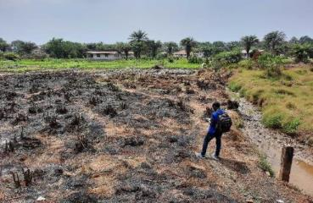Flood-prone area observed (29 N 0314590 UTM 0697009)
Omega Tower Community  Venue: Grace International Christian School Omega Community  Date: February 3, 2022 | 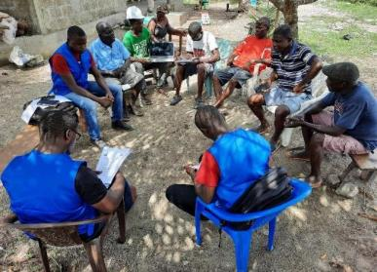  29N UTM 0315359/0696944  FDG Held with the Omega Community Leadership  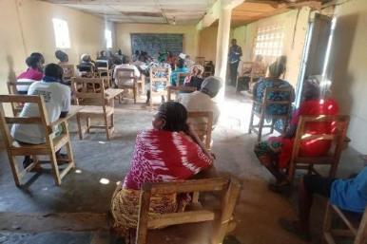  Participants at the Town Hall Meeting in Omega  29 N 0315089 UTM 0696919 | 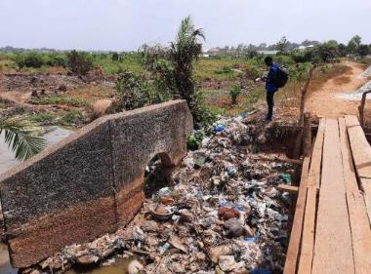  29N UTM 0315760/0696628  Disposal of waste along Drainage Channel  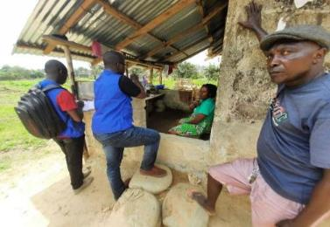  Household survey held in Omega  29 N 0315585 UTM 0696771
Central Monrovia North (Soniwein CBD)  (UN Drive, Soniwein, Buzzy Quarter, Capitol Hill and Redemption Road Communities)  Venue: Buzzy Quarter Town Hall  Date: February 4, 2022 | 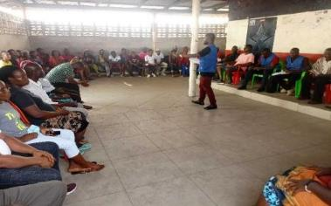  Town Hall Meeting held in Central Monrovia, Soniewein CBD  29N UTM 0315760/0696628  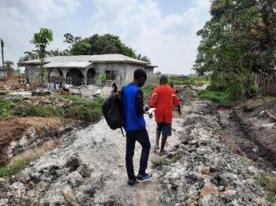  Partial view of a flood-prone area in Central Monrovia  29 N 0315494 UTM 0696944 | 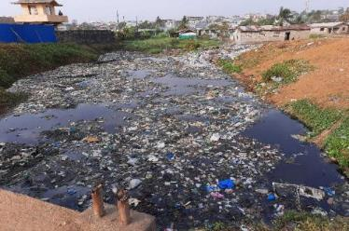  Stagnant Water due to waste disposal observed in Buzzy Quarter  29N 0315760 UTM 0696628  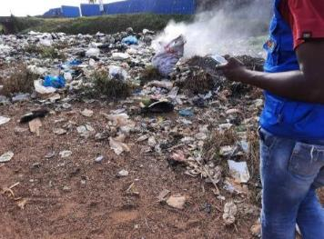  Improper waste management observed in Central Monrovia  29 N 0300856 UTM 0697063
Northern Bushrod Island (New Kru Town, Beer Factory, Duala North, and Logan Town)  Venue: New Kru Town, Town Hall  Date: February 6, 2022 | 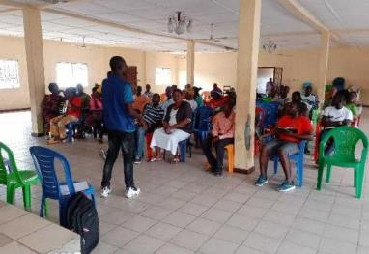  Town Hall Meeting held in Northern Bushrod Island (New Kru Town)  29 N 0301901 UTM 0703973  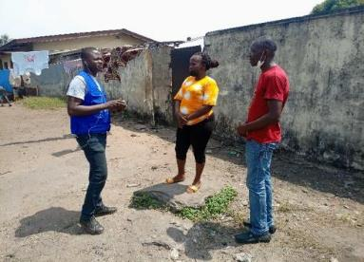  Resident narrating the flood situation in Beer Factory (Northern Bushrod Island) ( 29 N 0314073 UTM 0691831) | 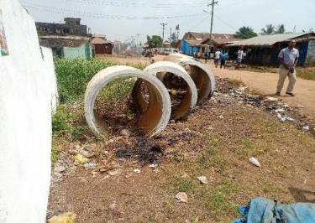  Culverts observed at a Flood-Prone site in New Kru Town  29 N 0301778 UTM 0703660  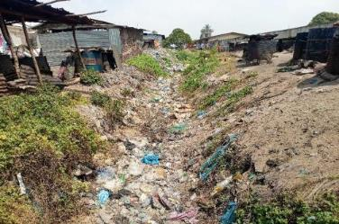  Drainage Channel sighted in Popo Beach (Northern Bushrod Island) (29 N 0301778 UTM 0703660)
Community | KIIs | Women FGDs
Northern Bushrod Island (New Kru Town, Beer Factory, Duala North, and Logan Town) | 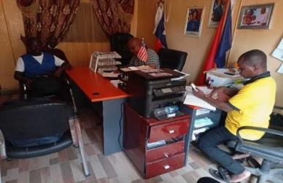  FGD held with the Governor, Borough of New Kru Town  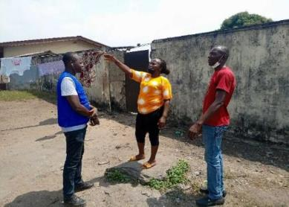  KII held in Northern Bushrod Island | 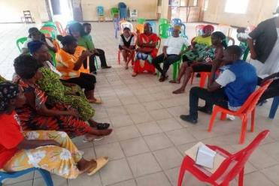  FGD held in Northern Bushrod Island (New Kru Town)  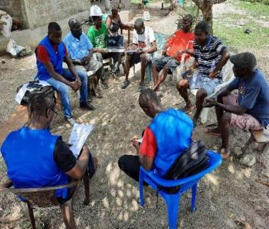  FDG held with the leadership of Omega
Central Monrovia North (Soniwein CBD)  (UN Drive, Soniwein, Buzzy Quarter, Capitol Hill and Redemption Road Communities) | 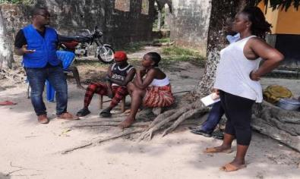  Consultation with Flood victims in South-Eastern Paynesville  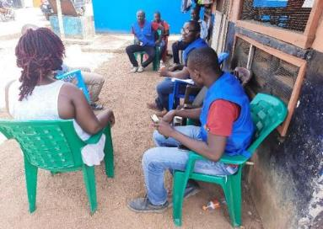  KII held with the Chairlady of GSA Community Block “B”  (South Eastern Paynesville) | 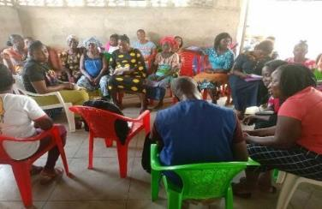  FGD held at Buzzy Quarter Town Hall (Central Monrovia, Soniewein CBD)  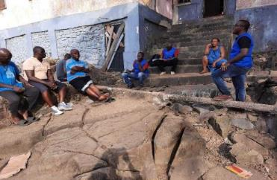  FDG held with the Leadership of Central Monrovia, Soniewein CBD
 | 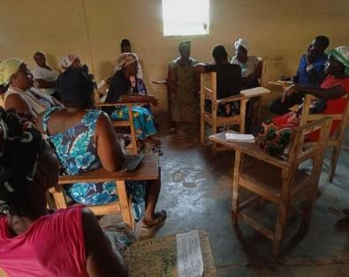  Women FGD held in Omega | 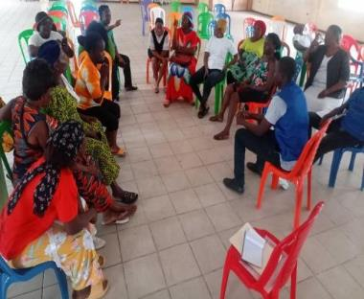  Women FGD held in South-Eastern Paynesville

Annex 3: Outline for preparing RP

Resettlement Plan The scope and level of detail in the resettlement plan will vary with the magnitude of land acquisition and complexity of resettlement. The plan is based on up-to-date and reliable information about (a) the proposed compensation payment and resettlement of adversely affected groups, and (b) the legal issues involved in resettlement. The resettlement plan covers the elements below, as relevant. When any element is not relevant to project circumstances, it should be stated clearly in the resettlement plan.
- Description of the Project. General description of the project and identification of the project area
- Policy and Legal Framework. A presentation of relevant Government of Liberia Policies, laws and regulations governing resettlement, World Bank Policies, as well as a gap analysis of the provisions and how they will be beached.
- Potential impacts. Identification of: (a) the project component or activities that give rise to land acquisition and resettlement; (b) the alternatives considered avoiding or minimizing land acquisition and resettlement; and (c) the mechanisms established to minimize resettlement, to the extent possible, during project implementation.
- Objectives. The main objectives of the resettlement program.
- Results of census socio-economic surveys. The findings of surveys to be conducted in the early stages of project preparation and with the involvement of potentially affected people, including: (a) the results of a census survey; (b) current occupants of the affected area to establish a basis for the design of the compensation payment and resettlement program and to exclude subsequent inflows of people from eligibility for compensation and resettlement assistance; (c) standard demographic and socio-economic characteristics of the affected households; (d) the magnitude of the expected loss - total or partial - of assets and the extent of impact, physical and/or economic; (e) public infrastructure and social services that will be affected; and (f) social and cultural characteristics of affected communities, including a description of formal and informal institutions (community organizations, NGOs, ritual groups, that may be relevant to the consultation strategy and to designing and implementing the resettlement activities.
- Eligibility. Definition of affected persons and criteria for determining their eligibility for compensation and other resettlement assistance, including relevant cut-off dates.
- Valuation of and compensation for losses. The methodology to be used in valuing losses to determine their replacement cost and a description of the proposed types/levels of compensation under local law and such supplementary measures, as are necessary to achieve replacement cost for lost assets.
- Resettlement measures. A description of the package/s of compensation and other resettlement measures that will assist each category of eligible affected persons to achieve the objectives of the policy. In addition to being technically and economically feasible, the resettlement packages should be compatible with the cultural preferences of the displaced persons and must be prepared in consultation with them. Should include any measures necessary to prevent land speculation or influx of ineligible persons at the selected sites.
- Income Restoration Measures. Wherever the livelihoods are affected, appropriate measures for improvement or restoring of livelihoods, including assistance during the transition period, will be proposed which should be compatible with the cultural preference and skill of the affected people.
- Community participation, Consultation and Disclosure. Involvement of affected people for consultation with and participation in the preparation and implementation; (b) a summary of the views expressed and how these views were taken into account in preparing the resettlement plan; (c) a review of the alternatives presented and the choices made by affected persons, wherever options are available to them, including choices related to forms of compensation and resettlement assistance; (d) Project policy RP should be disclosed to the public through various means – print/web sites/documents available at the concerned department offices.
- Integration with host population. Measures to mitigate the impact of resettlement on any host communities, including: (a) consultations with host communities and local governments; (b)arrangements for prompt tendering of any payment due the hosts for land or other assets provided to re-settlers; (c) arrangements for addressing any conflict that may arise between re-settlers and host communities; and (d) any measures necessary to augment services (e.g., water, and production services) in host communities to make them at least comparable to services available to re-settlers.
- Implementation Arrangements: The description of agencies responsible for implementation of compensation payment and resettlement activities should be outlined and an assessment of the institutional capacity of such agencies and NGOs should be made, including identification of any steps that would be required to enhance the institutional capacity of agencies responsible for resettlement implementation.
- Grievance procedures. Affordable and accessible procedures for redressed of disputes arising from resettlement - such grievance mechanisms should also take into account the availability of judicial recourse.
- Implementation schedule. Implementation schedule covering all payments of compensation and other applicable resettlement activities from preparation through implementation, including target dates for the achievement of expected benefits to re-settlers and hosts and terminating the various forms of assistance. The schedule should indicate how the resettlement activities are linked to the implementation of the over-all project.
- Costs and budget. Tables showing itemized cost estimates for all compensation payments and associated resettlement activities other contingencies; timetables for expenditure; sources of funds; and arrangements for timely flow of funds and funding arrangements for land acquisition and resettlement should be described.
- Monitoring and evaluation. Arrangements for monitoring of compensation payments and resettlement activities by the implementing agency, supplemented by independent monitors, as considered appropriate by the Bank, to ensure complete and objective information; performance monitoring indicators to measure inputs, outputs, and outcomes for resettlement activities; evaluation of the impact of resettlement for a reasonable period after all resettlement and related development activities have been completed; using the results of resettlement monitoring to guide subsequent implementation.

Annex 4: Census Assessment of Structure Form
Name of Representative: |  |  | Valuer:
Signature of Representative: |  |  | Interview Date:
Phone Number: |  |  | Structure Code:
Community: |  |  | GPS coordinates:
Total Area |  | Affected Area
Length | Width | Length |  | Width

- Structure Type: ( )Residential ( )Commercial ( )Monument ( )Billboard ( )Grave ( )septic tank ( )hand pump ( )water well

- If commercial, what is it used for? ( ) Commercial Apartment ( ) Office Space ( ) Business Center (shop, supermarket)

- Number of stories / floors ( ) Flat ( ) One Storey ( ) Two Storeys ( ) Three Storeys ( ) 4 Storeys

- Main material used on outer wall ( ) Dubbed mud house ( ) Dirt Brick ( ) Dirt brick and concrete ( ) Concrete ( ) Wood ( ) Zinc

- Main material used for roof ( ) Thatch ( ) Metal sheet/Zinc ( ) Decra/Onduline/Aluminum /28-guage channeled zinc ( ) Concrete ( )Others (Specify)

- Main material used for window ( ) Aluminum framed/ glass ( ) jalousie windows ( ) wood ( ) zinc ( ) decorative blocks (concrete ( )Others (Specify)

- Main material on the floor ( ) Mud ( ) concrete ( ) terrazzo or vinyl tiles ( ) ceramic tiles /marble ( ) wood ( )Others (Specify)

- Ceiling type ( ) plywood ( ) mat ( ) POP ( ) timber/wood ( ) none

- Door Type ( )Panel/plywood ( ) Panel /steel ( ) Glass /steel

- Number of Rooms ( )

- Number of Bathroom ( )

- Foundation
COMPLETE |  | INCOMPLETE
Length | Width | Length | Width

- Fence
Height
Length

- Warehouse ( ) Yes ( ) No
Reinforced concrete framed structure, usually with cast roof and concrete floor.
Concrete blocks structure with zinc roof and concrete floor.
Concrete foundation with prefab structures and roof or zinc.

- Shed ( ) Yes ( ) No
Channeled zinc roof, concrete floor with sides close with concrete block
Channeled zinc roof, concrete or laterite floor with open sides
Thatch roof, concrete or laterite floor with open sides

- Status of Land ( ) RoW ( ) Private Land

Annex 5: Land Tenure Assessment Form

Name of Respondent: |  | Valuer:
Signature of Respondent: |  | Date:
Phone Number: |  | Structure Code:
Community: |  | GPS coordinates:
Affected Area of Land
Length | Width

Land Tenure

- How long have you lived here?
(1).1- 5 years |  | (2).6- 10 years |  | (3).11- 20 years |  | (4).21- 30 years |  | (5).30 years above

- Status of Land ownership?
Customary | Statutory | Squatter | Caretaker

- Are you the Title holder of the Land?
Yes |  | No

- If not the owner, who is the Title holder of the Land?
Name of title holder

- Telephone number of Land owner ___________________

- what is the size of the land?

- If owner, how did you acquire the land, Processes?

F7. Besides this land, do you have another land?
1). Yes |  | 2). No

F8. If final decisions were made and your property is to be impacted, how would you want to be compensated?
1). Cash Compensation |  | 2). Land for Land

F10. If Cash compensation, why do you prefer this option?

Annex 6: Assessment of Grave and Tree Crop

Name of Representative: | Valuer:
Signature of Representative: | Date:
Phone Number: | Code:
Community: | GPS coordinates:

- Grave: Yes ( ) No ( )

- Grave Type ( ) Dirt ( ) Concrete ( )Tiled

- Number of Graves
Dirt Grave | Concrete Grave

- Tree Crop

Crop / Tree | Quantity / Area | Description/Condition (In production/ Immature/ Out of Production) | Affected Land Status (RoW/ Private) | Affected Land Area
***If located on private land, complete the Land Tenure Form for land acquisition

Annex 7: Socio-economic Baseline Data Collection Form

SOCIO-ECONOMIC BASELINE STUDY

Q1 GENERAL INFORMATION /INFORMATION GENERAL

Fieldworker note: Explain that this questionnaire is aimed at households. A household is herewith defined as all the members who consider themselves to be part of this house. These members usually eat and sleep in the same house at least once a week. However, this also includes people who may not live here all the time, but continue to be part of the home by returning to it and contributing resources to it; the people for whom this is home.

  - Fieldworker first name only
1.2 Community | Northern Bushrod Island | Central Monrovia, Soniwein CBD | South-eastern Paynesville |  | Omega Market
1.3 Date (automatic)
1.5 Gender | Male |  |  | Female
1.5 Age
1.6 Ethnicity | Kpelle | Mano | Gio |  | Lorma
 | Kissi | Belle | Mandigo |  | Kru
 | Grebo | Mande | Gbandi |  | Dei
 | Bassa | Gola | Vai |  | Krahn
1.8 Religion | Christianity | Muslim | Traditional Belief |  | Other
1.9 Education status | Primary Education | Secondary Education | Tertiary Education |  | No formal education
 | Vocational Training
1.10 Household Position | Household Head (HH) | Spouse of HH | Son/daughter of HH |  | Son-in-law/daughter-in-law of HH
 | Grandchild of HH | Parent of HH | Brother/sister of HH |  | Nephew/niece
 | Brother/sister-in-law of HH | Cousin of HH | Adopted/foster/step child |  | Other
1.11 Source of Income | Farming/ Agriculture | Contractor/Laborer | Profession (Teacher, Baker, Plumber, etc.) |  | Business
 | Family support | Gov’t/NGO Worker | I don’t know |  | Other (specify)
1.12 Occurrence of Flooding | Yes |  | No
Most Potential Hazard | Fire Hazard | Flooding | Prevalence of water borne diseases |  | Unsanitary conditions of the Communities
Q2 LIVING HOUSE STRUCTURE OWNERSHIP

2.1 Are some people in this household planning to leave this village/town | Yes |  |  | No
2.2 [If yes] Why do they want to leave
2.3 House structure | Concrete Bricks |  | Dirt/Mud Brick | Zinc | Mud stock
2.4 Do you rent this house | Yes |  |  | No
2.5 [If yes] for how much per month
2.6 Land ownership on which the living house structure is build | Obtained land ownership from traditional authority |  | Obtained land ownership through inheritance/family |  | Purchase land from Private Owner
 | Occupying the plot independently |  | Renting/leasing |  | Purchased land from government
Other (specify)
2.7 If applicable, how do you pay for the land on which your living house is built |  | Cash payment once off | Cash payment over time |  | Other (specify)
2.8 If applicable, how much cash did pay for the land

Q3 HOUSEHOLD COMPOSITION TABLE AND SOCIO-ECONOMIC PROFILE

In this next section we would like to find out some information about all the people that live in this household. Explain that this questionnaire is aimed at households. A household is herewith defined as all the members who consider themselves to be part of this house. These members usually eat and sleep in the same house at least once a week. However, this also includes people who may not live here all the time, but continue to be part of the home by returning to it and contributing resources to it; the people for whom this is home.

No | Name | Relation  to HH  (Refer to Column A below) | Disabled (this does not mean general illnesses such as malaria, headaches etc.)  Yes/No | Gender | Age | Residence status (refer to column B below) | Highest education  refer to column C below) | If tertiary, explain & where | Current occupation; refer to column D below | If formally employed, where

Q4 HOUSEHOLD LIVING CONDITIONS

We’d now like to talk about the services that this household has access to and uses.

4.1 PRIMARY ENERGY SOURCE (select more than one)
4.1.1 Sources of energy for cooking |  |  | Wood |  |  |  |  |  | Charcoal |  |  |  |  |  |  |  |  |  | Kerosene |  |  |  |  |  |  |  |  |  |  | Generator
Solar panel |  |  | Battery |  |  |  |  |  |  |  |  |  |  | Lantern |  |  |  |  |  |  |  |  |  |  |  |  |  | Candles
LEC/Commercial electricity |  |  | Other (specify)
4.2 DRINKING WATER
4.2.1 Household drinking water |  |  |  |  |  | Tank |  |  |  |  |  |  | Well with hand pump |  |  |  |  |  |  |  |  |  |  |  | Borehole without hand pump |  |  |  |  |  |  |  |  |  | Tap
Spring | Stream / river |  |  |  |  |  |  | Creek |  |  |  |  |  |  |  |  | Other: specify
4.2.2 Water quality |  |  |  |  |  | Always drinkable |  |  |  |  |  |  |  |  |  |  |  |  |  |  |  |  | Sometimes dirty, but always drinkable
Always dirty and sometimes undrinkable |  |  |  |  |  |  |  |  |  |  |  |  |  | Always dirty and needs purification
4.2.3 Do you think you have sufficient drinking water |  |  |  |  |  |  | Yes |  |  |  |  |  |  |  |  |  |  |  |  |  |  | No
4.3 SANITATION (circle one option)
4.3.1 Principal toilet used for household |  |  |  |  | Bushes/forest |  |  |  |  |  |  |  |  |  |  |  |  |  |  |  |  |  |  | Pit latrine
Flush toilet/septic tank/sewerage system
4.4 WASTE DISPOSAL (circle one option)
4.4.1 Waste disposal system |  |  |  |  |  | Bury waste |  |  |  | Burn waste |  |  |  |  |  |  |  |  |  |  | Compost waste |  |  |  |  |  |  |  | Feed waste to livestock
Central Waste Landfall |  | Private landfill |  |  |  |  |  |  |  | Throw in the bush |  |  |  |  |  |  |  |  |  |  | Other (specify)
4.5 TRANSPORT AND COMMUNICATION
4.5.1 What is the method of transport your household uses daily |  |  |  |  |  |  |  |  |  |  |  |  |  |  |  | Bicycle |  |  |  |  |  |  |  |  |  | Walking |  |  |  |  |  |  | Motorbike
 |  |  |  |  |  |  |  |  |  |  |  |  |  |  |  | Bus |  |  |  |  |  |  |  |  |  | Taxi |  |  |  |  |  |  | Kehkeh
Accessibility of road in PCAs to market |  |  |  |  |  |  |  |  |  |  |  |  |  |  |  | Partially accessible |  |  |  |  |  |  |  |  |  | Inaccessible |  |  |  |  |  |  | Accessible
Other:
4.5.3 Where does your Community receive important news from |  |  |  |  |  | Radio |  |  |  |  | TV |  |  |  | Chiefs |  |  |  |  |  |  | Politic administrative authority |  |  |  |  |  |  |  |  | Community members |  |  |  |  | Other (specify)
4.6 MARKETS
4.6.1 Which market do you go to for your groceries/food stuffs |  |  |  |  |  | Redlight |  |  |  |  |  |  |  |  |  |  |  | Gobachop |  |  |  |  |  |  |  |  |  |  |  |  |  |  |  |  |  | Duala
 |  |  |  |  |  | Omega |  |  |  |  |  |  |  |  |  |  |  | Joebar |  |  |  |  |  |  |  |  |  |  |  |  |  |  |  |  |  | Other (specify)
4.6.2 How often do you go there |  |  |  |  |  | Daily |  |  |  |  |  |  |  |  |  |  |  | Weekly |  |  |  |  |  |  |  |  |  |  |  |  | Monthly)
4.6.3 Who normally collects the groceries |  |  |  |  |  | Men |  |  |  |  |  |  |  |  |  |  |  | Women |  |  |  |  |  |  |  |  |  |  |  |  |  | Children
4.6.4 Which transport/medium do you used to get to the market |  |  |  |  |  |  |  |  |  |  |  |  |  |  |  |  |  | Bicycle |  |  |  |  |  |  |  |  |  |  |  |  |  | Walking
Motorbike |  |  |  | Kehkeh |  |  |  |  |  |  |  |  |  |  |  |  |  | Bus |  |  |  |  |  |  |  |  |  |  |  |  |  | Taxi
4.7 SCHOOLS
4.7.1. Are children attending primary school in your household |  |  |  |  |  | Yes |  |  |  |  |  |  |  |  |  |  |  |  |  |  |  |  |  | No
4.7.3 How do the children get to the school |  |  |  |  |  | Walk |  |  |  |  |  | Bicycle |  |  |  |  |  |  |  | Taxi |  |  |  |  |  |  |  |  |  |  | Other: specify
4.7.4 After primary school, will the children in your household attend secondary school |  |  |  |  |  |  |  |  |  |  |  |  |  |  |  |  |  |  |  |  |  |  |  |  |  |  | Yes |  |  |  |  |  |  | No |  | Do not know
4.7.5 If no, why not

4.8 HOUSEHOLD FERTILITY AND MORTALITY
4.8.1 How many babies were born in your household in the last 12 months
4.8.2 How many babies (1 year or less) in your household died in the last 12 months
4.8.3 What were the primary reasons for these deaths
4.8.4 How many people (excluding babies 0-1 years old) died in the last 12 months
4.8.5 What were the primary reasons for these deaths
4.9 Food security
4.9.1Can you list exactly the farm crops or garden you and or household has
Beans/nuts/peanuts |  |  |  |  |  |  |  |  |  | No Farm |  |  |  |  |  |  |  |  | Vegetables
Corn |  |  |  |  |  |  |  |  |  | Cabbage |  |  |  |  |  |  |  |  | Maize
Cassava |  |  |  |  |  |  |  |  |  | Rice |  |  |  |  |  |  |  |  | Sweet potatoes
Water greens |  |  |  |  |  |  |  |  |  | Palava sauce |  |  |  |  |  |  |  |  | Others:
4.9.2 Does your household share food with other households |  |  |  |  |  |  |  |  |  |  |  |  |  |  |  |  |  | Yes |  |  | No
4.9.3 Does your household obtain food from someone else’s household |  |  |  |  |  |  |  |  |  |  |  |  |  |  |  |  |  | Yes |  |  | No
4.9.4 Do you often buy food or do you only get food from your farm |  |  |  |  |  |  |  |  |  |  |  |  |  |  |  |  |  | Buy food only |  |  | Farm |  |  | Both
4.9.5 Did your household go hungry in the last 12 months |  |  |  |  |  |  |  |  |  |  |  |  |  |  |  |  |  | Yes |  |  | No
4.9.6 [Yes] What were the reasons for this
4.9.7 Please indicate during which months your household went hungry
Jan | Feb | March |  | Apr | May |  |  | Jun |  |  | Jul |  | Aug |  |  |  | Sep |  |  | Oct |  | Nov |  |  | Dec
Q5 HOUSEHOLD INCOMES AND EXPENDITURES
5.1 What is your households’ greatest income source in general (name one) |  |  | Agriculture |  |  |  | Profession (Carpenter, masonry) |  |  |  |  |  |  | NGO/Gov’t Worker
 |  |  | Business |  |  |  | Laborer |  |  |  |  |  |  | Donations
 |  |  | Livestock |  |  |  |  |  |  |  |  |  |  | Other (specify)
5.2 Do you spend money on food, or do you get most of your food from your own agricultural field |  |  | Spend money on food |  |  |  |  |  | Get food only from own agricultural field
 |  |  | Both
5.3 On what item do you spend the most (choose one; don’t prompt) |  |  | Food |  |  | Healthcare |  |  |  | Education |  |  |  |  | Clothes
Household material |  |  | Transport |  |  | Ceremonies |  |  |  | Funerals |  |  |  |  | Other (specify)
5.4 Can you tell me whether your household received money from the following sources in the last month (remember this refers to whether anyone in the household received money)
5.4.1 Formal employment receiving a monthly salary |  |  |  |  |  |  |  |  |  |  |  | Yes/No |  |  |  | Local Currency |  | Not sure how much
5.4.2 Receiving an income from farming (selling produce)
5.4.3 Receiving an income from sand mining
5.4.4 Receiving an income hard labour, example (crush rocks)
5.4.6 Selling fish
5.4.9 Fruits and plants from planted trees
5.4.10 Donations/money from family members
5.4.11 Selling charcoal
5.4.15 Informal piece jobs (driver/handyman etc.)

Annex 8: Structure Compensation Matrix

Republic of Liberia Ministry of Public Works Lynch Street

Monrovia, Liberia

MINISTRY OF PUBLIC WORKS APPROVED PRICE LIST FOR AFFECTED PROPERTIES FOR DEVELOPMENT PROJECTS
No. | Structure Type | Main Outer Wall | Main Roofing Material | Main Window Material | Main Floor  Material | Ceiling Type | Door Type | Cost Range  (per sq. ft.)
1 | Residential/ Commercial | Concrete/ Storey Build. | Decra/Onduline/ Aluminum/ 28-  gauge channeled zinc/ concrete | Aluminum Framed/glass | Porcelain tiles/  marble | plywood | panel/ steel | $30.00 - $40.00
2 | Residential/ Commercial | Concrete Wall | Decra/Onduline/ Aluminum/ 28- gauge channeled zinc/ concrete | Aluminum Framed/glass | ceramic/Terrazo/ Vinyl tiles | plywood | panel/ steel | $20.00 - $30.00
3 | Residential/ Commercial | Concrete Wall | Metal Sheet/zinc | Jalousie Window/ Wood/ Decorative Blocks | Concrete/ Terrazo/ vinyl tiles | plywood/ mat | plywood/ Panel | $20.00 - $25.00
4 | Residential/ Commercial | Dirt Brick & Concrete | Metal Sheet/zinc | Jalousie Window/ Wood/ Decorative Blocks | Concrete/ Terrazo  / Vinyl tiles | plywood | Wood/ plywood | $10.00 - $12.00
5 | Residential/ Commercial | Dirt Brick Unplastered | Metal Sheet/zinc | Wood/ Decorative Blocks | Concrete | plywood/ mat | Wood/ plywood | $6.00 - $8.00
6 | Residential/ Commercial | Dubbed Mud | Metal Sheet/zinc | Wood/ Zinc | Mud/Concrete | None/mat | Wood/ plywood | $5.00 - $7.00
7 | Residential/ Commercial | Dubbed Mud | Thatch | Wood/ Zinc | Mud/Concrete | None/mat | Wood/ plywood | $4.00 - $5.00
8 | Residential/ Commercial | Wooden | Zinc | Wood/Zinc | Wood | None/Mat | Wood/ plywood | $2.50 - $3.50
9 | Residential/ Commercial | Zinc Framing |  |  |  |  |  | $8.00 - $10.00
10 | Foundation/slab |  |  |  |  |  |  | $5.00-15.00
11 | Concrete Fence/B. Wire |  |  |  |  |  |  | $10.00 - $12.00
12 | Concrete Fence only |  |  |  |  |  |  | $7.50 - $10.00
13 | Hand pump |  |  |  |  |  |  | $3600.00 - $4000.00
14 | Well with culverts |  |  |  |  |  |  | $1,500.00
15 | Well without culverts |  |  |  |  |  |  | $540.00
16 | Grave/ Concrete |  |  |  |  |  |  | $900.00
17 | Grave/ Earth |  |  |  |  |  |  | $500.00

18 | Grave/ Tiles |  | $1,500.00
19 | Grave with shelter |  | $1,800.00
20 | Retaining wall |  | $3.50 - $5.00
21 | Pavement |  | $3.50
22 | Monument without engraving |  | $500.00
23 | Monument engraving |  | $350.00
24 | Shed | Channeled zinc roof, Ceramic Tile floor with sides close with concrete block | $5.00
 |  | Channeled zinc roof, concrete floor with sides close with concrete block | $3.50
 |  | Channeled zinc roof, concrete floor with sides close with wood | $3.00
 |  | Channeled zinc roof, concrete or laterite floor with open sides | $2.50
 |  | Thatch roof, concrete or laterite floor with open sides | $2.00
25 | Warehouse | Reinforced concrete framed structure, usually with cast roof and concrete floor | $35.00 - $40.00
 |  | Mud bricks structure with zinc roof, steel trusses and concrete floor | $10.00 - $12.00
 |  | Concrete blocks structure with zinc roof, steel trusses and concrete floor | $20.00 - $25.00
 |  | Concrete foundation with prefab structures and roof or zinc. | $10.00

Annex 9: Land Valuation Guide
Revision of Real Estate Tax, Ministry of Finance - Land Valuation Determination Guide (Based on Market Intelligence)

Land Valuation Average Market Value for Tax Determination (Based on Market Intelligence) |  |  | Land Tax Calculation as the Stated Rate of 7% on the Asset Value
 | Location/Description | Average minimum Value on  Vacant Land | Tax per Year in (U.S.D.) | Tax per Year in (L.D. @  105.00)
Central Monrovia
 |  |  | 2% | 120.00
Class A | Along the Broad Street and Mamba Point, Capitol Hill | 50,000.00 | 1,000.00 | 120,000.00
Class B | Along the Carey, Ashmun and Benson Streets | 30,000.00 | 600.00 | 72,000.00
Class C | Other Parts of Central Monrovia not in Class A & B | 20,000.00 | 400.00 | 48,000.00
Sinkor (Ocean View)
Class A | First Blocks South of the Tubman Boulevard, Warner  and Payne Avenue | 40,000.00 | 800.00 | 96,000.00
Class B | Second Blocks South of the Tubman Boulevard,  excluding Payne Avenue | 25,000.00 | 500.00 | 60,000.00
Class C | Third Blocks and Beach Front South of the Tubman  Boulevard | 15,000.00 | 300.00 | 36,000.00
Sinkor (North of Tubman Boulevard to Russell Avenue)
Class A | First Blocks along Tubman Boulevard, Warner | 40,000.00 | 800.00 | 96,000.00
Class C | Lots between First Lots North of Tubman Boulevard  and Rusell Avenue | 20,000.00 | 400.00 | 48,000.00
Class D | First Lots along Rusell Avenue | 10,000.00 | 200.00 | 24,000.00
Other Parts of Sinkor not mentioned above (Saye Town, Jallah Town, ICA Camp, Plunkor, Fiamah, Pyne People, Fish Market
Class E | Front Lots | 5,000.00 | 100.00 | 12,000.00
Class F | Back Lots | 3,000.00 | 60.00 | 7,200.00

Class G | Swamp Lots | 2,000.00 | 40.00 | 4,800.00
Congo Town (Old Road)
Class E | Lots Along the Tubman Boulevard | 5,000.00 | 100.00 | 12,000.00
Class F | Other Front Lots | 3,000.00 | 60.00 | 7,200.00
Class G | Back Lots | 2,000.00 | 40.00 | 4,800.00
Class H | Swamp Lots | 1,500.00 | 30.00 | 3,600.00
Paynesville, Gardnesville, Bardnesville, & New Georgia
Class G | Lots Along the Main Paved Street such as Somalia  Drive | 2,000.00 | 40.00 | 4,800.00
Class H | Other Front Lots | 1,500.00 | 30.00 | 3,600.00
Class I | Back Lots | 1,000.00 | 20.00 | 2,400.00
Class L | Swamp Lots | 500.00 | 10.00 | 1,200.00
Brewerville, Virginia, Cardwell, & Johnsonville
Class H | Lots Along the Main Paved Street | 1,500.00 | 30.00 | 3,600.00
Class I | Other Front Lots | 1,000.00 | 20.00 | 2,400.00
Class J | Back Lots | 800.00 | 16.00 | 1,920.00
Class M | Swamp Lots | 400.00 | 8.00 | 960.00
Bushrod Island (Via Town to St. Paul Bridge)
Class D | Lots Along the Main Paved Street (U.N. Drive) | 10,000.00 | 200.00 | 24,000.00
Class E | Other Front Lots | 5,000.00 | 100.00 | 12,000.00
Class G | Back Lots | 2,000.00 | 40.00 | 4,800.00
Class I | Swamp Lots | 1,000.00 | 20.00 | 2,400.00
Upper Montserrado (Lousiana Arthington, Todee, Careysburg, Bensonville, etc.)
Class K | Lots Along the Main Paved Street | 600.00 | 12.00 | 1,440.00
Class L | Other Front Lots | 500.00 | 10.00 | 1,200.00
Class N | Back Lots | 350.00 | 7.00 | 840.00
Class O | Swamp Lots | 200.00 | 4.00 | 480.00
Outside Montserrado County (Margibi, Grand Bassa, Nimba, & Maryland)
Class O | Administrative Centers | 200.00 | 4.00 | 480.00
Class Q | Other Major Cities and Economic Zones | 100.00 | 2.00 | 240.00

Class S | Towns and Urbanized Villages | 50.00 | 1.00 | 120.00
Outside Montserrado County (Cape Mount, Bomi, & Grand Gedeh)
Class P | Administrative Centers | 150.00 | 3.00 | 360.00
Class Q | Other Major Cities and Economic Zones | 100.00 | 2.00 | 240.00
Class S | Towns and Urbanized Villages | 50.00 | 1.00 | 120.00
Outside Montserrado County (Sinoe, Rivercess, Kru, Gbarpolu, & Gee)
Class Q | Administrative Centers | 100.00 | 2.00 | 240.00
Class R | Other Major Cities and Economic Zones | 75.00 | 1.50 | 180.00
Class S | Towns and Urbanized Villages | 50.00 | 1.00 | 120.00
Undeveloped Farmland above Five (5) Acres
Class I-1 | Paynesville, Gardnesville, Bardnesville, & New  Georgia | 1,000.00 | 100.00 | 12,000.00
Class L-1 | Brewerville, Virginia, Cardwell, & Johnsonville | 500.00 | 50.00 | 6,000.00
Class Q-1 | Upper Montserrado | 100.00 | 10.00 | 1,200.00
Class S-2 | Urban Areas outside Montserrado County | 30.00 | 3.00 | 360.00
Developed Farmland above Five (5) Acres
Class G-1 | Paynesville, Gardnesville, Bardnesville, & New  Georgia | 2,000.00 | 100.00 | 12,000.00
Class I-2 | Brewerville, Virginia, Cardwell, & Johnsonville | 1,200.00 | 60.00 | 7,200.00
Class O-1 | Upper Montserrado | 200.00 | 10.00 | 1,200.00
Class S-1 | Urban Areas outside Montserrado County | 50.00 | 2.50 | 300.00

Annex 10: Tree Crop Compensation Matrix

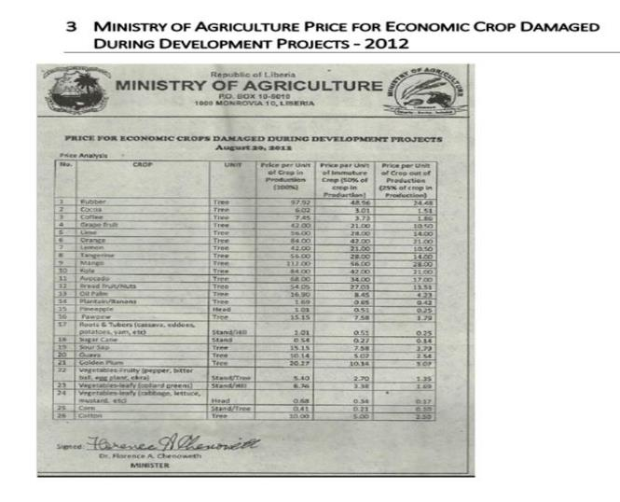

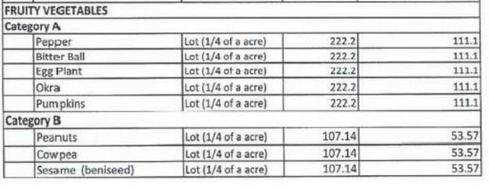
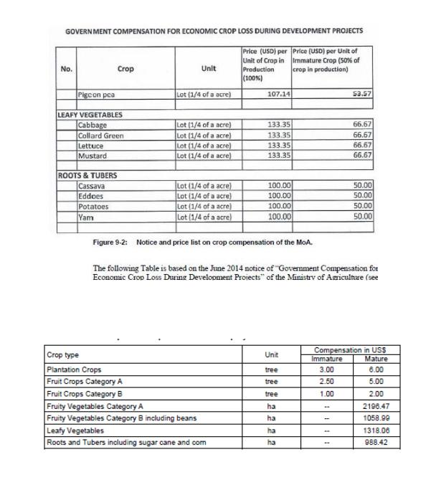

Annex 11: Grievance Log

Reference No. ______________________ Project Title: _______________
Full Name
Contact Details | Cell #:
 | Email:
 | Town/Farm
 | County: Montserrado
Category of Grievance | Land Acquisition: |  |  | Compensation
 | Construction: |  | Tree Crop |  | Other
Grievance/ Issue/ Complaint | Description
Date Incident Occurred |  | Location Incident Occurred
What would you like to see happen to resolve the problem

My identity can be disclosed
I wish to raise my grievance anonymously
I request disclosure of my identity, with my consent
Received by:
Date

Actions Taken

ACTION | OUTCOME | DATE
1st Action Taken: | Outcome: | Date:
2nd Action Taken: | Outcome: | Date:
3rd Action Taken: | Outcome: | Date:
4th Action Taken: | Outcome: | Date:
5th Action Taken: | Outcome: | Date:

Resolved
Not Resolved

Annex 12: RP Verification Form

REPUBLIC OF LIBERIA MINISTRY OF PUBLIC WORKS

PHOTO
SOUTH, LYNCH STREET MONROVIA, LIBERIA

RP DISCLOSURE FORM FOR AFFECTED PROPERTY ASSESSMENT
Liberia Urban Resilience PROJECT (LURP)

DATE: |  | LOCATION |  | CODE:
NAME: |  |  |  | SEX: | Male | Female

Type of Structure | Fully Affected | /Partially Affected | Length | Width/  Height | Dimension  (sq. ft.) | Rate  (USD)
 | FA | PA

Summary of Resettlement Package | Total (USD)
Total Cost of Affected Structure | -
Total Compensation for Relocation Assistance | -
Total Compensation for Loss of Business Income | -
Total Compensation for Rental Tenant | -
Total Compensation for Rental Landlord | -
Private Land Acquisition | -
Total Compensation for Vulnerable Persons-( Blind Cripple  Deaf/Mute Sick other Specified: ) | -
Total Compensation for Female Household Head/Widow | -
Processing of Attestation Cost Refund | -
GRAND TOTAL | -

1. Copy of your proof of ownership attached (Structure owner only)? | YES ( ) | NO ( )
2. Passport-sized photos attached (all Project Affect Persons)? | YES ( ) | NO ( )

Signed by: | Project Affected Person |  | Contact Number of Project Affected Person
Verified by: | Director, ESAFE Division, MPW | Verified by: | Auditor, MPW
Name: |  | Name:
Verified by: | Property Evaluators MPW | Verified by: | Zoning Officer  Project Coordinator Safeguard Officer
Name: |  | Name:

Annex 13: Payment Form

Ministry of Public Works
Lynch Street
Monrovia, Liberia

PROJECT AFFECTED PROPERTY COMPENSATION FORM

Date: Structure Code:

PHOTO | OWNER’s NAME
 | SEX
 | TOTAL AMOUNT (USD)
 | CHECK NUMBER
I, the undersigned, do accept and receive the sum above from the Government of Liberia by and through the Ministry of Public Works as resettlement package for my affected property that will be demolished for the Liberia Urban Resilience Project (LURP), Greater Monrovia Region, Liberia. I do hereby release, acquit and forever discharge to the GOL/MPW, their successors, assigns, agents, servants, employees and any other person (s) of any and all claims, present and future, to be made by me, my successors, assigns, agents, servants, employees, and any other person(s) acting on my behalf arising out of my relocation and/or assessed payment from the affected area mentioned above.

Received on this day of A.D. 20______.

BENEFICIARY FINGERS IMPRESSION
THUMB | INDEX FINGER | MIDDLE FINGER | RING FINGER | LITTLE FINGER

Signed by: Cell #: __ Affected Property Owner’s Name

Paid by: Paid by: __
Financial Management & Control Division, MPW Internal Audit Division, MPW

Paid by:
ESAFE Division, MPW

Annex 14: Attendance Log From Public Participation
Attendance Log- Southeastern Paynesville
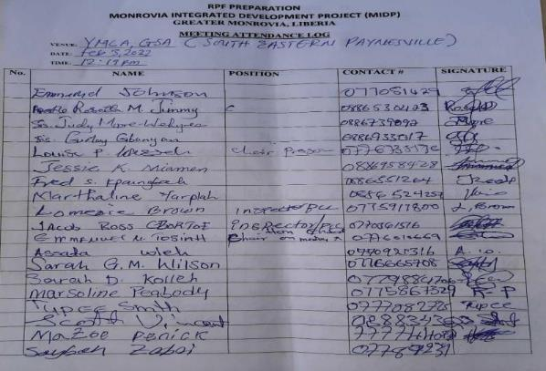
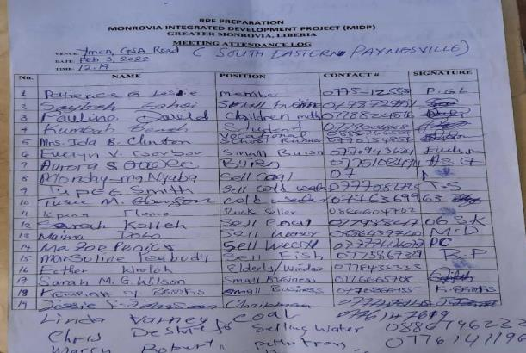
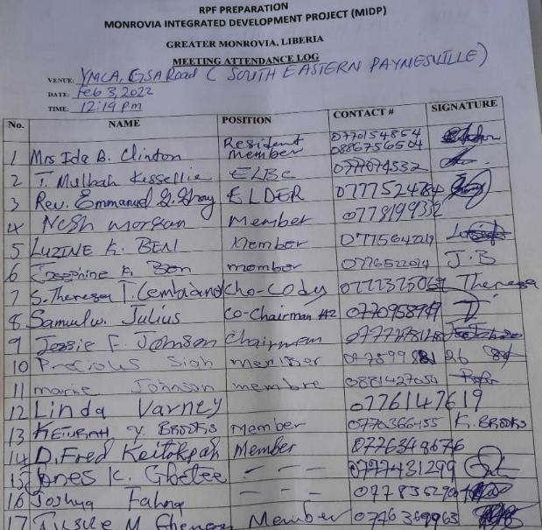
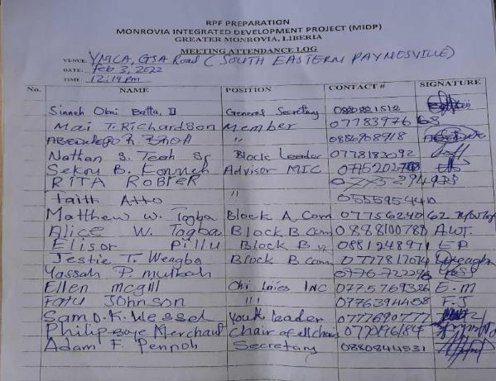
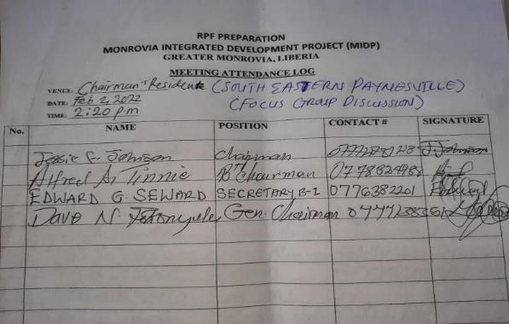
Attendance Log: Omega
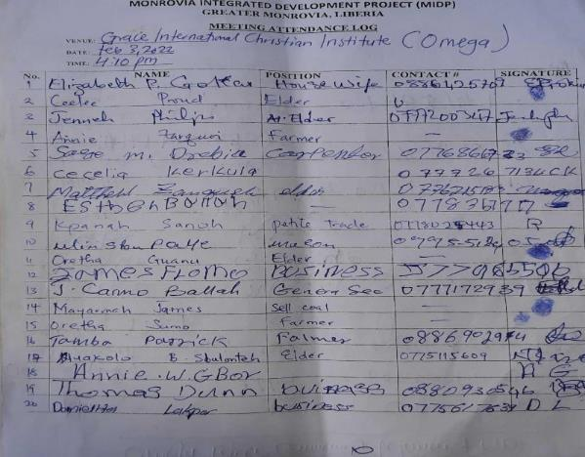
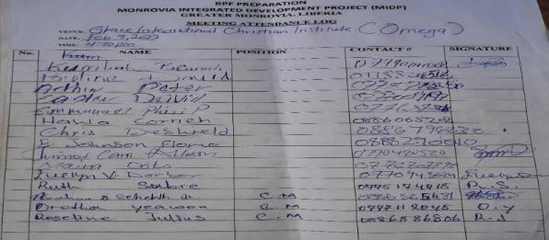

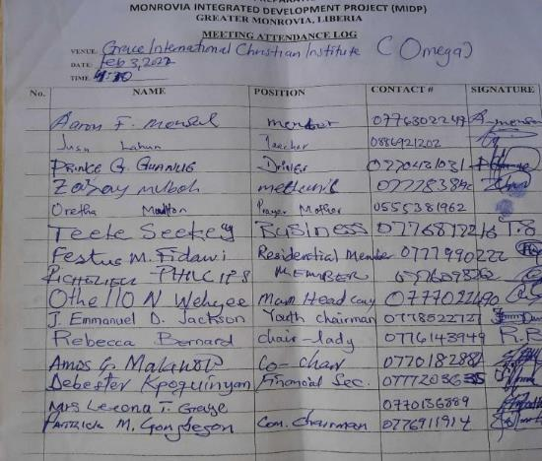
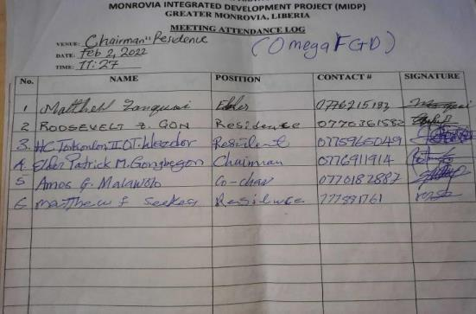
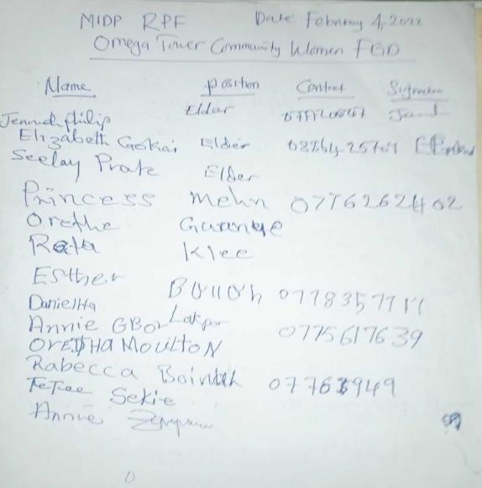
Attendance: Central Monrovia
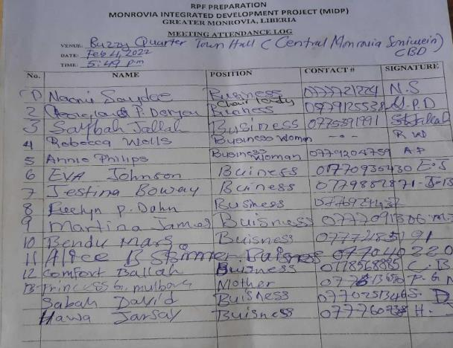
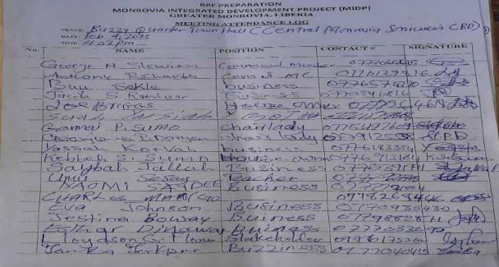
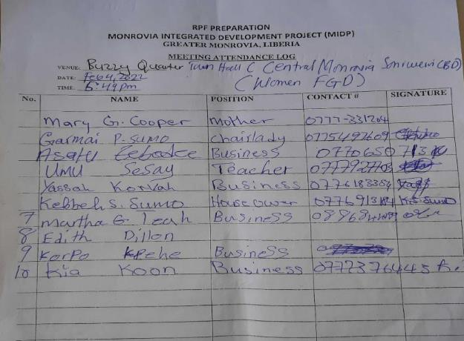
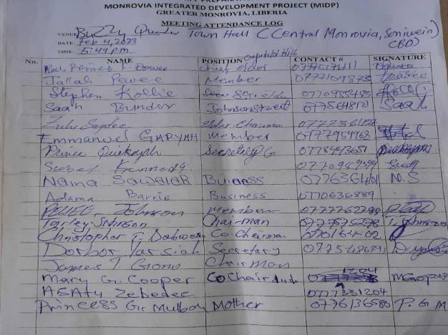
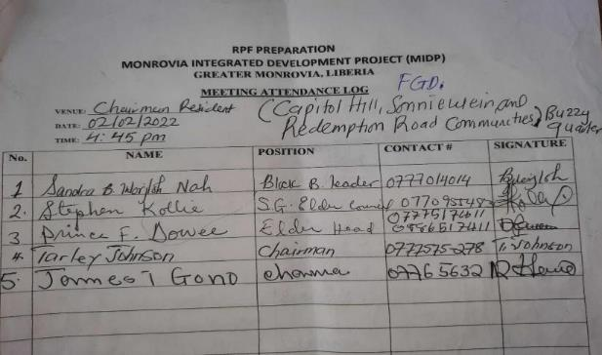
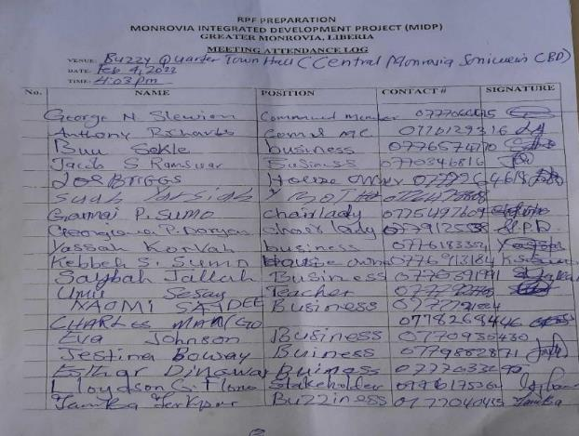

Attendance: Northern Bushrod Island
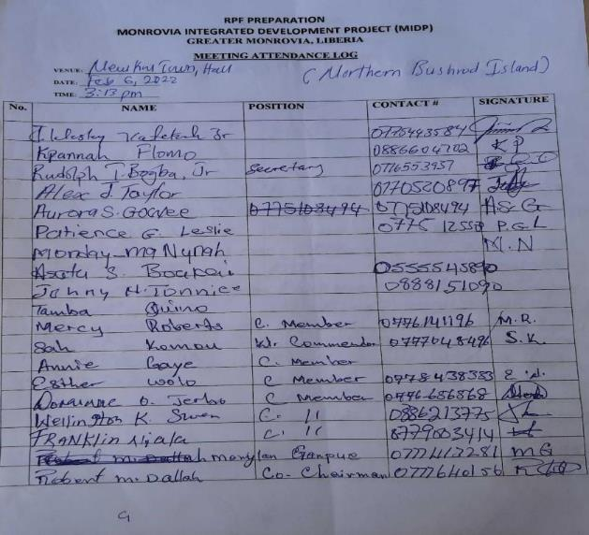
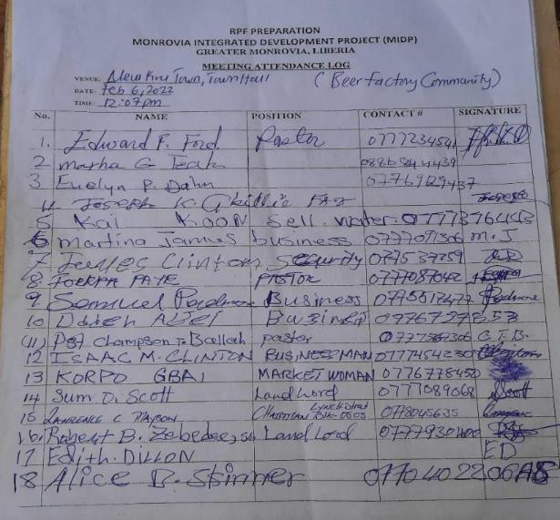
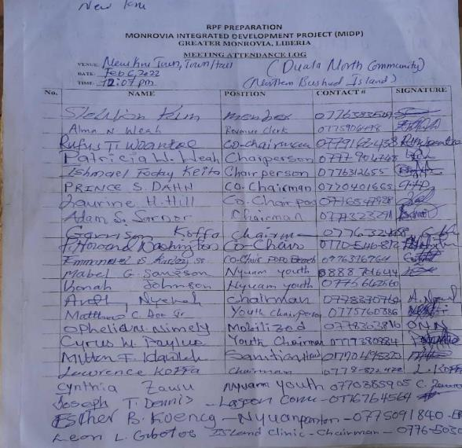
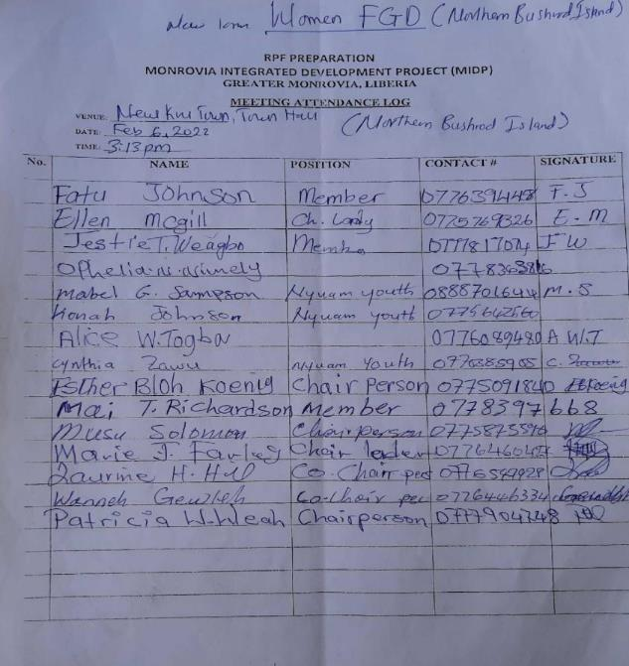

Corporate Results Indicator
This objective will be validated in the feasibility and design study to ensure that this is economically viable and cost effective. It may be that a 1-in-5 return period in 2050 is more cost effective.
Extracted from Cities Alliance (2020), Greater Monrovia Urban Development Strategy.
Land Right Law, 2018
Environmental Protection Agency 2022, accessed 6 February 2022, https://www.epa.gov.lr/content/brief-history.
Environmental Protection Agency 2022, accessed 6 February 2022, https://www.epa.gov.lr/content/brief-history
Ministry of Public Works 2022, accessed 6 February 2022, https://www.mpw.gov.lr/general/about-ministry-public-works.
Devex 2022, accessed 6 February 2022, https://www.devex.com/organizations/liberia-water-and-sewer-corporation-lwsc-121942.
Informea 2022, Liberia Land Authority Act. United Nations, accessed 6 February 2022. https://www.informea.org/en/legislation/land-authority-act-2016.
Devex 2022, accessed 6 February 2022, https://www.devex.com/organizations/ministry-of-agriculture-liberia-123240.
Environmental Protection Agency 2022, accessed 6 February 2022, https://www.epa.gov.lr/content/brief-history.
Liberia Electricity Corporation 2022, accessed 6 February 2022, https://lecliberia.com/?page_id=106.
Forestry Development Authority 2022, accessed 6 February 2022, https://www.fda.gov.lr/index.php/about-us/history.
DEVEX 2021, accessed February 6, 2022, https://www.devex.com/organizations/liberia-revenue-authority-lra-134245.
Center for National Documents and Records Agency 2017, Center for National Documents and Records Agency Act 1977, accessed February 6, 2022, Way Back Machine https://web.archive.org/web/20161021231047/http://cndra.gov.lr/doc/CNDRA%20Act%20of%201977.pdf.
Republic of Liberia 2012, An Act to Establish the National Disaster Management Agency, Ministry of Internal Affairs, accessed February 6, 2022, <https://www.mia.gov.lr/doc/Draft%20Act%20-The%20National%20Disaster%20Management%20Agency.pdf>.
Ministry of Health 2019, accessed February 6, 2022, https://moh.gov.lr/moh-madate/.
Devex 2022, accessed 6 February 2022, https://www.devex.com/organizations/monrovia-city-corporation-mcc-136941
Republic of Liberia, Act to Establish the Paynesville City Corporation, 1979, Monrovia, Liberia.
See section 6.4 -Supplemental Assistance for breakdown and how the amount was arrived at.
See section 6.4 -Supplemental Assistance for breakdown and how the amount was arrived at.
See section 6.4 -Supplemental Assistance for breakdown and how the amount was arrived at.
See section 6.4 -Supplemental Assistance for breakdown and how the amount was arrived at.
See section 6.4 -Supplemental Assistance for breakdown and how the amount was arrived at.
This amount is based the records of other RAP projects which paid the same amount to vulnerable groups.
Liberia County Programme, Baseline Survey Findings - July 2017 (https://www.citiesalliance.org/sites/default/files/BASELINE%20PRESENTATION%20JUNE%2017-2017.pdf)

